## GIFT University Gujranwala GIFT

Project Final Report

For

**Stay Ease**

**Submitted By:**

**Maryam Fazal FA24-BCS-211400155**

**Sumaira Ramzan FA24-BCS-211400100**

**Sitara Bibi FA24-BCS-211400125**

**Sehar Mazhar FA24-BCS-211400033**

**SupervisorMa’am Rahima Tanveer**

Original Version 1.0

Bachelor of Science in Software Engineering (2021-2025)



**GIFT University Gujranwala**

**Stay Ease**

**A project presented to**

**GIFT University, Gujranwala**

**In partial fulfillment**

**of the requirement for the degree of**

***Bachelors of Science in Software Engineering (2021-2025)***

**By**

**Maryam Fazal SP09-BCS-211400155**

**Sumaira Ramzan SP09-BCS-211400100**

**Sitara Bibi SP09-BCS-211400125**

**Sehar Mazhar SP09-BCS-211400033**

**DECLARATION**

We hereby declare that this software, neither in whole nor as a part has been copied from any source. It is further declared that we have developed this software and accompanied report entirely on the basis of our personal efforts. If any part of this project is proved to be copied from any source or found to be reproduction of someone else's work, we will stand by the consequences. No portion of the work presented has been submitted of any application for any other degree or qualification at this or any other university or institute of learning.

**Student Name 1 Student Name 2**

Sumaira Ramzan Sitara Bibi

**Student Name 3 Student Name 4**

Sehar MazharMaryam Fazal

**Executive Summary**

Manual and time-consuming management of rentals in Pakistan has always been the case. Generally, landlords have traditionally used old-fashioned methods such as paper work and direct face-to-face contact to manage the property and the tenants. All these cause a lot of problems, including inefficient management, lack of transparency in communication, trust issues, and no centralized system to follow for tracking rent and tenant details. Misunderstandings and even disputes occur due to the lack of transparency and documented evidence.

Stay Ease provides a modern, user-friendly digital rental management platform that streamlines the entire process for landlords, renters, and admins. For landlords, Stay Ease simplifies property management by allowing them to list properties, manage renters details, monitor rent payments, and handle property-related tasks in one place. The platform eliminates the need for manual record-keeping, making the process more efficient and stress-free. Renters can simply search for available rentals, make secure payments directly from the platform, and easily communicate with their landlords through a simple in-app chatbot. Admins help the platform to run smoothly by verifying properties and Renters, resolving disputes, and generally overseeing the performance of the system.

The platform's key features include a secure payment gateway that enables renters to make rent payments directly through the app while landlords can track transactions effortlessly. Stay Ease also provides centralized communication by documenting all interactions between landlords and renters within the platform, enhancing transparency and minimizing disputes. In addition, Stay Ease uses Firebase, a secure and scalable cloud storage solution, to store property listings, renters records, and payment histories, ensuring that all data is safe and easily accessible at any time.

It helps in automating manual tasks, ensuring transparency, and offering a centralized system; hence, it makes rental management easier and hassle-free. It eliminates inefficiencies, reduces misunderstandings, and increases the reliability and seamlessness of landlords and renters. Be it a landlord looking to simplify property operations or a renters seeking to have a stress-free rental journey, Stay Ease is conceptualized to make rental management modern, efficient, and trustworthy.

**Acknowledgement**

All praise is to Almighty Allah who bestowed upon us a minute portion of His boundless knowledge by virtue of which we were able to accomplish this challenging task.

We are greatly indebted to our project supervisor “**Ma’am Rahima Tanveer”**. Without his personal supervision, advice and valuable guidance, completion of this project would have been doubtful. We are deeply indebted to them for their encouragement and continual help during this work.

We are also thankful to our parents and family who have been a constant source of encouragement for us and brought us the values of honesty & hard work.

**Student Name 1 Student Name 2**

Sumaira Ramzan Sitara Bibi

**Student Name 3 Student Name 4**

Sehar MazharMaryam Fazal

**Abbreviations**

| **SRS** | Software Require Specification |
| --- | --- |
| **PC** | Personal Computer |
| **PCC** | Police Character Certificate |
| **UM** | User Management |
| **PM** | Property Management |
| **PCM** | Police Character Management |
| **SPM** | Shared Property Management |
| **RNM** | Reporting Notification Management |
| **CM** | Communication Management |
| **FMM** | Feedback Management Module |
| **PCM** | Payment Commission Management |
| **LI** | Limitations |
| **BO** | Business Objectives |
| **SCA** | Scalability |
| **AVA** | Availability |
| **INT** | Data Integrity |
| **COM** | Compliance |
| **LOC** | Localization |
| **MAIN** | Maintainability |
| **INT** | Interoperability |

**Table of Contents**

1 Introduction 11

1.1 Project Background 11

1.2 Comparative Analysis 11

1.3 Advantages/Benefits of Proposed System 12

1.4 Project Scope 13

1.5 Module 14

1.5.1 User Management Module 14

1.5.2 Property Management Module 14

1.5.3 Police Character Certificate Management Module 14

1.5.4 Shared Property Management Module 15

1.5.5 Reporting and Notification Management Module 15

1.5.6 Communication Management Module 15

1.5.7 Agreement Management Module 15

1.5.8 Feedback Management Module 15

1.5.9 Payment and Commission Management Module 15

1.6 System Limitations/Constraints 17

1.7 Tools and Technologies 17

1.8 Team Members Individual Tasks/Work Division 18

1.9 WBS and Gantt Chart 19

1.9.1 Gantt Chart 20

1.10 Cost of Project 21

2 Problem Definition 22

2.1 Problem Statement 22

2.2 Problem Statement 22

2.3 Proposed Solution 23

2.4 Current System (if applicable to your project) 23

3 Requirement Analysis 25

3.1 Requirement Elicitation Techniques 25

3.1.1 Document Analysis 25

3.1.2 Brainstorming 25

3.2 Business Requirements 25

3.3 Use Cases Diagram(s) 25

3.4 Detailed Use Case (Tabular- Module Wise) 29

3.4.1 Use Case Names 29

3.4.2 Use Case Description 31

3.5 Functional Requirements (Tabular FR- Module Wise) 97

3.5.1 User Management Module 97

3.5.2 Property Management Module 113

3.5.3 Police Character Certificate Management Module 136

3.5.4 Shared Property Management Module 139

3.5.5 Reporting and Notification Management Module 141

3.5.6 Communication Management Module 143

3.5.7 Agreement Management Modul 144

3.5.8 Feedback Management Module 145

3.5.9 Payment and Commission Management Module 148

3.6 Non-Functional Requirements 151

3.6.1 Scalability 151

3.6.2 Availability 151

3.6.3 Data Integrity 151

3.6.4 Compliance 152

3.6.5 Localization 152

3.6.6 Auditability 152

3.6.7 Maintainability 152

3.6.8 Interoperability 152

3.7 External Interface Requirements 152

3.7.1 User Interface Requirements 152

3.7.2 Software Interface 153

3.7.3 Hardware Interfaces 153

3.7.4 Communication Interfaces 154

4 Architecture and Design 154

4.1 System Architecture 154

4.2 Design Methodology 154

4.3 Data Representation [Diagram + Description] (ERD, JSON SCHEMA) 155

4.4 Design Models [along with descriptions] 160

4.4.1 Class Diagram 160

4.4.2 Activity Diagram 162

4.4.3 Sequence Diagram 176

4.4.4 State Diagram 186

4.4.5 Layered Architecture 187

5 Human Interface Design 188

5.1.1 Screen Images 188

6 . Implementation Screens 256

**List of Figures**

Figure 1:Context Diagram Of The System 13

Figure 2: WBS with Gantt Chart 20

Figure 3:Current System 23

Figure 4: Renter Use Case Diagram 25

Figure 5:LandLord Use Case Diagram 26

Figure 6:Admin Use Case Diagram 27

**List of Tables**

Table 1 :Related System Analysis 12

Table 2:Tools &Technologies 17

Table 3:Team Members Work Divion 17

Table 4:Admin Use Case Description 30

Table 5:LandLord Use Case Description 45

Table 6:Renter Use Case Description 69

**Project Category: (**Select all the major domains of proposed project**)**



# Introduction

The purpose of developing the **Stay Ease** application is to make it easier for students and job seekers to find short-term rentals tailored to their needs. Presently, finding the right rental option is difficult due to the absence of centralized systems, dependence on outdated manual processes, and limited access to verified listings. This often leads to inefficiencies, wasted time, and potential security risks. Stay Ease seeks to bridge this gap by offering a digital solution that simplifies the process of finding, comparing, and securing temporary rentals. The project is therefore seeking to bridge the gap in the market for a dedicated rental platform focused on short-term accommodations for those with unique needs and constraints. The main aims are a well-protected, user-friendly interface, an intelligent search and filtering mechanism, and an online review system that helps enhance transparency and trust. Such objectives will bring the Stay Ease application to save users' precious time and serve them accurate information without additional stress concerning temporary accommodation searches. This project is of importance because it simplifies and modernizes the process of finding accommodation, making it convenient and reliable for its target audience.

## Project Background

The concept of Stay Ease is based on the problems in Pakistan's rental property market, where manual processes and fragmented systems often make renting inefficient and unreliable. Existing platforms cater to general users but fail to address the specific needs of students and job seekers seeking temporary housing. Issues such as unverified listings, lack of trust, and limited affordability highlight the need for a tailored solution. Stay Ease is developed to bridge the gap by offering a central platform that incorporates landlord verification, secure online payments, installment plans, and rental agreements. Featuring property recommendations based on user choices, scheduling of visits to properties and sentiment analysis for feedback, Stay Ease offers a transparent and efficient, user-friendly rental experience that meets the unique requirements of short-term Renters, simplifying the property management processes for the landlords involved.

## Comparative Analysis

**Granna.com:** Mainly focused on property listings and rental agreements, Granna doesn't have sophisticated features such as AI-powered chatbots, renters-landlord communication tools, or integrated maintenance request handling, which

**Feeta:** Feeta offers property search and financial tools but does not include features such as digital contract management or renters feedback systems.

**Property.hamariweb.com:** This website is dedicated to real estate listings with basic search and filter options but lacks comprehensive role-based features for Landlords and Renters.

**Table 1 :Related System Analysis**

| **Application Name** | **Weakness** | **Proposed Project Solution** |
| --- | --- | --- |
| **Graana.com** | Mainly focuses on long-term rentals and property sales, lacks features for short-term rentals ,no proper verification process for landlords and Renters, no secure online payments or rental agreements | *Stay Ease* addresses the need for temporary housing by providing a platform with secure online payments, verified listings, rental agreements, and features that are tailored to short-term rentals. |
| **Feeta** | Landlord and Renter verification is very minimal; there is no safe method of payment, and the rental agreement cannot be automatically generated; mainly buys/sells properties instead of short-term rentals. | *Stay Ease*completes this gap with a safe online transaction, landlord, and Renter verification and automatically generates rental agreements for short-term stays, which particularly focuses on students and job seekers. |
| **Property.hamari.web** | It doesn't provide an easily navigable interface for short-term rentals, offers no secure payment or Renter/landlord verification and does not personalize property suggestions. | *Stay Ease* enhances the rental process with an intuitive interface, secure payments, landlord and Renter verification, and a personalized recommendation system based on user preferences. |

## Advantages/Benefits of Proposed System

* **Safe Transaction:** Stay Ease offers safety and reliability in online transactions, thus saving Renters from scams while landlords are also saved.
* **Verified User:** Both the landlord and the Renter will pass a vetting process to ensure they are trustworthy and genuine before entering into any rental.
* **Focusing on Short-Term Rental:** Unlike other websites, the specific specialty of StayEase is for short-term rentals, catering to students and job seekers.
* **Installment Payments:** Renters can pay in installments, thus making it easier to handle rental costs.
* **Automated Rental Agreements:** The system makes the process of renting easier with automated agreements, thus eliminating paperwork and speeding up transactions.
* **Personalized Recommendations:** It suggests properties based on the preferences of Renters and their previous searches, saving time and effort.
* **Convenient Property Visits:** The Renter can easily book visits so that the visit goes as smooth as possible.

## Project Scope

The Stay Ease project is an advanced platform designed to streamline the rental process for short-term accommodations across Pakistan. It serves three primary user types: Admin, Landlord, and Renter, each with distinct functionalities to ensure a smooth and transparent experience for all parties involved. The **Admin module** allows administrators to manage the entire platform, including verifying landlord profiles, approving or rejecting rental requests, and tracking payments. Admins will also be able to generate detailed reports on transactions, commissions, and landlord activities. They are responsible for monitoring feedback from both landlords and renters and taking action when necessary, such as disabling accounts based on negative feedback. The **Landlord module** enables landlords to create accounts, submit property details for approval, and upload property information, including images, videos, and descriptions, once their properties are approved. Landlords can set rules, visiting hours, and payment plans for their properties. The system also allows landlords to interact with renters, schedule property visits, and finalize rental agreements and fill feedback on the renter. The **Renter module** provides renters with an easy-to-use interface to search for properties based on their preferences, including budget, location, and property type (flat, Appointment Room) shared or unshared. Renters can shortlist properties, view detailed information, and contact landlords. Once a property is selected, renters can review and accept rental agreements, make secure payments, and leave feedback on the property.

**Figure 1:Context Diagram Of The System**

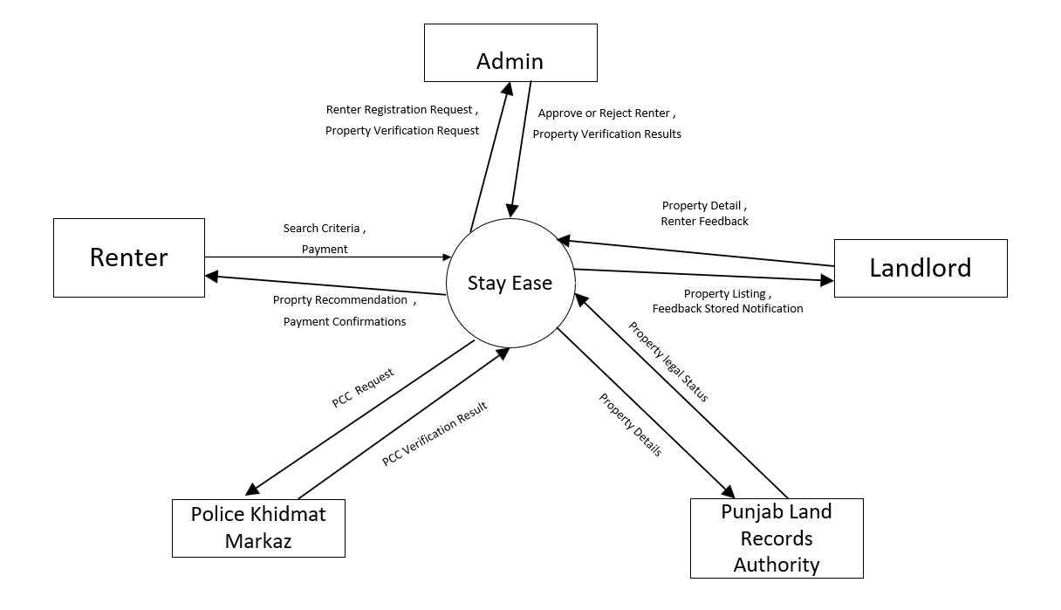

## Module

### User Management Module

It offers role-based account management for administrators, landlords, and renters, involving registration, log in, password reset, updates of their profile, and accounts deletion. Every role has control and is granted permission to view and manage their profile with proper access control mechanisms.

### Property Management Module

This module deals with property verification, approval, and listing by landlords. Admins verify property requests through third-party integrations, while renters search, view, and filter properties based on their preferences like location, budget, and type.

### Police Character Certificate Management Module

This module authenticates the police character certificates for renters through third-party platforms. The admins will approve or reject certificates, and the result is communicated to the renters. Only verified renters will proceed with the rental agreement.

### Shared Property Management Module

This module deals with the shared property listing management; this is where landlords can set up capacity and monitor tenants. Tenants are given the ability to choose shared properties and guided through form submissions in order to facilitate shared space management.

### Reporting and Notification Management Module

This module automatically generates reports for admins and landlords, such as transaction and property reports. It also manages notifications for agreements, payments, and feedback, keeping all users updated.

### Communication Management Module

This module facilitates interaction between landlords and renters through a chatbot and direct calls, ensuring smooth communication for queries, agreements, and issue resolution.

### Agreement Management Module

It automatically generates a rental agreement for each property and renter. The agreement can be seen and finalized after the police character certificate is approved by the authorities.

### Feedback Management Module

This module collects feedbacks from tenants and landlords and helps generate property and renter ratings using sentiment analysis. The feedback improves service quality and property management.

### Payment and Commission Management Module

All financial transactions are managed through this module, including one-time commission payments by landlords, rent payments from tenants, and penalties for late payments. Admins oversee and enforce financial compliance.

**Special Features**

* **Integration with Third-Party Services**: Verification of property and police character certificates through Punjab Land Records Authority and Police Khidmat Markaz, ensuring authenticity.
* **Advanced Search and Filtering**: Renters can search properties by location, budget, type, and shared/unshared status.
* **AI-Powered Feedback Analysis**: Sentiment analysis to evaluate feedback and generate property and user ratings automatically.
* **Automated Agreement Generation**: Rental agreements are auto-generated based on property rules and renter details.
* **Penalties and Notifications**: Automatic penalties for late payments and real-time notifications for renters and landlords.
* **Shared Property Management**: Special handling for shared properties with capacity limits and dynamic forms.
* **Secure Payment Gateways**: Robust mechanisms for seamless transactions with penalty tracking

**Module 1: User Management Module**

*UM-1: Manage role-based accounts for Admins, Landlords, and Renters, including registration, login, profile updates, and deletion.  
UM-2: Provide secure password reset and access control mechanisms for all roles.  
UM-3: Allow users to view and manage their profiles with appropriate permissions.*

**Module 2: Property Management Module**

*PM-1: Handle property verification, approval, and listing by landlords.  
PM-2: Allow renters to search, view, and filter properties based on location, budget, and type.  
PM-3: Enable admins to verify property details using third-party integrations.*

**Module 3: Police Character Certificate Management Module**

*PCM-1: Authenticate renters' police character certificates through third-party platforms.  
PCM-2: Allow admins to approve or reject certificates and notify renters of the results.  
PCM-3: Restrict renters with rejected certificates from proceeding with agreements*

**Module 4: Shared Property Management Module**

*SPM-1: Enable landlords to define capacity limits and monitor tenants in shared properties.  
SPM-2: Allow renters to choose shared properties and manage form submissions.  
SPM-3: Facilitate efficient management of shared spaces by landlords.*

**Module 5: Reporting and Notification Management Module**

*RNM-1: Generate reports for admins and landlords, such as transaction and property reports.  
RNM-2: Notify users about agreements, payments, feedback, and system updates.  
RNM-3: Ensure timely delivery of reminders and alerts to keep users informed.*

**Module 6: Communication Management Module**

*CM-1: Facilitate communication between landlords and renters through chatbots.  
CM-2: Support direct calls for queries, agreements, and issue resolution.  
CM-3: Provide 24/7 chatbot assistance for smooth interaction.*

**Module 7: Agreement Management Module**

*AGM-1: Automatically generate rental agreements based on property and renter details.  
AGM-2: Allow renters to review and finalize agreements post certificate approval.  
AGM-3: Ensure all agreements adhere to the system's rules and regulations..*

**Module 8: Feedback Management Module**

*FMM-1: Collect and analyze feedback from tenants and landlords using sentiment analysis.  
FMM-2: Generate property and renter ratings based on feedback.  
FMM-3: Improve service quality through actionable insights from feedback.*

**Module 9:  Payment and Commission Management Module**

*PCM-1: Manage financial transactions, including one-time commissions and rent payments.  
PCM-2: Enforce penalties for late payments and notify users accordingly.  
PCM-3: Allow admins to oversee and ensure financial compliance.*

## System Limitations/Constraints

*LI-1: Stay Ease is only operational within Pakistan and therefore cannot hold properties or users outside of the country*

*LI-2: The platform relies on external verification systems for police clearance certificates and landlord registration numbers, which may lead to delays if these systems are unavailable or slow to respond.*

*LI-3: The system requires reliable internet connectivity, as all operations, including property searches, payments, and communication, are online-based.*

*LI-4 : Sentiment analysis for review feedback is subject to user-provided review quality that may lead to rating errors if users give very biased or low-quality reviews*

## Tools and Technologies

**Table 2:Tools &Technologies**

| **Tools and Technologies** | **Tools** | **Version** | **Rationale** | **Paid/Free** |
| --- | --- | --- | --- | --- |
| Visual Studio Code | 1.59 | IDE | Free |
| Firebase | 9.12.1 | DBMS | Free |
| MS Project | 2016 | Project Management | Free |
| MS Word | 365 | Documentation | Free |
| MS Power Point | 365 | Presentation | Free |
| MS Visio | 2013 | Diagram Creation | Free |
| Figma | 1.7 | Mockups Creation | Free |
| Strip | 2.23.1 | Payment Method | Free |
| **Technology** | **Version** | **Rationale** | **Paid/Free** |
| Python | 3.9.0 | Programming language | Free |
| React Native | React 17 | Programming language | Free |
| LambdaMART | 4.1.0 | Programming language | Free |
| Node JS | 14.17.4 | Runtime Environment | Free |

## Team Members Individual Tasks/Work Division

**Table 3:Team Members Work Divion**

| **Student Name** | **Student Registration Number** | **Responsibility/ Modules** |
| --- | --- | --- |
| * **Sehar Mazhar** | **211400033** | **Module 1-Module 6** |
| * **Sitara Bibi** | **211400125** | **Module 4-Module 5-Module 9** |
| * **Sumaira Ramzan** | **211400100** | **Module 2-Module 8** |
| * **Maryam Fazal** | **211400155** | **Module 7-Module 3** |

## WBS and Gantt Chart

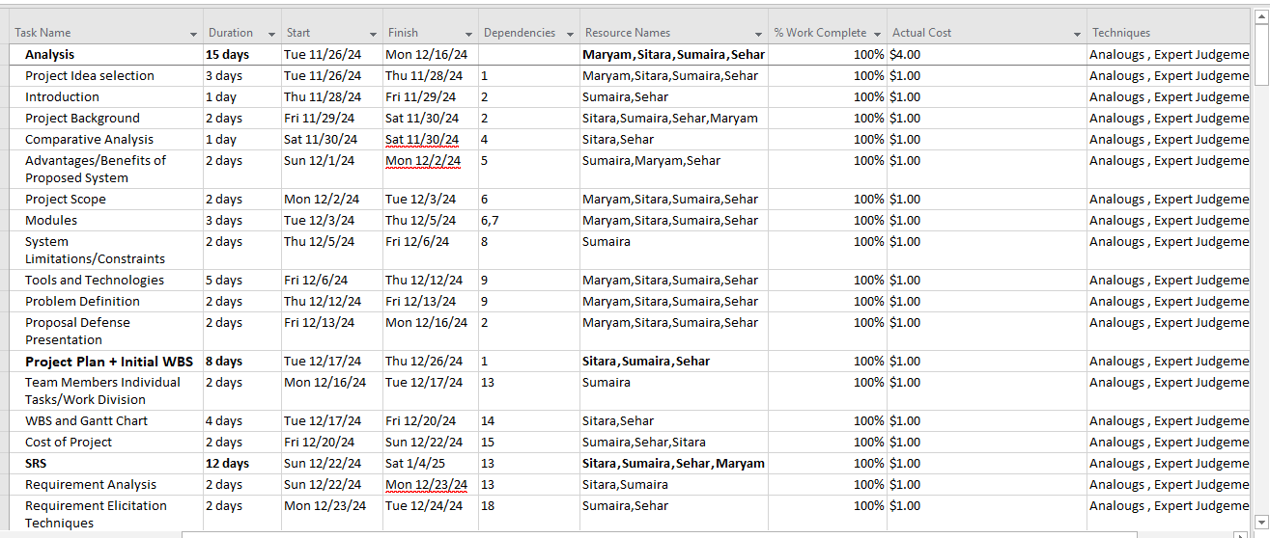

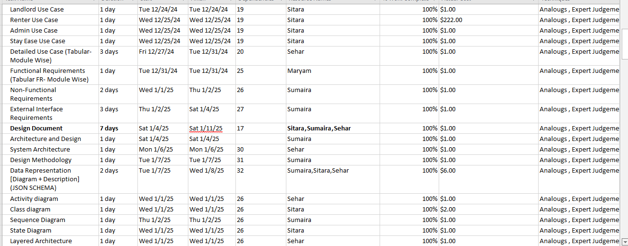

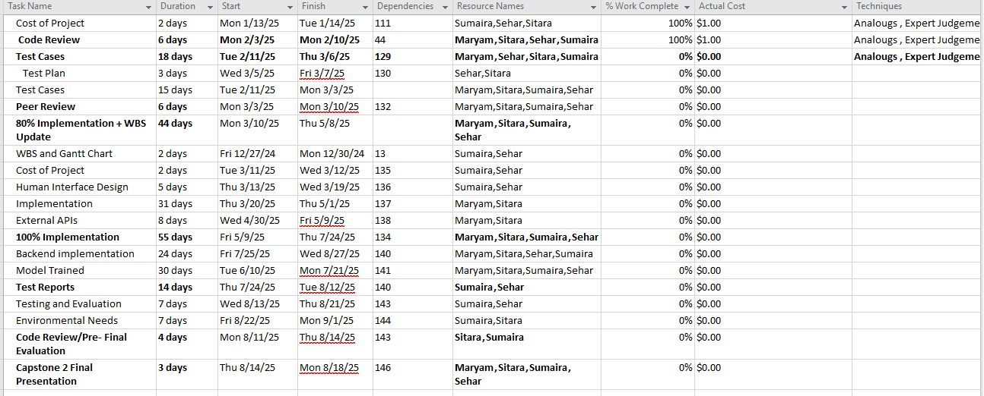

### Gantt Chart

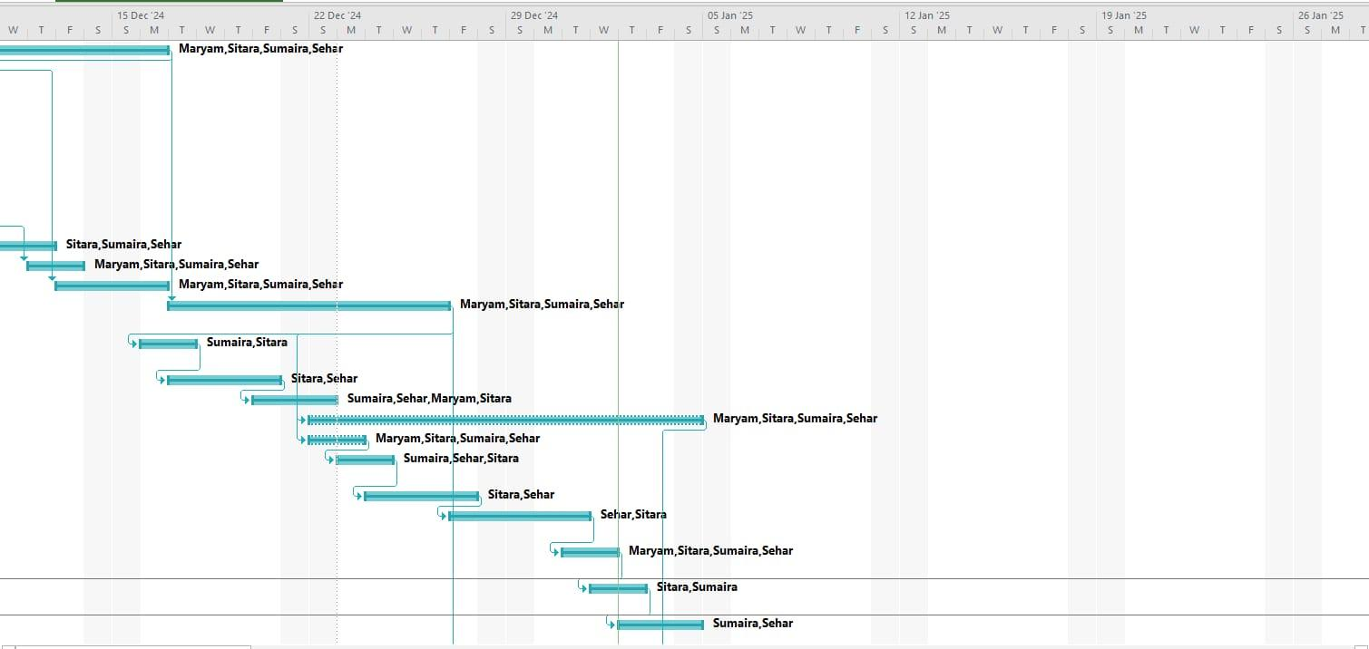

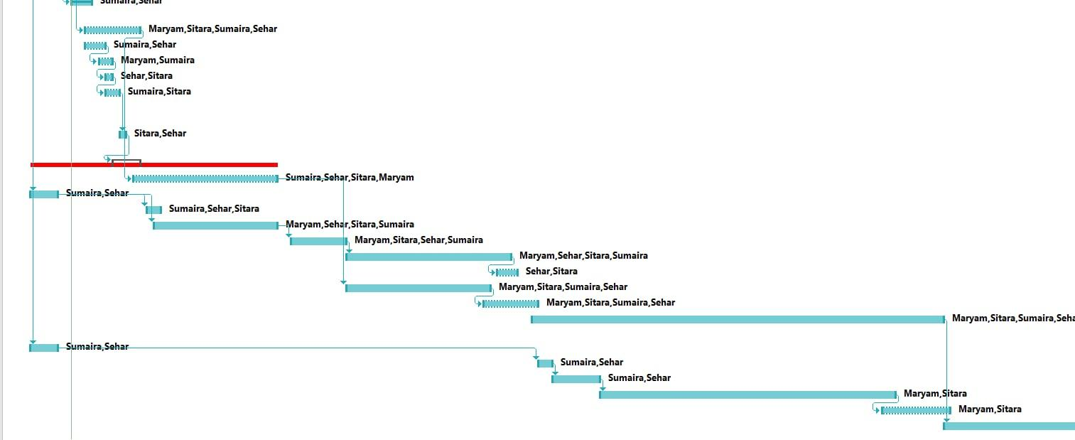

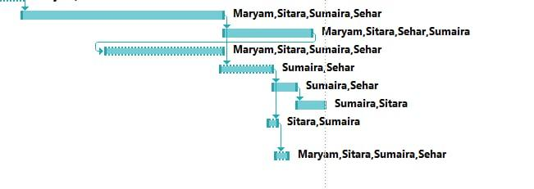

**Figure 2: WBS with Gantt Chart**

## Cost of Project

**Effort Calculation (COCOMO Semi-Detached Model)**

Formula:

E=3.0×(KLOC)^1.12

Substituting **KLOC = 40**

E=3.0×(40)^1.12

E=3.0×49.64=148.92 Person-Months

**Required Effort :** 148.92 Person-Months

**Development Time Calculation**

Formula:

T=2.5×(E)0.35

T=2.5×(148.92)0.35

T=2.5×5.61=14.03 Months

**Cost Estimation**

Each developer’s salary = **PKR 200,000/month**

Total Cost=4×200,000×8

PKR6,400,000 (PKR 64 Lakh)

# Problem Definition

This chapter discusses the specific problem to be solved and should also elaborate on the expected outcome.

## Problem Statement

This chapter discusses the specific problem to be solved and should also elaborate on the expected outcome.

## Problem Statement

The rental management process in Pakistan currently faces several inefficiencies, as landlords and renters are finding it difficult to manage property details, communication, and transactions. Most landlords lack a comprehensive platform to manage their properties, set rules, track payments, and approve rental requests efficiently. Renters face problems in finding the right properties according to their preferences and budget, which creates frustration and delays in securing a rental. Moreover, the lack of a single platform for communication and feedback between landlords and renters leads to more misunderstandings and dissatisfaction.

The proposed **StayEase** system is going to overcome these challenges by providing an integrated platform that streamlines property management, rental requests, bookings, payments, and communication. The system will enable landlords to create and manage property listings, approve or reject rental requests, set payment plans, and track their rental income. Renters will be able to intuitively search for properties, read in-depth information, and make safe bookings. In addition, the platform will offer a communication tool to facilitate live conversations about issues raised between the renter and landlord. There will be feedback and review mechanisms to provide transparency and accountability.

Although there are some rental platforms, they usually specialize in only one aspect, such as property listings or payment processing, and lack the integration of all features necessary for seamless management. The re-implementation of such a system will not only allow me to gain hands-on experience in full-stack development but also give me an opportunity to improve user experience through real-time communication and automated processes. Furthermore, building this platform will help me understand the depth of database management, payment systems integration, and the importance of user-centered design in developing practical solutions for real-world problems.

This project will enable me to acquire valuable technical skills, including web development, database management, payment gateway integration, and UI/UX design.

## Proposed Solution

StayEase will solve the inefficiency and challenges in the Pakistan rental property market. Through the system, a centrally managed rental property market provides a transparent platform for various stakeholders. Landlords can freely upload and manage listings from the property with description images, and schedules for more accessible renters search processes based on their needs

It has implemented renters and landlord verification where the risk of frauds is reduced by verifying the CNICs and the PCC through third-party verification mechanisms. It secures the payment, thereby having an in-built system for managing rental advances as well as refundable security deposits to ensure safe transaction processes for all users involved.

Unique features like chatbots facilitate seamless communication between renterss and landlords, while sentiment analysis ensures actionable feedback for improving property and user experiences. Automated generation of rental agreements further simplifies the legal formalities, making the process more efficient.

Unlike existing systems, StayEase offers end-to-end functionality such as user management, reporting, analytics, and compliance monitoring. It is also scalable to accommodate a growing number of users and increasing property listings without a decrease in performance

By automating and integrating these processes, StayEase saves time and effort while building trust and reliability in the rental market. It is a comprehensive, cost-effective solution that improves the rental experience for both landlords and renters.

**Objectives**

* BO-1: Reduce the time taken by renterss to find and finalize a property by 50%.
* BO-2: Ensure 100% verification of all users to eliminate fraud in the rental process.
* BO-3: Increase user satisfaction by 50% by improving feedback and sentiment analysis.
* BO-4: Reduce manual intervention for the creation of rental agreements by 70% in order to increase efficiency.

## Current System (if applicable to your project)

A brief description of an existing system, along with pictures of existing system and modules.

The following figure is a sample figure of existing system, Figure 3



**Figure 3:Current System**

**Table 4:Current System Modules**

| **Name of Modules** | **Sub Module** | **Sub Module** |
| --- | --- | --- |
| **User Management** | Admin Registration/Login | Landlord Registration/Login |
|  |  |  |
| **Property Listings** | Residential,Commercial, Agricultural, | New Listings, Featured Properties, Price Drop Listings |
| **Search and Filters** | Location, Type, Price, Size, Amenities | Nearby Landmarks, Property Status |
| **Seller and Buyer Portal** | Listing Management, Transaction Tracking | Profile Management, Communication with Agents, Price Alerts |

# Requirement Analysis

## Requirement Elicitation Techniques

### Document Analysis

**Reason:** This will be used to review existing documentation on the rental management system and i1ndustry standards to identify best practices and regulatory requirements for the rental management system. Document analysis ensures that the system design aligns with legal, technical, and business standards.

### Brainstorming

**Reason:** Since the project will have an AI chatbot feature, brainstorming will help generate ideas on innovative functionalities, user interface designs, and ways to improve renters-landlord interactions. It can be done with the project team or with stakeholders to ensure creative and useful solutions are considered.

## Business Requirements

This project provides significant business benefits by creating a secure, efficient, and profitable rental platform.

For admins, the system generates revenue through one-time commission fees from landlords when they list their first property and ensures streamlined financial handling through automated payment notifications and transaction summaries. The platform enhances trust by implementing thorough verification processes for landlords and renters, reducing fraudulent activities and fostering credibility.

Landlords benefit from features like detailed property management tools, timely rent notifications, and renter feedback visibility, allowing them to make informed decisions and maximize their earnings.

Renters enjoy a seamless experience with personalized property recommendations, secure payment options, and transparent transaction histories, ensuring satisfaction and repeat usage.

Overall, the platform not only generates revenue but also establishes itself as a trusted intermediary by promoting high-quality interactions, efficient operations, and a secure environment for all stakeholders.

## Use Cases Diagram(s)

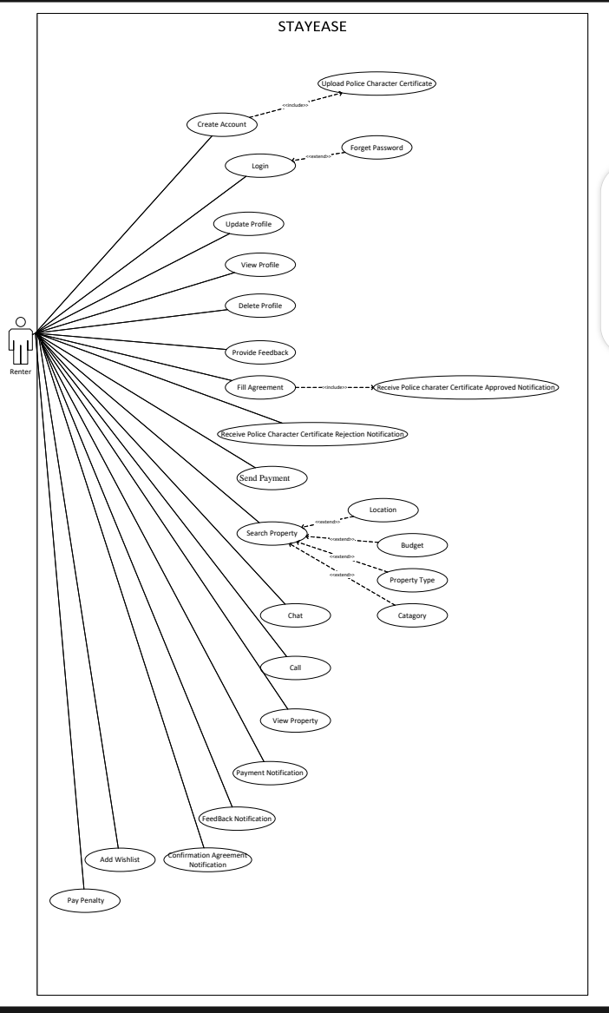

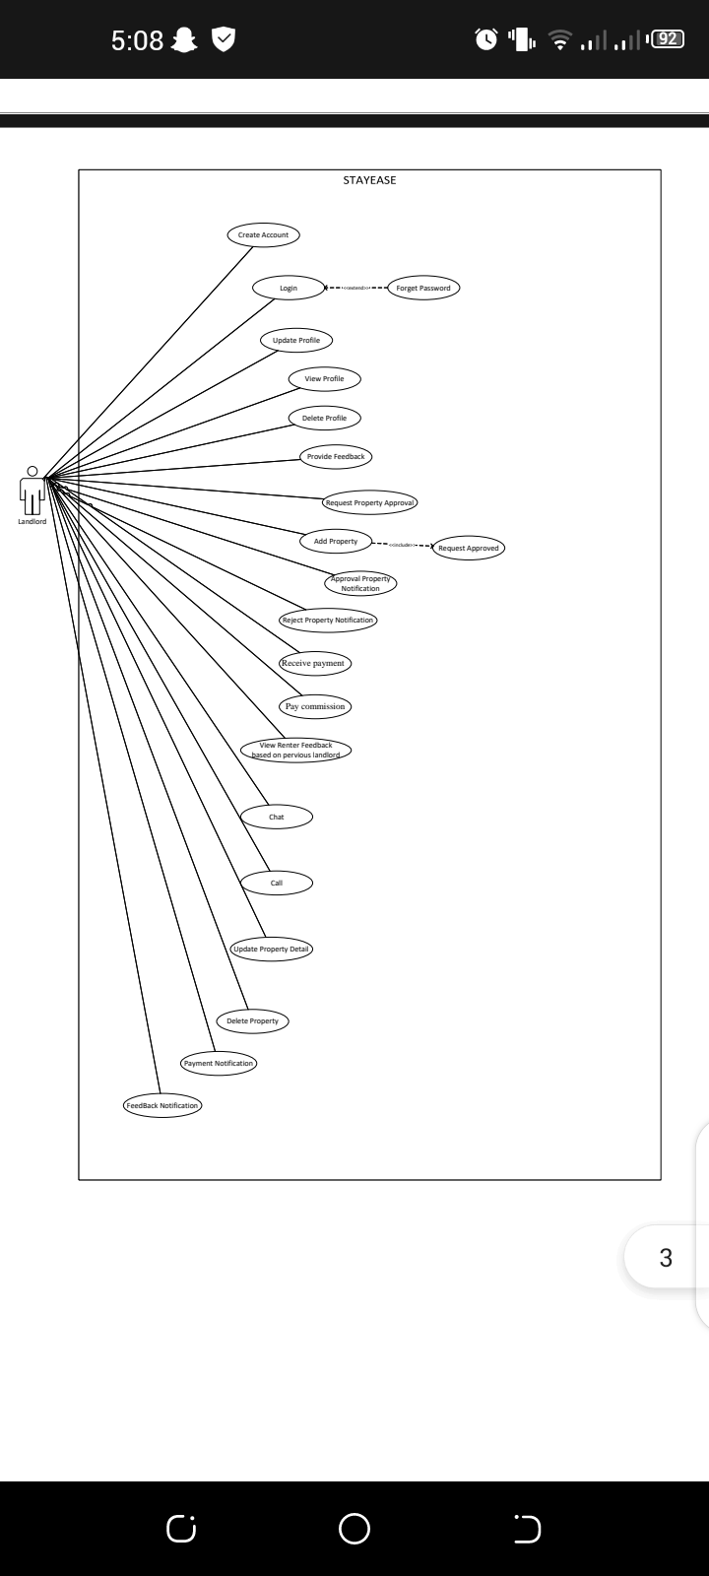



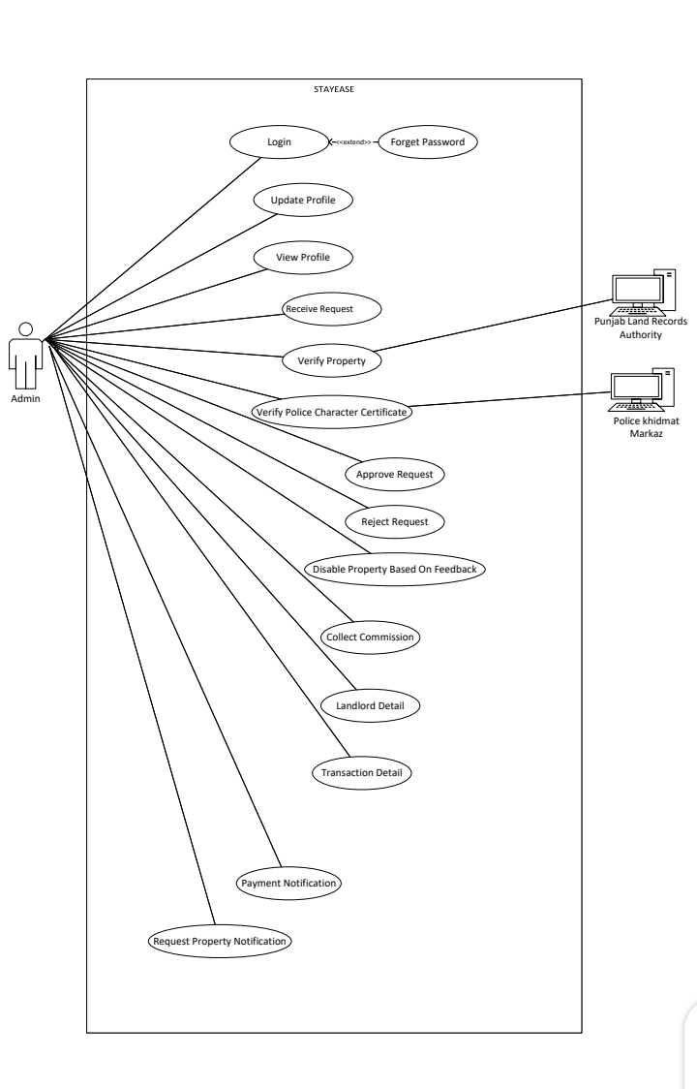

## Detailed Use Case (Tabular- Module Wise)

This section of the SRS should contain all the details that the software developer needs to create a design. This is typically the largest and most important part of the SRS. This section contains an overview of the use-case model or the subset of the use-case model that is applicable for this subsystem or feature.  This includes a list of names and brief descriptions of all use cases and actors, along with their applicable relationships.

### Use Case Names

**Admin Use Case**

* Login
* Update profile
* View profile
* Receive Request
* Verify Property
* Verify PCC
* Approve Request
* Reject Request
* Disable Property Based On Feedback
* Collect Commission
* Landlord Detail
* Transaction Detail
* Payment Notification
* Request Property Notification

**Landlord Use Case**

* Create Account
* Login
* Update Profile
* View Profile
* Update Profile
* View Profile
* Delete Profile
* Provide Feedback
* Request Property Approval
* Add Property
* Approval Property Notification
* Reject Property Notification
* Receive Payment
* Pay Commission
* Request Rejected
* View Renter Feedback Based on Previous Landlord
* Chat
* Call
* Update Property Detail
* Delete Property
* Payment Notification
* Feedback Notification

**Renter Use Case**

* Create Account
* Login
* Update Profile
* View Profile
* Delete Profile
* Provide Feedback
* Receive PCC Approved Notification
* Receive PCC Rejected Notification
* Search Property
* Send Payment
* View Property
* Chat
* Call
* Fill Agreement
* Payment Notification
* Feedback Notification
* Confirmation Agreement Notification
* Add Wishlist
* Pay Penalty

### Use Case Description

**Table 4:Admin Use Case Description**

| **Use Case ID:** | UC-1 |
| --- | --- |
| **Use Case Name:** | Login |
| **Actors:** | **Primary Actor:** Admin  **Secondary Actor**: None |
| **Description:** | This use case describes how the Admin logs into the system to access their dashboard and functionalities. |
| **Trigger:** | The Admin opens the system login page. |
| **Level:** | High |
| **Preconditions:** | PRE-1: The Admin must have valid login credentials (email and password).  PRE-2: The system must be online and accessible. |
| **Post conditions:** | POST-1: The Admin is authenticated and redirected to their dashboard.  POST-2: The system logs the login activity for auditing purposes. |
| **Include** | None |
| **Extend** | UC-1.1 Forget Password |
| **Normal Flow:** | 1. The Admin opens the login page. 2. The Admin enters their email and password. 3. The Admin clicks the "Login" button. 4. The system validates the credentials. 5. Upon successful authentication, the Admin is redirected to their dashboard. |
| **Alternative Flows:** | **Incorrect email or Password:**  The system notifies the Admin: "Invalid email or password. Please try again." |
| **Exceptions:** | 1: Invalid Credentials:   * The system displays an error message: "Invalid email or password. Please try again."   2: System Unavailable:   * The system notifies the Admin: "The system is currently unavailable. Please try again later." |
| **Business Rules** | None. |
| **Assumptions:** | 1. Assume the Admin has a valid account in the system. 2. Assume the login page is accessible through a web browser or application. |

| **Use Case ID:** | UC-1.1 |
| --- | --- |
| **Use Case Name:** | Forget Password |
| **Actors:** | **Primary Actor:** Admin  **Secondary Actor**: None |
| **Description:** | This use case describes how the Admin resets their password in case of forgetting it. |
| **Trigger:** | The Admin selects the "Forget Password" option on the login page. |
| **Level:** | High |
| **Preconditions:** | PRE-1: The Admin's email must be registered in the system.  PRE-2: The system must be able to send emails. |
| **Post conditions:** | POST-1: The Admin successfully resets their password.  POST-2: The system logs the password reset activity for auditing purposes. |
| **Include** | None |
| **Extend** | None |
| **Normal Flow:** | 1. The Admin clicks the "Forget Password" link on the login page. 2. The system prompts the Admin to enter their registered email address. 3. The Admin provides their email address and submits the form. 4. The system sends a password reset link to the Admin's email. 5. The Admin clicks the link and resets their password. |
| **Alternative Flows:** | **Invalid Email Address:**  The system notifies the Admin: "The entered email address is not associated with any account. Please try again."  **Expired Reset Link:**  The system notifies the Admin: "This password reset link has expired. Please request a new one. |
| **Exceptions:** | **Unregistered Email:**   * The system notifies the Admin: "The provided email address is not registered."   **Expired Link:**   * The system displays an error message: "The reset link has expired. Please request a new one." |
| **Business Rules** | None |
| **Assumptions:** | 1. Assume the Admin has access to their registered email. 2. Assume the system is configured to send password reset emails. |

| **Use Case ID:** | UC-2 |
| --- | --- |
| **Use Case Name:** | Update Profile |
| **Actors:** | **Primary Actor:** Admin  **Secondary Actor:** None |
| **Description:** | This use case describes how the Admin updates their profile information in the system. |
| **Trigger:** | The Admin selects the "Update Profile" option from their dashboard. |
| **Level:** | High |
| **Preconditions:** | PRE-1: The Admin is logged into the system. |
| **Post conditions:** | POST-1: The Admin's profile is updated successfully.  POST-2: The system logs the update activity for auditing purposes. |
| **Include** | None |
| **Extend** | None |
| **Normal Flow:** | 1. The Admin navigates to the "Update Profile" section. 2. The Admin updates their details (e.g., email, password,contact number). 3. The Admin clicks the "Save Changes" button. 4. The system validates the changes and updates the profile. |
| **Alternative Flows:** | **Incomplete Fields:**  The Admin attempts to save changes but leaves required fields empty.  **Invalid Data:**  The Admin enters data in an invalid format (e.g., incorrect email format or phone number). |
| **Exceptions:** | **Invalid Data:**   * The system notifies the Admin: "Invalid input. Please check your details and try again." |
| **Business Rules** | . None |
| **Assumptions:** | 1. Assume the Admin has permissions to update their profile. |

| **Use Case ID:** | UC-3 |
| --- | --- |
| **Use Case Name:** | View Profile |
| **Actors:** | **Primary Actor:** Admin  **Secondary Actor**: None |
| **Description:** | This use case describes how the Admin views their profile details stored in the system. |
| **Trigger:** | The Admin selects the "View Profile" option from their dashboard. |
| **Level:** | High |
| **Preconditions:** | PRE-1: The Admin is logged into the system. |
| **Post conditions:** | POST-1: The Admin’s profile details are displayed.  POST-2: The system logs the profile viewing activity for auditing purposes. |
| **Include** | None |
| **Extend** | None |
| **Normal Flow:** | 1. The Admin navigates to the "View Profile" section. 2. The system retrieves and displays the Admin’s profile details. |
| **Alternative Flows:** | **Profile Not Found:**   * + The system notifies the Admin: "Profile details not found. Please contact support."   **Session Timeout:**   * The system logs the Admin out due to inactivity, requiring re-login before viewing the profile. |
| **Exceptions:** | **Profile Retrieval Failure:**   * The system notifies the Admin: "Unable to retrieve profile details at the moment. Please try again later." |
| **Business Rules** | None |
| **Assumptions:** | 1.Assume the system can retrieve and display profile data in real-time. |

| **Use Case ID:** | UC-4 |
| --- | --- |
| **Use Case Name:** | Receive Request |
| **Actors:** | **Primary Actor:** Admin  **Secondary Actor**: None |
| **Description:** | This use case describes how the Admin receives a property rental request submitted by a Landlord. |
| **Trigger:** | The Landlord sends a request for property listing approval. |
| **Level:** | High |
| **Preconditions:** | PRE-1: The Landlord has submitted a request for listing their property. |
| **Post conditions:** | POST-1: The Admin receives the property request. |
| **Include** | None |
| **Extend** | None |
| **Normal Flow:** | 1. The Landlord submits a property request for approval. 2. The system validates the request and forwards it to the Admin. 3. The Admin navigates to the "Property Requests" section. 4. The system displays the list of pending property requests. 5. The Admin reviews the details of a selected request. |
| **Alternative Flows:** | **Invalid Request:**  If required details are missing, the system notifies the Landlord: "Property request incomplete. Please provide all required details." |
| **Exceptions:** | **Invalid Property Request Data**   * The system displays a validation error message: "Invalid property request. Please ensure all required fields are filled correctly." * The system highlights the missing or incorrect fields. |
| **Business Rules** | BR-2: Uploaded videos must meet format (MP4) and size limitations (1080p, 5 Mbps) with proper compression for efficient storage and streaming.  BR-3: Uploaded images must meet size (KB) and format requirements (PNG) and be stored securely in the system. |
| **Assumptions:** | 1. The system ensures that only verified Landlords can send property requests. 2. The Admin can review, approve, or reject property requests. |

| **Use Case ID:** | UC-5 |
| --- | --- |
| **Use Case Name:** | Verify Property |
| **Actors:** | **Primary Actor:** Admin  **Secondary Actor:** Punjab Land Records Authority |
| **Description:** | This use case describes how the Admin verifies property details submitted by landlords through integration with the Punjab Land Records Authority. |
| **Trigger:** | The Admin selects the "Verify Property" option from the property request details page. |
| **Level:** | High |
| **Preconditions:** | PRE-1: The Admin is logged into the system.  PRE-2: The landlord has submitted property details for verification. |
| **Post conditions:** | POST-1: The property is verified successfully.  POST-2: Verification activity is logged in the system. |
| **Include** | None |
| **Extend** | None |
| **Normal Flow:** | 1. The Admin selects a property request to verify. 2. The system retrieves property details and sends them to the Punjab Land Records Authority for validation. 3. The Authority responds with the verification status. 4. The system displays the verification result to the Admin. |
| **Alternative Flows:** | 1. **Invalid Property Details:**    * The system notifies the Admin: "The property details provided are invalid or incomplete. Please review and try again." 2. **Verification Service Down:**    * The system notifies the Admin: "The Punjab Land Records Authority service is currently unavailable. Please try again later." |
| **Exceptions:** | **Verification Failure:**   * The system notifies the Admin: "Unable to verify property details. Please try again later." |
| **Business Rules** | None |
| **Assumptions:** | 1. Assume the Punjab Land Records Authority’s API is operational and reliable. |

| **Use Case ID:** | UC-6 |
| --- | --- |
| **Use Case Name:** | Verify Police Character Certificate |
| **Actors:** | **Primary Actor:** Admin  **Secondary Actor:** Police Khidmat Markaz |
| **Description:** | This use case describes how the Admin verifies the Police Character Certificate submitted by landlords through integration with Police Khidmat Markaz. |
| **Trigger:** | The Admin selects the "Verify Police Character Certificate" option from the landlord’s profile. |
| **Level:** | High |
| **Preconditions:** | PRE-1: The Admin is logged into the system.  PRE-2: The landlord has uploaded a Police Character Certificate. |
| **Post conditions:** | POST-1: The certificate is verified successfully.  POST-2: Verification activity is logged in the system. |
| **Include** | None |
| **Extend** | None |
| **Normal Flow:** | 1. The Admin selects a landlord’s profile to verify the certificate. 2. The system retrieves certificate details and sends them to Police Khidmat Markaz for validation. 3. The Markaz responds with the verification status. 4. The system displays the verification result to the Admin. |
| **Alternative Flows:** | 1. **Invalid Certificate Details:**    * The system notifies the Admin: "The certificate details provided are invalid or incomplete. Please review and try again."   2.**Verification Service Down:**   * + The system notifies the Admin: "The Police Khidmat Markaz service is currently unavailable. Please try again later." |
| **Exceptions:** | Verification Failure:   * The system notifies the Admin: "Unable to verify the certificate. Please try again later." |
| **Business Rules** | None |
| **Assumptions:** | 1. Assume the Police Khidmat Markaz’s API is operational and reliable. |

| **Use Case ID:** | UC-7 |
| --- | --- |
| **Use Case Name:** | Approve Request |
| **Actors:** | **Primary Actor:** Admin |
| **Description:** | This use case describes how the Admin approves a property request after reviewing the details. |
| **Trigger:** | The Admin selects the "Approve" option for a specific property request. |
| **Level:** | High |
| **Preconditions:** | PRE-1: The Admin is logged into the system.  PRE-2: The property request has been verified. |
| **Post conditions:** | POST-1: The request is approved, and the landlord is notified.  POST-2: Approval activity is logged in the system. |
| **Include** | None |
| **Extend** | None |
| **Normal Flow:** | 1. The Admin selects a pending property request. 2. The Admin clicks the "Approve" button. 3. The system updates the request status to "Approved" and notifies the landlord. |
| **Alternative Flows:** | 1. **Approval Confirmation:**    * The system prompts the Admin to confirm approval before proceeding. 2. **Notification Failure:**    * The system updates the status but notifies the Admin: "Unable to notify the landlord. Please contact support." |
| **Exceptions:** | **System Error:**   * The system notifies the Admin: "Unable to approve the request. Please try again later." |
| **Business Rules** | BR-1: Only authorized admins can manage property status.  **BR**-4: Notifications should be sent via email, including a confirmation of approval and rejection. |
| **Assumptions:** | 1. Assume the Admin has permissions to approve requests. |

| **Use Case ID:** | UC-8 |
| --- | --- |
| **Use Case Name:** | Reject Request |
| **Actors:** | **Primary Actor:** Admin |
| **Description:** | This use case describes how the Admin rejects a property request after reviewing the details. |
| **Trigger:** | The Admin selects the "Reject" option for a specific property request. |
| **Level:** | High |
| **Preconditions:** | PRE-1: The Admin is logged into the system.  PRE-2: The property request has been reviewed. |
| **Post conditions:** | POST-1: The request is rejected, and the landlord is notified.  POST-2: Rejection activity is logged in the system. |
| **Include** | None |
| **Extend** | None |
| **Normal Flow:** | 1. The Admin selects a pending property request. 2. The Admin clicks the "Reject" button. 3. The system updates the request status to "Rejected" and notifies the landlord. |
| **Alternative Flows:** | 1. **Rejection Confirmation:**    * The system prompts the Admin to confirm rejection before proceeding. 2. **Notification Failure:**    * The system updates the status but notifies the Admin: "Unable to notify the landlord. Please contact support." |
| **Exceptions:** | **System Error:**   * The system notifies the Admin: "Unable to reject the request. Please try again later." |
| **Business Rules** | BR-1: Only authorized admins can manage property status. |
| **Assumptions:** | 1. Assume the Admin has permissions to reject requests |

| **Use Case ID:** | UC-9 |
| --- | --- |
| **Use Case Name:** | Disable Property Based on Feedback |
| **Actors:** | **Primary Actor:** Admin |
| **Description:** | This use case describes how the Admin disables a property reported for violations or poor feedback from renters. |
| **Trigger:** | The Admin selects the "Disable Property Based on Feedback" option for a specific property. |
| **Level:** | High |
| **Preconditions:** | PRE-1: The Admin is logged into the system.  PRE-2: The property exists in the system. |
| **Post conditions:** | POST-1: The property is disabled successfully.  POST-2:**:** The landlord is notified about the action and provided with the feedback details. |
| **Include** | None |
| **Extend** | None |
| **Normal Flow:** | 1. The Admin navigates to the property management section and selects a reported property. 2. The Admin reviews the feedback linked to the property. 3. The Admin clicks the "Disable Property" button and and disable the property according to renter’s feedback. 4. The system updates the property status to "Disabled." 5. The system notifies the landlord about the property's status change, including the feedback summary. |
| **Alternative Flows:** | **1.Feedback Review Error:** The system notifies the Admin: "Unable to retrieve feedback details. Please try again later."  **2.Notification Failure:** The system disables the property but notifies the Admin: "Unable to notify the landlord. Please contact support." |
| **Exceptions:** | **System Error:**   * The system notifies the Admin: "Unable to disable the property. Please try again later." |
| **Business Rules** | BR-1: Only authorized admins can manage property status.  BR-5: The system must verify feedback and complaints, and properties with low ratings or multiple complaints must trigger an automatic notification to the admin before blocking. |
| **Assumptions:** | 1. Assume the Admin has permissions to disable properties. |

| **Use Case ID:** | UC-10 |
| --- | --- |
| **Use Case Name:** | Collect Commission |
| **Actors:** | **Primary Actor:** Admin  **Secondary Actor**:None |
| **Description:** | This use case describes how the Admin collects a commission from landlords for completed property transactions. |
| **Trigger:** | The system identifies a completed property transaction, and the Admin initiates the commission collection process. |
| **Level:** | High |
| **Preconditions:** | PRE-1: The Admin is logged into the system.  PRE-2: The property transaction is marked as completed. |
| **Post conditions:** | POST-1: The commission is collected successfully.  POST-2: The system logs the transaction for auditing purposes. |
| **Include** | None |
| **Extend** | None |
| **Normal Flow:** | 1. The Admin navigates to the commission collection section. 2. The system displays a list of completed property transactions eligible for commission. 3. The system calculates the commission and updates the payment status. 4. The system deducts the commission amount from the landlord’s account or adds it to the Admin’s account. 5. The system notifies the landlord about the commission collection. |
| **Alternative Flows:** | 1. Insufficient Funds:    * The system notifies the Admin: "Unable to collect commission due to insufficient funds in the landlord’s account." 2. Payment Failure:    * The system notifies the Admin: "Commission collection failed. Please try again later." |
| **Exceptions:** | **System Error:**   * The system notifies the Admin: "Unable to process the commission collection. Please try again later." |
| **Business Rules** | None |
| **Assumptions:** | 1. Assume the Admin has permissions to collect commissions. |

| **Use Case ID:** | UC-11 |
| --- | --- |
| **Use Case Name:** | Landlord Details |
| **Actors:** | **Primary Actor:** Admin  **Secondary Actor**:None |
| **Description:** | This use case describes how the Admin views detailed information about a landlord, including contact details, property ownership, and transaction history |
| **Trigger:** | The Admin selects a landlord's profile from the dashboard or search results. |
| **Level:** | High |
| **Preconditions:** | PRE-1: The Admin is logged into the system.  PRE-2: The landlord's information exists in the system database. |
| **Post conditions:** | POST-1: The landlord's details are displayed successfully.  POST-2: The system logs the viewing activity for auditing purposes. |
| **Include** | None |
| **Extend** | None |
| **Normal Flow:** | 1. The Admin navigates to the landlord management section. 2. The Admin searches for a specific landlord using filters (e.g., name, email, phone, or property ID). 3. The Admin selects a landlord to view details. |
| **Alternative Flows:** | 1. **Landlord Not Found:**    * The system notifies the Admin: "No landlord found matching the search criteria." 2. **Incomplete Profile Data:**    * The system notifies the Admin: "Some details are missing in the landlord’s profile. Please contact support." |
| **Exceptions:** | **Data Retrieval Failure:**   * The system notifies the Admin: "Unable to retrieve landlord details at the moment. Please try again later." |
| **Business Rules** | None |
| **Assumptions:** | 1. Assume the system has a robust search and retrieval mechanism. 2. Assume the Admin has appropriate permissions to access landlord details. |

| **Use Case ID:** | UC-12 |
| --- | --- |
| **Use Case Name:** | Transaction Details |
| **Actors:** | **Primary Actor:** Admin  **Secondary Actor**:None |
| **Description:** | This use case describes how the Admin views the transaction details associated with a specific landlord or property. |
| **Trigger:** | The Admin selects the "View Transaction Details" option from the dashboard |
| **Level:** | High |
| **Preconditions:** | PRE-1: The Admin is logged into the system.  PRE-2: Transaction data exists in the system database. |
| **Post conditions:** | POST-1: The transaction details are displayed successfully.  POST-2: The system logs the viewing activity for auditing purposes. |
| **Include** | None |
| **Extend** | None |
| **Normal Flow:** | 1. The Admin navigates to the transactions section or selects a specific landlord/property profile. 2. The Admin clicks on the "View Transaction Details" option. 3. The system retrieves and displays the transaction details, including:    * Transaction ID    * Date and time of transaction    * Amount involved    * Payment method    * Status (e.g., completed, pending, failed)    * Commission deducted (if applicable) |
| **Alternative Flows:** | **No Transactions Found:**  The system notifies the Admin: "No transactions found for the selected criteria."  **Incomplete Transaction Data:**  The system notifies the Admin: "Some transaction details are missing. Please contact support." |
| **Exceptions:** | **Data Retrieval Failure:**  The system notifies the Admin: "Unable to retrieve transaction details at the moment. Please try again later." |
| **Business Rules** | None |
| **Assumptions:** | 1. Assume the system has a robust database to store and retrieve transaction data. 2. Assume the Admin has appropriate permissions to view transaction details. |

| **Use Case ID:** | UC-13 |
| --- | --- |
| **Use Case Name:** | Payment Notification. |
| **Actors:** | **Primary Actor:** Admin  **Secondary Actor**:None |
| **Description:** | This use case describes how the system notifies the admin about a successful payment transaction, such as a one-time commission or fee payment. |
| **Trigger:** | The payment is processed successfully by the system. |
| **Level:** | High |
| **Preconditions:** | **PRE-1:** The payment transaction is completed successfully. |
| **Post conditions:** | **POST-1:** The admin receives a payment confirmation notification. |
| **Include** | None |
| **Extend** | None |
| **Normal Flow:** | 1. The system processes the admin payment and confirms it was successful. 2. The system generates a payment confirmation notification, including:  * Transaction ID * Payment amount * Date and time of the payment * Payment method   3.The landlord receives the notification and reviews the payment details. |
| **Alternative Flows:** | **Invalid Contact Information:**  The system logs the issue and notifies the Admin: "Unable to send payment confirmation notification. Please verify landlord’s contact details."  **Notification Delivery Failure:**  The system retries delivery. If retries fail, the system notifies the Admin: "Notification delivery failed. Please contact support." |
| **Exceptions:** | * The system logs the error and notifies the Admin: "An error occurred while processing the notification. Please try again." |
| **Business Rules** | BR-4: Notifications should be sent via email, including a confirmation of approval and rejection. |
| **Assumptions:** | 1.Assume the system retries notification delivery in case of temporary failures. |

| **Use Case ID:** | UC-14 |
| --- | --- |
| **Use Case Name:** | Request Property Notification |
| **Actors:** | **Primary Actor:** Admin  **Secondary Actor**:None |
| **Description:** | This use case describes how the system notifies the Admin when a landlord submits a property request. |
| **Trigger:** | A landlord submits a property request through the system. |
| **Level:** | High |
| **Preconditions:** | **PRE-1:** The landlord has successfully submitted the property request.  **PRE-2:** The system has validated the request details. |
| **Post conditions:** | **POST-1:** The Admin receives a notification about the submitted property request.  **POST-2:** The system logs the notification activity for auditing purposes. |
| **Include** | None |
| **Extend** | None |
| **Normal Flow:** | 1. The landlord submits a property request via the system. 2. The system validates the request details and ensures they are complete. 3. The system generates a notification for the Admin. 4. The system sends the notification to the Admin 5. The Admin acknowledges receipt of the notification and views the property request in detail. |
| **Alternative Flows:** | **Invalid Request Details:**   * The system identifies incomplete or invalid details in the property request.   **Duplicate Request Detection:**   * The system identifies that a similar property request has already been submitted. |
| **Exceptions:** | **System Error During Notification:**  The system logs the error and alerts the Admin: "An error occurred while generating the notification. Please review property requests manually." |
| **Business Rules** | BR-4: Notifications should be sent via email, including a confirmation of approval and rejection. |
| **Assumptions:** | 1. Assume the landlord submits complete and accurate property request details. 2. Assume the Admin monitors notifications regularly for updates. |

**Table 5:LandLord Use Case Description**

| **Use Case ID:** | UC-1 |
| --- | --- |
| **Use Case Name:** | Create Account |
| **Actors:** | **Primary Actor:** Landlord  **Secondary Actor**:None |
| **Description:** | This use case describes how a landlord creates an account on the system to access its features. |
| **Trigger:** | The landlord selects the "Sign Up" option on the system's interface. |
| **Level:** | High |
| **Preconditions:** | **PRE-1:** The landlord has access to the internet and the system.  **PRE-2:** The landlord provides valid details (e.g., email, contact number, CNIC, address, and full name). |
| **Post conditions:** | **POST-1:** A new landlord account is created in the system.  **POST-2:** The system sends a confirmation email to the landlord. |
| **Include** | None |
| **Extend** | None |
| **Normal Flow:** | 1. The landlord selects the "Sign Up" button. 2. The system displays a registration form. 3. The landlord fills in the required fields:    * Full Name    * Email    * Contact Number    * CNIC    * Address    * Password    * Confirm Password 4. The landlord submits the form. 5. The system validates the provided details. |
| **Alternative Flows:** | 1. **Duplicate Email Address:**    * The landlord provides an email address already associated with an account.    * The system notifies the landlord: "This email address is already in use. Please use a different email." |
| **Exceptions:** | 1. **Server Error:**   .The system notifies the landlord: "An error occurred while creating your account. Please try again later."   1. **Network Failure:**   The system notifies the landlord: "Unable to connect to the server. Please check your connection and try again." |
| **Business Rules** | None |
| **Assumptions:** | 1. Assume the landlord has access to all required details during registration. |

| **Use Case ID:** | UC-2 |
| --- | --- |
| **Use Case Name:** | Login |
| **Actors:** | **Primary Actor:** Landlord  **Secondary Actor**:None |
| **Description:** | This use case describes how a landlord logs into the system. |
| **Trigger:** | The landlord selects the "Login" option on the system's interface. |
| **Level:** | High |
| **Preconditions:** | **PRE-1:** The landlord has an active account.  **PRE-2:** The landlord provides valid login credentials. |
| **Post conditions:** | **POST-1:** The landlord gains access to their account dashboard. |
| **Include** | None |
| **Extend** | UC-2.1 Forget Password |
| **Normal Flow:** | 1. The landlord selects the "Login" button. 2. The system displays the login form. 3. The landlord enters their email and password. 4. The system verifies the credentials. 5. If valid, the system redirects the landlord to their dashboard. |
| **Alternative Flows:** | 1. **Invalid Credentials:**    * The landlord enters incorrect email or password.    * The system notifies the landlord: "Invalid email or password. Please try again."   **Account Not Verified:**   * + The landlord attempts to log in without confirming their email.   + The system notifies the landlord: "Please verify your email address before logging in." |
| **Exceptions:** | **Server Error:**   * The system encounters an error while verifying credentials. * The system notifies the landlord: "An error occurred. Please try again later." |
| **Business Rules** | None |
| **Assumptions:** | 1.Assume the landlord remembers their login credentials. |

| **Use Case ID:** | UC-2.1 |
| --- | --- |
| **Use Case Name:** | Forget Password |
| **Actors:** | **Primary Actor:** Landlord  **Secondary Actor**:None |
| **Description:** | This use case describes how a landlord recovers their account when they forget their password. |
| **Trigger:** | The landlord selects the "Forgot Password" option. |
| **Level:** | Medium |
| **Preconditions:** | **PRE-1:** The landlord has an active account. |
| **Post conditions:** | **POST-1:** The landlord resets their password and regains account access. |
| **Include** | None |
| **Extend** | None |
| **Normal Flow:** | 1. The landlord selects the "Forgot Password" option. 2. The system prompts for the landlord's email address. 3. The landlord provides their email address. 4. The system verifies the email. 5. The system sends a password recovery link to the provided email address. 6. The landlord clicks the link and is redirected to the password reset page. 7. The landlord enters a new password and confirms it. |
| **Alternative Flows:** | **Link Expired:**   * + The landlord attempts to use an expired recovery link.   + The system notifies the landlord: "This link has expired. Please request a new password reset." |
| **Exceptions:** | **Email Not Sent:**   * + The system fails to send the password recovery email.   + The system notifies the landlord: "Unable to send the recovery email. Please try again later." |
| **Business Rules** | None |
| **Assumptions:** | 1.Assume the landlord has access to their registered email address. |

| **Use Case ID:** | UC-3 |
| --- | --- |
| **Use Case Name:** | Update Profile |
| **Actors:** | **Primary Actor:** Landlord  **Secondary Actor**:None |
| **Description:** | This use case describes how the landlord updates their profile details such as name, email, contact number, CNIC, and address. |
| **Trigger:** | The landlord selects the "Update Profile" option under the “Profile Settings” section to modify their details |
| **Level:** | Medium |
| **Preconditions:** | **PRE-1:** The landlord is logged into their account.  **PRE-2:** The system displays the landlord’s current profile information. |
| **Post conditions:** | **POST-1:** The updated profile details are saved in the database. |
| **Include** | None |
| **Extend** | None |
| **Normal Flow:** | 1. The landlord selects the "Update Profile" option. 2. The system displays editable fields with existing information. 3. The landlord edits one or more fields. 4. The landlord submits the changes. 5. The system validates the updated information. 6. The system saves the changes. 7. The system notifies the landlord: "Profile updated successfully." |
| **Alternative Flows:** | **Incomplete Fields:**   * The landlord submits the form with missing mandatory fields. * The system notifies: "Please complete all required fields before submitting." |
| **Exceptions:** | **Update Failure:**  The system encounters an error while saving the updated information and notifies: "An error occurred while updating your profile. Please try again later." |
| **Business Rules** | None |
| **Assumptions:** | 1.The landlord has valid and editable data available in the system. |

| **Use Case ID:** | UC-4 |
| --- | --- |
| **Use Case Name:** | View Profile |
| **Actors:** | **Primary Actor:** Landlord  **Secondary Actor**:None |
| **Description:** | This use case allows the landlord to view their profile details without making any changes. |
| **Trigger:** | The landlord selects the "View Profile" option under “Profile Setting" sections to review their details. |
| **Level:** | High |
| **Preconditions:** | **PRE-1:** The landlord is logged into their account. |
| **Post conditions:** | **POST-1:** The landlord successfully views their profile details. |
| **Include** | None |
| **Extend** | None |
| **Normal Flow:** | 1. The landlord selects the "View Profile" option under "Manage Profile." 2. The system retrieves the landlord's profile information from the database. 3. The system checks if the profile data is complete and accurate. 4. The system displays the landlord's profile details in a read-only format such as Full Name, Email,Contact Number , CNIC and Address. 5. The landlord reviews the displayed profile details. |
| **Alternative Flows:** | **Session Timeout:**   * The landlord’s session expires while viewing the profile. * The system redirects to the login page with a message: "Your session has expired. Please log in again." |
| **Exceptions:** | **Data Retrieval Error:** The system encounters an issue fetching profile data and notifies: "Unable to retrieve profile details. Please try again later." |
| **Business Rules** | None |
| **Assumptions:** | The landlord’s profile data exists and is accessible in the system. |

| **Use Case ID:** | UC-5 |
| --- | --- |
| **Use Case Name:** | Delete Profile |
| **Actors:** | **Primary Actor:** Landlord  **Secondary Actor**:None |
| **Description:** | This use case describes the process for a landlord to delete their profile from the system permanently. |
| **Trigger:** | The Renter selects the "Delete Profile" option under the "Profile Settings" section to permanently remove their account. |
| **Level:** | Low |
| **Preconditions:** | **PRE-1**:The landlord is logged into their account. |
| **Post conditions:** | **POST-1:** The landlord’s profile is deleted from the database.  **POST-2:** Any associated data is removed if no dependencies exist. |
| **Include** | None |
| **Extend** | None |
| **Normal Flow:** | 1. The landlord selects the "Delete Profile" option. 2. The system asks for confirmation with the message: "Are you sure you want to delete your profile? This action cannot be undone." 3. The landlord confirms the action. 4. The system deletes the profile and associated data from the database. 5. The system notifies the landlord: "Your profile has been successfully deleted." |
| **Alternative Flows:** | **Associated Data Exists:**   * + The landlord has pending property requests linked to the profile.   + The system notifies: "Profile cannot be deleted until all property requests are resolved." |
| **Exceptions:** | **Data Deletion Error:**   * The system fails to delete the profile due to a backend error. * The system notifies the landlord: "An error occurred while deleting your profile. Please contact support." |
| **Business Rules** | None |
| **Assumptions:** | 1. The landlord has no active dependencies (e.g., pending property requests) blocking the deletion process. 2. The system can securely delete all associated data. |

| **Use Case ID:** | UC-6 |
| --- | --- |
| **Use Case Name:** | Provide Feedback |
| **Actors:** | **Primary Actor:** Landlord  **Secondary Actor**:None |
| **Description:** | This use case describes how a landlord provides feedback regarding their experience, system issues, or suggestions for improvements. |
| **Trigger:** | The landlord selects the "Provide Feedback" option from the dashboard. |
| **Level:** | High |
| **Preconditions:** | **PRE-1:** The landlord is logged into their account.  **PRE-2:** The feedback form is accessible in the system. |
| **Post conditions:** | **POST-1:** The feedback is saved in the system and sent to the Admin for review.  **POST-2:** The system notifies the landlord of successful feedback submission. |
| **Include** | None |
| **Extend** | None |
| **Normal Flow:** | 1. The landlord selects the "Provide Feedback" option from the dashboard. 2. The system displays a feedback related to suggestions and complaint. 3. The landlord fills out the form and submits it. 4. The system validates the input to ensure all required fields are completed. 5. The system saves the feedback in the database. 6. The system sends a notification to the Admin for review. |
| **Alternative Flows:** | **Incomplete Fields:**   * The landlord submits the form without completing all required fields. * **System Response:** "Please complete all required fields before submitting your feedback." |
| **Exceptions:** | **Duplicate Feedback:**   * + The landlord submits feedback that closely resembles previously submitted feedback.   + **System Response:** "It seems you’ve already submitted similar feedback. Do you still want to proceed?" |
| **Business Rules** | BR-5: The system must verify feedback and complaints, and properties with low ratings or multiple complaints must trigger an automatic notification to the admin before blocking. |
| **Assumptions:** | 1. The landlord is motivated to provide constructive feedback. 2. The Admin reviews submitted feedback regularly. |

| **Use Case ID:** | UC-7 |
| --- | --- |
| **Use Case Name:** | Request Property Approval |
| **Actors:** | **Primary Actor:** Landlord  **Secondary Actor**:None |
| **Description:** | This use case describes how a landlord submits a property for approval to make it available for listing on the platform. |
| **Trigger:** | The landlord selects the "Request Property Approval" option from their dashboard. |
| **Level:** | High |
| **Preconditions:** | **PRE-1:** The landlord is logged into their account.  **PRE-2:** The landlord has added the property details to the system. |
| **Post conditions:** | **POST-1**:The property request is submitted to the Admin for approval.  **POST-2:** The system notifies the landlord about the status of their request |
| **Include** | None |
| **Extend** | None |
| **Normal Flow:** | 1. The landlord selects the "Request Property Approval" option from their dashboard. 2. The system displays a list of properties the landlord has added but not yet submitted for approval. 3. The landlord selects a property to submit for approval. 4. The system prompts the landlord to confirm submission and review the property details. 5. The landlord confirms the submission. |
| **Alternative Flows:** | 1. **Incomplete Property Details:**    * The landlord attempts to submit a property with incomplete or missing details.    * **System Response:** "Please complete all required fields before submitting your property for approval." 2. **Duplicate Property Submission:**    * The landlord tries to submit the same property for approval multiple times.    * **System Response:** "This property is already under review. Please wait for approval or rejection before resubmitting. |
| **Exceptions:** | **System Error During Submission:**   * + The system encounters an error while submitting the property request.   + **System Response:** "An error occurred while submitting your property for approval. Please try again later." |
| **Business Rules** | BR-1: Only authorized admins can manage property status. |
| **Assumptions:** | 1. The landlord has valid property details ready for submission. 2. The Admin reviews property approval requests within a reasonable time. |

| **Use Case ID:** | UC-8 |
| --- | --- |
| **Use Case Name:** | Add Property |
| **Actors:** | **Primary Actor:** Landlord  **Secondary Actor**:None |
| **Description:** | This use case describes how a landlord adds a property for approval. |
| **Trigger:** | The landlord selects the "Add Property" option from their dashboard. |
| **Level:** | High |
| **Preconditions:** | **PRE-1:** The landlord is logged into the system.  **PRE-2:** The landlord’s profile is verified. |
| **Post conditions:** | **POST-1:** The property is submitted successfully and awaits admin approval.  **POST-2:** The system logs the property submission for tracking purposes. |
| **Include** | UC-8.1 Request Approved |
| **Extend** | None |
| **Normal Flow:** | 1. The landlord navigates to the property management section and selects "Add Property." 2. The system prompts the landlord to enter property details, including:    * Property title, description, location, and rules.    * Images and videos .    * Payment plans and visiting hours and duration. 3. The landlord submits the property for approval. 4. The system validates the entered details and saves the property with a "Request Approval" status. |
| **Alternative Flows:** | **1. Incomplete Property Details:**   * The system notifies the landlord: "Property details are incomplete. Please fill in all required fields."   **2. Upload Failure:**   * The system notifies the landlord: "Failed to upload property images/videos. Please try again." |
| **Exceptions:** | **System Error:**  The system notifies the landlord: "Unable to submit the property. Please try again later." |
| **Business Rules** | BR-2: Uploaded videos must meet format (MP4) and size limitations (1080p, 5 Mbps) with proper compression for efficient storage and streaming.  BR-3: Uploaded images must meet size (KB) and format requirements (PNG) and be stored securely in the system. |
| **Assumptions:** | 1. The landlord has an active and verified account. |

| **Use Case ID:** | UC-8.1 |
| --- | --- |
| **Use Case Name:** | Request Approved |
| **Actors:** | **Primary Actor:** Landlord  **Secondary Actor**:None |
| **Description:** | This use case describes the process through which a landlord receives approval for their submitted property, enabling the property to be listed on the platform. |
| **Trigger:** | The Admin reviews and approves the property submitted by the landlord. |
| **Level:** | High |
| **Preconditions:** | **PRE-1**: The landlord has submitted a property for approval.  **PRE-2**: The property details, including complete and verified specific information, have been uploaded to the system. |
| **Post conditions:** | **POST-1**: The property is approved and visible to renters in the system.  **POST-2**: The landlord is notified of the property's approved status.  **POST-3**: The landlord can now manage the property. |
| **Include** | None |
| **Extend** | None |
| **Normal Flow:** | 1. The Landlord selects the **"Property Approval Requests"** option on their dashboard. 2. The system displays a list of submitted properties pending approval. 3. The landlord selects a property to review its details, including region-specific criteria. 4. The landlord validates the property details (e.g., registration number, region, CNIC copy). 5. If the property meets all the requirements, the landlord marks it as **approved**. 6. The system updates the property status to "Approved." |
| **Alternative Flows:** | **Rejected Request:**   * **Condition**: The Landlord finds issues with the property details. * **System Response**: The landlord marks the request as **rejected** and provides feedback. |
| **Exceptions:** | **System Error During Approval**:   * The system fails while updating the property status. * **System Response**: "An error occurred while processing the property request. Please try again later." |
| **Business Rules** | BR-1: Only authorized admins can manage property status. |
| **Assumptions:** | 1.The system supports notifications for landlords, including detailed feedback on approval or rejection. |

| **Use Case ID:** | UC-9 |
| --- | --- |
| **Use Case Name:** | Approval Property Notification |
| **Actors:** | **Primary Actor:** Landlord  **Secondary Actor**:None |
| **Description:** | This use case describes how a landlord receives and responds to a notification when their property listing is approved by the Admin. The notification informs the landlord that their property is now live and visible to renters. |
| **Trigger:** | The system generates an approval property notification to the landlord when the Admin approves the property listing. |
| **Level:** | Low |
| **Preconditions:** | **PRE-1:** The landlord has submitted a property listing for approval.  **PRE-2:** The Admin has reviewed and approved the property.  **PRE-3:** The system has generated a notification for the approval. |
| **Post conditions:** | **POST-1:** The landlord successfully reviews the approval notification.  **POST-2:** The system marks the property as active and visible to renters. |
| **Include** | None |
| **Extend** | None |
| **Normal Flow:** | 1. The system displays a list of notifications, including the approval property notification. 2. The landlord selects the notification related to the property approval. 3. The system displays the property details, including listing status, approval date, and visibility settings. 4. The landlord reviews the approval details. |
| **Alternative Flows:** | **Property Approved with Conditions:**  The Admin approves the property but with required changes or conditions.  **System Response:** "Your property has been approved, but some details need updates. Please review the required changes." |
| **Exceptions:** | **Property Approval Delayed:**  The landlord does not receive the approval notification on time due to system processing delays.  **System Response:** "Your property approval is in progress. You will be notified once the process is complete." |
| **Business Rules** | BR-4: Notifications should be sent via email, including a confirmation of approval and rejection. |
| **Assumptions:** | 1. Landlords are promptly notified when their property is approved. 2. The platform provides all necessary property approval details in a clear and organized manner. |

| **Use Case ID:** | UC-10 |
| --- | --- |
| **Use Case Name:** | Reject Property Notification |
| **Actors:** | **Primary Actor:** Landlord  **Secondary Actor**:None |
| **Description:** | This use case describes how a landlord receives a notification when the Admin rejects their property listing. The notification informs the landlord of the rejection reason and any required changes for resubmission. |
| **Trigger:** | The system generates a reject property notification when the Admin rejects the landlord’s property listing. |
| **Level:** | Low |
| **Preconditions:** | **PRE-1:** The landlord has submitted a property listing for approval.  **PRE-2:** The Admin has reviewed the property and rejected it.  **PRE-3:** The system has generated a rejection notification with reasons. |
| **Post conditions:** | **POST-1:** The landlord successfully reviews the rejection notification.  **POST-2:** The system marks the property as **rejected** and provides guidelines for resubmission. |
| **Include** | None |
| **Extend** | None |
| **Normal Flow:** | 1. The system displays a list of notifications, including the **reject property notification**. 2. The landlord selects the notification related to the property rejection. 3. The system displays the rejection details, including reasons and necessary modifications. 4. The landlord reviews the rejection reasons. |
| **Alternative Flows:** | **Property Rejected with Modification Request:**  The Admin rejects the property but provides a modification request.  **System Response:** "Your property listing has been rejected due to missing/inaccurate details. Please update and resubmit for approval." |
| **Exceptions:** | **Landlord Cannot Access Rejection Details:**   * The landlord tries to view the rejection details, but the system fails to load them. * **System Response:** "There was an issue loading your rejection details. Please try again later." |
| **Business Rules** | BR-4: Notifications should be sent via email, including a confirmation of approval and rejection. |
| **Assumptions:** | 1. Landlords are promptly notified when their property is rejected. 2. The platform provides clear reasons and guidelines for resubmission. |

| **Use Case ID:** | UC-11 |
| --- | --- |
| **Use Case Name:** | Receive Payment |
| **Actors:** | **Primary Actor:** Landlord  **Secondary Actor**:None |
| **Description:** | This use case describes how a landlord receives payments from renters for property rentals via the platform. |
| **Trigger:** | The system notifies the landlord of a recieve payment from a renters. |
| **Level:** | Low |
| **Preconditions:** | **PRE-1:** The renter has initiated a payment for the property rental.  **PRE-2:** The landlord has a valid payment method set up in the system. |
| **Post conditions:** | **POST-1:** The landlord successfully receives the payment in their account.  **POST-2:** The payment transaction is recorded in the system. |
| **Include** | None |
| **Extend** | None |
| **Normal Flow:** | 1. The landlord logs into their account and navigates to the "Payments" section. 2. The system displays a list of receive payments from renters. 3. The landlord selects a payment to review the details (e.g., amount, reneter name, payment date). 4. The landlord confirms receipt of the payment. 5. The system processes the payment and transfers the amount to the landlord's account.   6. The system notifies the landlord: "Payment of amount has been successfully received." |
| **Alternative Flows:** | **Payment Not Confirmed:**   * The landlord delays confirming the receipt of a payment. * **System Response:** "This payment is still pending. Please confirm receipt to complete the process." |
| **Exceptions:** | **Renters Cancellation:**   * The renter cancels the payment before it is processed. * **System Response:** "The payment has been canceled by the renters." |
| **Business Rules** | None |
| **Assumptions:** | 1. The landlord has provided a valid and verified payment method in their profile settings. 2. The system can notify landlords promptly about receiving payments from renters. |

| **Use Case ID:** | UC-12 |
| --- | --- |
| **Use Case Name:** | Pay Commission |
| **Actors:** | **Primary Actor:** Landlord  **Secondary Actor**:None |
| **Description:** | This use case describes how a landlord pays a commission fee to the platform for listing their property. |
| **Trigger:** | The landlord is notified of a pending commission fee. |
| **Level:** | Low |
| **Preconditions:** | **PRE-1:** The landlord has listed a property that requires a commission payment.  **PRE-2:** The landlord has a valid payment method added to their account. |
| **Post conditions:** | **POST-1:** The commission payment is successfully processed and recorded.  **POST-2:** The property status is updated to "Active" after payment. |
| **Include** | None |
| **Extend** | None |
| **Normal Flow:** | 1. The landlord logs into their account and navigates to the "Payments" section. 2. The system displays a notification about the pending commission fee. 3. The landlord reviews the commission details (e.g., amount, property name). 4. The landlord selects a payment method and confirms the payment. 5. The system processes the commission payment and updates the property status to "Active." 6. The system notifies the landlord: "Your commission fee for Property has been successfully paid." |
| **Alternative Flows:** | **Insufficient Funds:**   * The landlord's payment method has insufficient funds. * **System Response:** "Payment failed due to insufficient funds. Please try again with a different payment method." |
| **Exceptions:** | **System Error During Payment:**   * The system encounters an error while processing the commission payment. * **System Response:** "An error occurred while processing your payment. Please try again later." |
| **Business Rules** | None |
| **Assumptions:** | 1. The system enforces the payment of the commission before the property listing becomes "Active." |

| **Use Case ID:** | UC-13 |
| --- | --- |
| **Use Case Name:** | View Renter Feedback based on Pervious landlord |
| **Actors:** | **Primary Actor:** Landlord  **Secondary Actor**:None |
| **Description:** | This use case describes how a landlord views renter feedback submitted for a property by a previous landlord. |
| **Trigger:** | The landlord selects the "View Previous Feedback" option for a property from their dashboard. |
| **Level:** | Low |
| **Preconditions:** | **PRE-1**: The property was previously managed by another landlord.  **PRE-2**: Renters had submitted feedback for the property under the previous landlord. |
| **Post conditions:** | **POST-1**: The landlord successfully views previous renter feedback for the property.  **POST-2:** The landlord can analyze past feedback to assess renter experiences and improve services. |
| **Include** | None |
| **Extend** | None |
| **Normal Flow:** | 1. The landlord logs into their account and navigates to the dashboard. 2. The landlord selects a specific property from the list of their properties. 3. The landlord clicks on the "View Previous Feedback" option. 4. The system retrieves and displays feedback submitted by renters during the previous landlord’s ownership. 5. The landlord reads the feedback and notes any patterns, concerns, or positive aspects. |
| **Alternative Flows:** | **No Previous Feedback Available:**   * The landlord selects a property that has no renter feedback from the previous landlord. * **System Response:** *"No previous feedback is available for this property."* |
| **Exceptions:** | **Feedback Retrieval Failure:**   * The system displays an error message: *"*Unable to retrieve previous feedback at the moment. Please try again later." |
| **Business Rules** | None |
| **Assumptions:** | 1. Previous renter feedback remains accessible to the new landlord for reference. 2. Landlords cannot modify or delete previous feedback; they can only view it. |

| **Use Case ID:** | UC-14 |
| --- | --- |
| **Use Case Name:** | Chat |
| **Actors:** | **Primary Actor:** Landlord  **Secondary Actor**:None |
| **Description:** | This use case describes how a landlord communicates with renters through the platform’s chat feature to discuss property details, address queries, or respond to feedback. |
| **Trigger:** | The landlord initiates a chat from the communication dashboard or responds to a renter's message. |
| **Level:** | Low |
| **Preconditions:** | **PRE-1:** The landlord has at least one active property listed on the platform.  **PRE-2:** The renter has initiated or is open to receiving messages. |
| **Post conditions:** | **POST-1:** The landlord successfully exchanges messages with the renter via the platform’s chat system.  **POST-2:** The conversation is logged and accessible for future reference. |
| **Include** | None |
| **Extend** | None |
| **Normal Flow:** | 1. The landlord logs into their account and navigates to the "Chat" section. 2. The system displays a list of existing chat threads organized by renters or properties. 3. The landlord selects a chat thread or initiates a new conversation by selecting a renter. 4. The landlord types a message into the chat interface and sends it. 5. The system delivers the message to the renter in real time. 6. The landlord receives the renter’s response in the chat thread and continues the conversation as needed. |
| **Alternative Flows:** | **No Active Threads:**   * The landlord opens the chat section but has no active conversations. * **System Response:** "No active chats found. Start a new conversation from the property details page." |
| **Exceptions:** | **Blocked Communication:**   * The landlord has blocked communication with the renters. * **System Response:** "You cannot message this landlord. Communication is restricted by the landlord's settings." |
| **Business Rules** | None |
| **Assumptions:** | 1. The platform provides a user-friendly and real-time chat interface. 2. Renters and landlords are responsible for adhering to communication guidelines set by the platform. |

| **Use Case ID:** | UC-15 |
| --- | --- |
| **Use Case Name:** | Call |
| **Actors:** | **Primary Actor:** Landlord  **Secondary Actor**:None |
| **Description:** | This use case describes how a landlord uses the platform to initiate or receive calls with renters to discuss property details or address rental-related queries. |
| **Trigger:** | The landlord selects the "Call" option from the platform's communication dashboard. |
| **Level:** | Low |
| **Preconditions:** | **PRE-1:** The renter's contact information is accessible via the platform, and they have allowed communication through calls. |
| **Post conditions:** | **POST-1:** The landlord successfully communicates with the renter via a call. |
| **Include** | None |
| **Extend** | None |
| **Normal Flow:** | 1. The landlord logs into their account and navigates to the communication dashboard. 2. The system displays a list of renters or properties linked to the landlord. 3. The landlord selects a specific renter or property and clicks the "Call" option. 4. The system initiates the call either via an in-app calling feature or by securely sharing the renter's contact details. 5. The landlord communicates with the renter. |
| **Alternative Flows:** | **Renter Unavailable:**   * The landlord initiates a call, but the renter does not answer or is unavailable. * **System Response:** "The renter is currently unavailable. Please try calling later or send a message." |
| **Exceptions:** | **Insufficient Permissions:**   * + The landlord attempts to call a renter without the required permissions.   + **System Response:** "You do not have permission to call this renter”. |
| **Business Rules** | None |
| **Assumptions:** | 1. Both parties have access to reliable internet or phone networks for seamless communication. 2. The landlord adheres to platform communication policies during calls. |

| **Use Case ID:** | UC-16 |
| --- | --- |
| **Use Case Name:** | Update Property Detail |
| **Actors:** | **Primary Actor:** Landlord  **Secondary Actor**:None |
| **Description:** | This use case describes how a landlord updates the details of a property already listed on the platform. The updates could include changes to pricing, description, photos, or other property-related information. |
| **Trigger:** | The landlord selects the Update Property Detail option from their dashboard. |
| **Level:** | Low |
| **Preconditions:** | **PRE-1:** The property to be updated is already listed on the platform.  **PRE-2:** The landlord has permission to update the detail of selected property. |
| **Post conditions:** | **POST-1:** The property details are successfully updated and saved in the system. |
| **Include** | None |
| **Extend** | None |
| **Normal Flow:** | 1. The landlord selects a property and clicks the “Update Property" button. 2. The system displays the editable fields of the property details (e.g., title, description, price, photos, location). 3. The landlord makes the necessary updates to the property details. 4. The landlord clicks "Save" to confirm the changes. 5. The system validates the updated details (e.g., required fields, correct formats) and saves the changes. 6. The system notifies the landlord: "Property details have been updated successfully." |
| **Alternative Flows:** | **Invalid Input:**   * The landlord enters incorrect or incomplete information while updating the property. * **System Response:** Please provide valid inputs for the following fields |
| **Exceptions:** | **Restricted Updates During Approval Process:**   * + The property is undergoing an approval process or already rented, and some fields are locked for updates.   + **System Response:** "Updates to certain fields are restricted during the approval process or when the property is rented." |
| **Business Rules** | BR-3: Uploaded images must meet size (KB) and format requirements (PNG) and be stored securely in the system. |
| **Assumptions:** | 1. The landlord is responsible for maintaining accurate and truthful property details.   2.The platform provides a user-friendly interface for updating property details. |

| **Use Case ID:** | UC-17 |
| --- | --- |
| **Use Case Name:** | Delete Property |
| **Actors:** | **Primary Actor:** Landlord  **Secondary Actor**:None |
| **Description:** | This use case describes how a landlord removes a property from the platform. Deleting a property might be necessary when it is no longer available for rent or the landlord decides to delist it permanently. |
| **Trigger:** | The landlord selects the "Delete Property" option from the property management dashboard. |
| **Level:** | Low |
| **Preconditions:** | **PRE-1:** The property is currently listed on the platform under the landlord’s management. |
| **Post conditions:** | **POST-1:** The property is successfully removed from the platform. |
| **Include** | None |
| **Extend** | None |
| **Normal Flow:** | 1. The landlord selects the property to delete and clicks the "Delete Property" button. 2. The system displays a confirmation prompt: "Are you sure you want to delete this property? This action cannot be undone." 3. The landlord confirms the deletion. 4. The system validates that the property can be deleted (e.g., no active rentals or pending approvals). 5. The system removes the property from the platform and updates the landlord's property list. 6. The system notifies the landlord: "The property has been deleted successfully." |
| **Alternative Flows:** | **Active Rental Agreements Exist:**   * The landlord attempts to delete a property that has active rental agreements. * **System Response:** "This property cannot be deleted because there are active rental agreements associated with it." |
| **Exceptions:** | **System Error During Deletion:**   * The system encounters an error while deleting the property. * **System Response:** "An error occurred while deleting the property. Please try again later." |
| **Business Rules** | BR-1: Only authorized admins can manage property status. |
| **Assumptions:** | 1.The landlord has the right and responsibility to manage their listed properties, including deletion. |

| **Use Case ID:** | UC-18 |
| --- | --- |
| **Use Case Name:** | Payment Notification |
| **Actors:** | **Primary Actor:** Landlord  **Secondary Actor**:None |
| **Description:** | This use case describes how a landlord receives and manages notifications related to payments, such as receiving rental payments, pending payments, or updates about completed payments. |
| **Trigger:** | The system generates a payment notification when a renter pays the payment. |
| **Level:** | Low |
| **Preconditions:** | **PRE-1:** Payment events (e.g., successful payment, overdue payment) are linked to properties managed by the landlord.  **PRE-2:** The system has generated the payment notification for the landlord. |
| **Post conditions:** | **POST-1:** The landlord reviews the payment notification and acknowledges it.  **POST-2:** The system updates the payment status as "viewed" or "acknowledged." |
| **Include** | None |
| **Extend** | None |
| **Normal Flow:** | 1. The system displays a list of notifications, including payment-related notifications. 2. The landlord selects a payment notification to view its details. 3. The system displays the payment details, such as amount received or pending and date and time of payment. 4. The landlord acknowledges the notification or takes a related action . |
| **Alternative Flows:** | **Payment Discrepancy:**   * The landlord notices a discrepancy in the payment amount or details.   **Notification Already Acknowledged:**   * The landlord tries to acknowledge a notification that has already been marked as read. |
| **Exceptions:** | **System Error Fetching Payment Details:**   * The system encounters an error while loading the payment details. |
| **Business Rules** | BR-4: Notifications should be sent via email, including a confirmation of approval and rejection. |
| **Assumptions:** | 1. The platform supports real-time notifications for payment-related events. 2. Payment details are accurate and up-to-date when displayed to the landlord. |

| **Use Case ID:** | UC-19 |
| --- | --- |
| **Use Case Name:** | Feedback Notification |
| **Actors:** | **Primary Actor:** Landlord  **Secondary Actor**:None |
| **Description:** | This use case describes how a landlord receives and manages notifications about renter feedback, such as reviews or ratings for properties. The landlord is able to view, acknowledge, or respond to feedback received for their properties. |
| **Trigger:** | The system generates a feedback notification when a renter submits a review or rating for a property managed by the landlord. |
| **Level:** | Low |
| **Preconditions:** | **PRE-1:** A renter has submitted feedback ( rating, or comment) for a property managed by the landlord.  **PRE-2:** The system has generated the feedback notification for the landlord. |
| **Post conditions:** | **POST-1:** The landlord successfully views or acknowledges the feedback notification. |
| **Include** | None |
| **Extend** | None |
| **Normal Flow:** | 1. The landlord logs into their account and navigates to the "Notifications" section. 2. The system displays a list of notifications, including feedback notifications. 3. The landlord selects the feedback notification to view the details. 4. The system displays the feedback details, such as renter’s review and rating and the date of feedback submission 5. The landlord reviews the feedback. 6. The landlord may take action based on the feedback. |
| **Alternative Flows:** | **Feedback Contains Inappropriate Content:**  The landlord finds that the feedback contains inappropriate content or violates platform rules.  **No Feedback for Property:**  The landlord accesses the feedback notifications section but finds no new feedback for their properties. |
| **Exceptions:** | * **Invalid Feedback Notification:**   + The landlord opens a feedback notification that is no longer relevant or valid. |
| **Business Rules** | BR-4: Notifications should be sent via email, including a confirmation of approval and rejection.  BR-5: The system must verify feedback and complaints, and properties with low ratings or multiple complaints must trigger an automatic notification to the admin before blocking. |
| **Assumptions:** | 1. Landlords are notified in real time when new feedback is submitted for their properties. 2. Feedback notifications are categorized based on the property or renter. |

**Table 6:Renter Use Case Description**

| **Use Case ID:** | UC-1 |
| --- | --- |
| **Use Case Name:** | Create Account |
| **Actors:** | **Primary Actor:** Renter  **Secondary Actor**:None |
| **Description:** | This use case describes how a renter creates an account on the system to access its features. |
| **Trigger:** | The renter selects the "Sign Up" option on the system's interface. |
| **Level:** | High |
| **Preconditions:** | **PRE-1:** The renter has access to the internet and the system.  **PRE-2:** The renter provides valid details (e.g., upload police character certificate,Full Name,Email, contact number and CNIC) |
| **Post conditions:** | **POST-1:** A new renter account is created in the system.  **POST-2:** The system sends a confirmation email to the renter. |
| **Include** | UC-1.1 Upload Police Character Certificate |
| **Extend** | None |
| **Normal Flow:** | 1. The renter selects the "Sign Up" button. 2. The system displays a registration form. 3. The renter fills in the required fields:    * Full Name    * Email    * Contact Number    * CNIC    * Address    * Upload Police Character Certificate 4. The renter submits the form. 5. The system validates the provided details. |
| **Alternative Flows:** | 1. **Duplicate Email Address:**    * The renter provides an email address already associated with an account.    * The system notifies the renter: "This email address is already in use. Please use a different email." |
| **Exceptions:** | 1. **Server Error:**   .The system notifies the renter: "An error occurred while creating your account. Please try again later."   1. **Network Failure:**   The system notifies the renter: "Unable to connect to the server. Please check your connection and try again." |
| **Business Rules** | None |
| **Assumptions:** | 1. Assume the renter has a valid email address. 2. Assume the renter has access to all required details during registration. |

| **Use Case ID:** | UC-1.1 |
| --- | --- |
| **Use Case Name:** | Upload Police Character Certificate |
| **Actors:** | **Primary Actor:** Renter  **Secondary Actor**:None |
| **Description:** | This use case describes how a renter uploads their Police Character Certificate (PCC) as part of the account creation process to comply with platform requirements and ensure verification. |
| **Trigger:** | The system prompts the renter to upload their Police Character Certificate. |
| **Level:** | Low |
| **Preconditions:** | **PRE-1:** The renter has successfully created an account on the platform.  **PRE-2:** The renter has access to a valid Police Character Certificate in the required format. |
| **Post conditions:** | **POST-1:** The Police Character Certificate is successfully uploaded to the system. |
| **Include** | None |
| **Extend** | None |
| **Normal Flow:** | 1. After logging into the platform for the first time, the system prompts the renter to upload their Police Character Certificate. 2. The system displays instructions and requirements for the PCC upload, including acceptable file formats and size limits. 3. The renter clicks on the "Upload PCC" button and selects the certificate file from their device. 4. The system validates the uploaded file: 5. If the file is valid, the system successfully uploads the PCC to the renter’s profile. |
| **Alternative Flows:** | **Invalid File Format:**   * The renter attempts to upload a file in an unsupported format .   **No Internet Connection:**   * The renter attempts to upload the file but loses internet connectivity during the process. |
| **Exceptions:** | **Duplicate Uploads:**   * The renter tries to upload the PCC multiple times.   **System Error During Upload:**   * The system encounters an error while processing the file upload. |
| **Business Rules** | None |
| **Assumptions:** | 1. Renters are informed of the requirement to upload the PCC during the account creation process. |

| **Use Case ID:** | UC-2 |
| --- | --- |
| **Use Case Name:** | Login |
| **Actors:** | **Primary Actor:** Renter  **Secondary Actor**:None |
| **Description:** | This use case describes how a renter logs into the system. |
| **Trigger:** | The renter selects the "Login" option on the system's interface. |
| **Level:** | High |
| **Preconditions:** | **PRE-1:** The renter has an active account.  **PRE-2:** The renter provides valid login credentials. |
| **Post conditions:** | **POST-1:** The renter gains access to their account dashboard. |
| **Include** | None |
| **Extend** | UC-2.1 Forget Password |
| **Normal Flow:** | 1. The renter selects the "Login" button. 2. The system displays the login form. 3. The renter enters their email and password. 4. The system verifies the credentials. 5. If valid, the system redirects the renter to their dashboard. |
| **Alternative Flows:** | 1. **Invalid Credentials:**    * The renter enters incorrect email or password.    * The system notifies the renter: "Invalid email or password. Please try again."   **Account Not Verified:**   * + The renter attempts to log in without confirming their email.   + The system notifies the renter: "Please verify your email address before logging in." |
| **Exceptions:** | **Server Error:**   * The system encounters an error while verifying credentials. * The system notifies the renter: "An error occurred. Please try again later." |
| **Business Rules** | None |
| **Assumptions:** | 1.Assume the renter remembers their login credentials. |

| **Use Case ID:** | UC-2.1 |
| --- | --- |
| **Use Case Name:** | Forget Password |
| **Actors:** | **Primary Actor:** Renter  **Secondary Actor**:None |
| **Description:** | This use case describes how a renter recovers their account when they forget their password. |
| **Trigger:** | The renter selects the "Forgot Password" option. |
| **Level:** | Medium |
| **Preconditions:** | **PRE-1:** The renter has an active account. |
| **Post conditions:** | **POST-1:** The landlord resets their password and regains account access. |
| **Include** | None |
| **Extend** | None |
| **Normal Flow:** | 1. The renter selects the "Forgot Password" option. 2. The system prompts for the renter's email address. 3. The renter provides their email address. 4. The system verifies the email. 5. The system sends a password recovery link to the provided email address. 6. The renter clicks the link and is redirected to the password reset page. 7. The renter enters a new password and confirms it. |
| **Alternative Flows:** | **Link Expired:**   * + The renter attempts to use an expired recovery link.   + The system notifies the renter: "This link has expired. Please request a new password reset." |
| **Exceptions:** | **Email Not Sent:**   * + The system fails to send the password recovery email.   + The system notifies the renter: "Unable to send the recovery email. Please try again later." |
| **Business Rules** | None |
| **Assumptions:** | 1.Assume the renter has access to their registered email address. |

| **Use Case ID:** | UC-3 |
| --- | --- |
| **Use Case Name:** | Update Profile |
| **Actors:** | **Primary Actor:** Renter  **Secondary Actor**:None |
| **Description:** | This use case describes how the renter updates their profile details such as name, email, contact number and CNIC. |
| **Trigger:** | The Renter selects the "Update Profile" option under the "Profile Settings" section to modify their details. |
| **Level:** | Medium |
| **Preconditions:** | **PRE-1:** The renter is logged into their account.  **PRE-2:** The system displays the renter’s current profile information. |
| **Post conditions:** | **POST-1:** The updated profile details are saved in the database. |
| **Include** | None |
| **Extend** | None |
| **Normal Flow:** | 1. The renter selects the "Update Profile" option. 2. The system displays editable fields with existing information. 3. The renter edits one or more fields. 4. The renter submits the changes. 5. The system validates the updated information. 6. The system saves the changes. 7. The system notifies the renter: "Profile updated successfully." |
| **Alternative Flows:** | **Incomplete Fields:**   * The renter submits the form with missing mandatory fields. * The system notifies: "Please complete all required fields before submitting." |
| **Exceptions:** | **Update Failure:**  The system encounters an error while saving the updated information and notifies: "An error occurred while updating your profile. Please try again later." |
| **Business Rules** | None |
| **Assumptions:** | 1.The renter has valid and editable data available in the system. |

| **Use Case ID:** | UC-4 |
| --- | --- |
| **Use Case Name:** | View Profile |
| **Actors:** | **Primary Actor:** Renter  **Secondary Actor**:None |
| **Description:** | This use case allows the renter to view their profile details without making any changes. |
| **Trigger:** | The Renter selects the "View Profile" option under the "Profile Settings" section to review their details. |
| **Level:** | High |
| **Preconditions:** | **PRE-1:** The renter is logged into their account. |
| **Post conditions:** | **POST-1:** The renter successfully views their profile details. |
| **Include** | None |
| **Extend** | None |
| **Normal Flow:** | 1. The renter selects the "View Profile" option under "Manage Profile." 2. The system retrieves the renter's profile information from the database. 3. The system checks if the profile data is complete and accurate. 4. The system displays the renter's profile details in a read-only format such as Full Name, Email, Contact Number , CNIC and Upload Police Character Certificate. 5. The renter reviews the displayed profile details. |
| **Alternative Flows:** | **Session Timeout:**   * The renter’s session expires while viewing the profile. * The system redirects to the login page with a message: "Your session has expired. Please log in again." |
| **Exceptions:** | **Data Retrieval Error:** The system encounters an issue fetching profile data and notifies: "Unable to retrieve profile details. Please try again later." |
| **Business Rules** | None |
| **Assumptions:** | The renter’s profile data exists and is accessible in the system. |

| **Use Case ID:** | UC-5 |
| --- | --- |
| **Use Case Name:** | Delete Profile |
| **Actors:** | **Primary Actor:** Renter  **Secondary Actor**:None |
| **Description:** | This use case describes the process for a renter to delete their profile from the system permanently. |
| **Trigger:** | The Renter selects the "Delete Profile" option under the "Profile Settings" section to permanently remove their account. |
| **Level:** | Low |
| **Preconditions:** | **PRE-1**:The renter is logged into their account. |
| **Post conditions:** | **POST-1:** The renter’s profile is deleted from the database.  **POST-2:** Any associated data is removed if no dependencies exist. |
| **Include** | None |
| **Extend** | None |
| **Normal Flow:** | 1. The renter selects the "Delete Profile" option. 2. The system asks for confirmation with the message: "Are you sure you want to delete your profile? This action cannot be undone." 3. The renter confirms the action. 4. The system deletes the profile and associated data from the database. 5. The system notifies the renter: "Your profile has been successfully deleted." |
| **Alternative Flows:** | **Associated Data Exists:**   * + The renter has pending property requests linked to the profile.   + The system notifies: "Profile cannot be deleted until all property requests are resolved." |
| **Exceptions:** | **Data Deletion Error:**   * The system fails to delete the profile due to a backend error. * The system notifies the renter: "An error occurred while deleting your profile. Please contact support." |
| **Business Rules** | None |
| **Assumptions:** | 1.The system can securely delete all associated data |

| **Use Case ID:** | UC-6 |
| --- | --- |
| **Use Case Name:** | Provide Feedback |
| **Actors:** | **Primary Actor: Renter**  **Secondary Actor**:None |
| **Description:** | This use case describes how a renter provides feedback on their experience with a property or interaction with a landlord on the platform. |
| **Trigger:** | The renter selects the "Provide Feedback" option from the dashboard. |
| **Level:** | High |
| **Preconditions:** | **PRE-1:** The renter is logged into their account.  **PRE-2:** The feedback form is accessible in the system. |
| **Post conditions:** | **POST-1:** The feedback is successfully submitted and stored in the system.  **POST-2:** The landlord is notified about the feedback received. |
| **Include** | None |
| **Extend** | None |
| **Normal Flow:** | 1. The renter selects the "Provide Feedback" option from the dashboard. 2. The system displays a feedback related to suggestions and complaint. 3. The renter fills out the form and submits it. 4. The system validates the input to ensure all required fields are completed. 5. The system saves the feedback in the database. 6. The system sends a notification to the landlord for review. |
| **Alternative Flows:** | **Incomplete Feedback Submission:**   * The renter submits feedback without filling mandatory fields (e.g., rating).   **Invalid Feedback Submission:**   * The renter enters inappropriate or prohibited content in the feedback form. |
| **Exceptions:** | **No Eligible Transactions:**   * The renter accesses the feedback section but has no completed transactions eligible for feedback. |
| **Business Rules** | BR-5: The system must verify feedback and complaints, and properties with low ratings or multiple complaints must trigger an automatic notification to the admin before blocking. |
| **Assumptions:** | 1. The renter has access to the "Provide Feedback" feature within their account. 2. Feedback impacts the landlord's rating and reputation on the platform. |

| **Use Case ID:** | UC-7 |
| --- | --- |
| **Use Case Name:** | Fill Agreement |
| **Actors:** | **Primary Actor:** Renter  **Secondary Actor**:None |
| **Description:** | This use case describes how a renter fills out a rental agreement before their Police Character Certificate has been approved and the system allows them to proceed. |
| **Trigger:** | The renter initiates the process of filling out the agreement before receiving the notification that their Police Character Certificate has been approved. |
| **Level:** | Medium |
| **Preconditions:** | **PRE-1:** The renter’s Police Character Certificate has been approved..  **PRE-2:** The system has generated the rental agreement template for the renter. |
| **Post conditions:** | **POST-1:** The rental agreement is successfully filled and submitted.  **POST-2:** The agreement is sent to the landlord for review and approval. |
| **Include** | UC-7.1 Receive Police Character Certificate Approved Notification |
| **Extend** | None |
| **Normal Flow:** | 1. The renter logs into their account and navigates to the "Fill Agreement" section. 2. The renter reviews the agreement details and fills in any additional required fields (e.g., rental duration, agreement start date). 3. The renter uploads any supporting documents (if required). 4. The renter submits the filled agreement. 5. The system validates the provided information and saves the agreement. |
| **Alternative Flows:** | **Incomplete Agreement Submission:**   * The renter tries to submit the agreement without filling all required fields. |
| **Exceptions:** | **System Error During Submission:**   * The system encounters an error while saving the agreement.   **Session Timeout:**   * The renter's session expires during the agreement process. |
| **Business Rules** | None |
| **Assumptions:** | 1. The system provides a pre-filled agreement template based on renter and landlord details. 2. The renter has access to the "Fill Agreement" section only before completing the Police Character Certificate verification process. |

| **Use Case ID:** | UC-7.1 |
| --- | --- |
| **Use Case Name:** | Receive Police Character Certificate Approved Notification |
| **Actors:** | **Primary Actor:** Renter  **Secondary Actor**:None |
| **Description:** | This use case describes how a renter receives a notification after their uploaded Police Character Certificate (PCC). |
| **Trigger:** | The system triggers the notification once the renter's PCC is reviewed and marked as approved. |
| **Level:** | Low |
| **Preconditions:** | **PRE-1:** The renter has uploaded their Police Character Certificate to the platform.  **PRE-2:** The PCC is successfully reviewed and approved by the admin or landlord. |
| **Post conditions:** | **POST-1:** The renter is notified of the approval status of their Police Character Certificate.  **POST-2:** The renter’s account is updated to reflect a "Verified" status. |
| **Include** | UC-5.1 Fill Agreement |
| **Extend** | None |
| **Normal Flow:** | 1. The admin reviews the Police Character Certificate uploaded by the renter. 2. Upon approval, the system marks the PCC as "Approved." 3. The system generates a notification for the renter about the approval. 4. The renter receives the notification through one or more channels (e.g., in-app notification, email). 5. The system displays a success message: "Your Police Character Certificate has been approved. Your account is now verified." |
| **Alternative Flows:** | **Notification Settings Disabled:**   * The renter has disabled notifications in their account settings. |
| **Exceptions:** | **Notification Delivery Failure:**   * The notification fails to deliver due to a system error or incorrect email/contact information. |
| **Business Rules** | None |
| **Assumptions:** | 1. The renter has provided valid contact information for receiving notifications. 2. Approval of the PCC automatically updates the renter’s account to "Verified" status. |

| **Use Case ID:** | UC-8 |
| --- | --- |
| **Use Case Name:** | Receive Police Character Certificate Rejection Notification |
| **Actors:** | **Primary Actor:** Renter  **Secondary Actor**:None |
| **Description:** | This use case describes how a renter is notified when their submitted Police Character Certificate (PCC) is reviewed and rejected by the landlord or admin. |
| **Trigger:** | The system triggers the rejection notification after the renter's Police Character Certificate fails verification. |
| **Level:** | Low |
| **Preconditions:** | **PRE-1:** The renter has uploaded their Police Character Certificate to the platform.  **PRE-2:** The admin or system has reviewed the PCC and marked it as rejected. |
| **Post conditions:** | **POST-1:** The renter is notified about the rejection of their PCC.  **POST-2:** The renter can review the reason for rejection and resubmit their PCC. |
| **Include** | None |
| **Extend** | None |
| **Normal Flow:** | 1. The admin or system reviews the renter's Police Character Certificate and identifies an issue (e.g., missing details, invalid document). 2. The system marks the PCC as "Rejected." 3. The system generates a notification for the renter, detailing the rejection reason. 4. The renter receives the notification via the chosen communication channel (e.g., in-app, email). 5. The system displays the rejection message: |
| **Alternative Flows:** | **Notification Settings Disabled:**   * The renter has disabled notifications in their account settings. |
| **Exceptions:** | **Notification Delivery Failure:**   * The notification fails to deliver due to system error or invalid contact information. |
| **Business Rules** | None |
| **Assumptions:** | 1. The platform supports detailed notifications, including reasons for PCC rejection. |

| **Use Case ID:** | UC-9 |
| --- | --- |
| **Use Case Name:** | Send Payment |
| **Actors:** | **Primary Actor:** Renter  **Secondary Actor**:None |
| **Description:** | This use case describes how a renter sends payment for their rental obligations, such as rent or other associated charges. |
| **Trigger:** | The renter selects an outstanding payment and chooses to proceed with sending the payment. |
| **Level:** | High |
| **Preconditions:** | **PRE-1:** The renter is logged into their account.  **PRE-2:** The renter has navigated to the “ Payment" section and selected a payment to process. |
| **Post conditions:** | **POST-1:** The renter and landlord are notified of the successful send payment.  **POST-2:** The payment status is updated to "Paid" in the system. |
| **Include** | None |
| **Extend** | None |
| **Normal Flow:** | 1. The renter selects a payment to send from the "Payment" section. 2. The system displays the payment details, including the amount, due date, and purpose of the payment. 3. The renter selects their preferred payment method. 4. The renter enters the required payment details (e.g., card information) and confirms the payment. 5. The system processes the payment and validates the transaction. |
| **Alternative Flows:** | **Payment Cancellation:**   * The renter cancels the payment before confirming.   **Insufficient Funds:**   * The renter's selected payment method has insufficient funds. |
| **Exceptions:** | **Invalid Payment Details:**   * + The renter provides incorrect payment details.   + **System Response:** "Invalid payment details. Please verify and try again." |
| **Business Rules** | None |
| **Assumptions:** | 1. The system supports secure and reliable payment processing. |

| **Use Case ID:** | UC-10 |
| --- | --- |
| **Use Case Name:** | Search Property |
| **Actors:** | **Primary Actor:** Renter  **Secondary Actor**:None |
| **Description:** | This use case describes how a renter searches for properties on the platform by specifying various criteria such as location, budget, property type, and category. |
| **Trigger:** | The renter initiates the search by selecting the "Search Property" option on the platform. |
| **Level:** | High |
| **Preconditions:** | **PRE-1:** The renter has access to the platform.  **PRE-2:** The platform has a database of available properties. |
| **Post conditions:** | **POST-1:** The system displays a list of properties matching the search criteria.  **POST-2:** The renter can further refine their search or select a property to view details. |
| **Include** | None |
| **Extend** | UC-10.1 Location,UC-10.2 Budget ,UC-10.3 Property type,UC-10.4 Category |
| **Normal Flow:** | 1. The renter navigates to the "Search Property" section. 2. The system displays options for specifying search criteria including location ,Budget,Property type and Category 3. The renter selects and fills in the desired criteria. 4. The renter confirms the search. 5. The system processes the search request and retrieves matching properties. 6. The system displays the search results, including brief details of each property. |
| **Alternative Flows:** | **No Results Found:**   * The system finds no properties matching the renter's criteria. * **System Response:** "No properties found. Please modify your search criteria." |
| **Exceptions:** | **System Error During Search:**   * + A technical issue occurs during the search process.   + **System Response:** "An error occurred while processing your request. Please try again later." |
| **Business Rules** | BR-1: Only authorized admins can manage property status. |
| **Assumptions:** | 1. The system can handle complex search queries with multiple filters. |
|  |  |
| **Use Case ID:** | UC-10.1 |
| **Use Case Name:** | Location |
| **Actors:** | **Primary Actor:** Renter  **Secondary Actor**:None |
| **Description:** | This use case describes how a renter selects or specifies the location while searching for a property on the platform. |
| **Trigger:** | The renter navigates to the "Search Property" section and selects the option to filter by location. |
| **Level:** | Low |
| **Preconditions:** | **PRE-1:** The renter has access to the "Search Property" functionality.  **PRE-2:** The system has a database of properties tagged with location details. |
| **Post conditions:** | **POST-1:** The selected location is applied as a filter to the property search results. |
| **Include** | None |
| **Extend** | None |
| **Normal Flow:** | 1. The renter selects the "Location" filter in the "Search Property" section. 2. The system displays a search bar or dropdown list of available locations (e.g., cities, neighborhoods, areas). 3. The renter selects a location or types in the desired location. 4. The renter confirms the location selection. 5. The system applies the selected location as a filter to the property search query. |
| **Alternative Flows:** | **Location Not Found:**   * + The renter searches for a location not present in the system's database.   + **System Response:** "The specified location is not available. Please try a different location." |
| **Exceptions:** | **System Error:**   * + A technical issue occurs while loading location data.   + **System Response:** "Unable to load locations. Please try again later." |
| **Business Rules** | None |
| **Assumptions:** | 1. Renters can select multiple locations simultaneously if supported by the system. |

| **Use Case ID:** | UC-10.2 |
| --- | --- |
| **Use Case Name:** | Budget |
| **Actors:** | **Primary Actor:** Renter  **Secondary Actor**:None |
| **Description:** | This use case describes how a renter sets their budget for property searches, allowing them to filter properties within their specified price range on the platform. |
| **Trigger:** | The renter navigates to the "Search Property" section and selects the option to filter by budget. |
| **Level:** | Low |
| **Preconditions:** | **PRE-1:** The renter is logged into their account (if required).  **PRE-2:** The system has property listings with prices tagged. |
| **Post conditions:** | **POST-1:** The system filters and displays properties that match the renter's budget criteria. |
| **Include** | None |
| **Extend** | None |
| **Normal Flow:** | 1. The renter navigates to the "Search Property" section and selects the "Budget" filter. 2. The system prompts the renter to enter a minimum and maximum budget range. 3. The renter enters their desired budget range. 4. The renter confirms the budget selection. 5. The system applies the budget filter and updates the search results with properties falling within the specified price range. |
| **Alternative Flows:** | **Invalid Budget Range:**   * + The renter enters a maximum budget lower than the minimum budget.   + **System Response:** "Invalid budget range. Please ensure your maximum budget is greater than the minimum budget." |
| **Exceptions:** | * **System Error:**   + A technical issue occurs while applying the budget filter.   + **System Response:** "An error occurred while applying your budget filter. “ |
| **Business Rules** | None |
| **Assumptions:** | 1. Renters can modify their budget filter at any time during the search process. 2. The system can handle various currencies and price formats if the platform supports |

| **Use Case ID:** | UC-10.3 |
| --- | --- |
| **Use Case Name:** | Property Type |
| **Actors:** | **Primary Actor:** Renter  **Secondary Actor**:None |
| **Description:** | This use case describes how a renter selects the property type they are interested in when searching for properties on the platform. The renter can filter properties based on various types such as flats or rooms. |
| **Trigger:** | The renter navigates to the "Search Property" section and selects the "Property Type" filter. |
| **Level:** | Low |
| **Preconditions:** | **PRE-1:** The renter is logged into the platform (if required).  **PRE-2:** The system has a list of available property types for filtering. |
| **Post conditions:** | **POST-1:** The system displays only properties matching the selected property type. |
| **Include** | None |
| **Extend** | None |
| **Normal Flow:** | 1. The renter navigates to the "Search Property" section and selects the "Property Type" filter. 2. The system displays available property types such as apartment, house, commercial, etc. 3. The renter selects one or more property types from the options. 4. The renter confirms their selection. 5. The system applies the selected property type filter and updates the search results to only show properties that match the specified type. |
| **Alternative Flows:** | **No Property Type Selected:**   * The renter does not select a property type and proceeds with the search. |
| **Exceptions:** | **System Error:**   * A technical issue occurs while applying the property type filter. * **System Response:** "An error occurred while applying the property type filter. |
| **Business Rules** | None |
| **Assumptions:** | 1. The platform supports various property types such as apartments, houses, and commercial spaces. 2. The renter can modify their property type filter anytime during the search process. |

| **Use Case ID:** | UC-10.4 |
| --- | --- |
| **Use Case Name:** | Category |
| **Actors:** | **Primary Actor:** Renter  **Secondary Actor**:None |
| **Description:** | This use case describes how a renter filters properties based on the category they are interested in during a property search. |
| **Trigger:** | The renter navigates to the "Search Property" section and selects the "Category" filter to refine their search. |
| **Level:** | Low |
| **Preconditions:** | **PRE-1:** The renter has access to the property search functionality.  **PRE-2:** The system has properties listed under different categories such as shared and unshared . |
| **Post conditions:** | **POST-1:** The system filters the search results to show only properties within the selected category. |
| **Include** | None |
| **Extend** | None |
| **Normal Flow:** | 1. The renter accesses the "Search Property" section. 2. The system displays an option to filter properties by category (e.g. shared or unshared.). 3. The renter selects the desired category filter. 4. The renter confirms their selection. 5. The system applies the category filter and updates the search results to show only properties within the selected category. |
| **Alternative Flows:** | **No Category Selected:**   * The renter does not select a category and proceeds with the search. |
| **Exceptions:** | **System Error:**   * A technical issue occurs while applying the category filter. |
| **Business Rules** | None |
| **Assumptions:** | 1. Renters can modify or clear their category filter at any time during the search process. 2. The system should allow renters to select multiple categories if needed |

| **Use Case ID:** | UC-11 |
| --- | --- |
| **Use Case Name:** | Chat |
| **Actors:** | **Primary Actor:** Renter  **Secondary Actor**:None |
| **Description:** | This use case describes how a renters communicates with landlord through the platform’s chat feature to discuss property details, address queries, or respond to feedback. |
| **Trigger:** | The renters initiates a chat from the communication dashboard or responds to a landlord's message. |
| **Level:** | Low |
| **Preconditions:** | **PRE-1:** The renter has at least one active property listed on the platform.  **PRE-2:** The renter has initiated or is open to receiving messages. |
| **Post conditions:** | **POST-1:** The renter successfully exchanges messages with the landlord via the platform’s chat system.  **POST-2:** The conversation is logged and accessible for future reference. |
| **Include** | None |
| **Extend** | None |
| **Normal Flow:** | 1. The renter logs into their account and navigates to the "Chat" section. 2. The system displays a list of existing chat threads organized by landlords or properties. 3. The renter selects a chat thread or initiates a new conversation by selecting a renter. 4. The renter types a message into the chat interface and sends it. 5. The system delivers the message to the renter in real time. 6. The renter receives the renter’s response in the chat thread and continues the conversation as needed. |
| **Alternative Flows:** | **No Active Threads:**   * The renters opens the chat section but has no active conversations. * **System Response:** "No active chats found. Start a new conversation from the property details page." |
| **Exceptions:** | **Blocked Communication:**   * The renters has blocked communication with landlords. * **System Response:** "You cannot message this renters. Communication is restricted by the renter’s settings." |
| **Business Rules** | None |
| **Assumptions:** | 1. The platform provides a user-friendly and real-time chat interface. 2. Renters and landlords are responsible for adhering to communication guidelines set by the platform. |

| **Use Case ID:** | UC-12 |
| --- | --- |
| **Use Case Name:** | Call |
| **Actors:** | **Primary Actor:** Renter  **Secondary Actor**:None |
| **Description:** | This use case describes how a renter uses the platform to initiate or receive calls with landlords to discuss property details. |
| **Trigger:** | The renters selects the "Call" option from the platform's communication dashboard. |
| **Level:** | Low |
| **Preconditions:** | **PRE-1:** The renter's contact information is accessible via the platform, and they have allowed communication through calls. |
| **Post conditions:** | **POST-1:** The renters successfully communicates with the landlord via a call. |
| **Include** | None |
| **Extend** | None |
| **Normal Flow:** | 1. The renter logs into their account and navigates to the communication dashboard. 2. The system displays a list of renters or properties linked to the landlord. 3. The renters selects a specific renter or property and clicks the "Call" option. 4. The system initiates the call either via an in-app calling feature or by securely sharing the renter's contact details. 5. The landlord communicates with the renter. |
| **Alternative Flows:** | **Renter Unavailable:**   * The renter initiates a call, but the renter does not answer or is unavailable. * **System Response:** "The landlord is currently unavailable. Please try calling later or send a message." |
| **Exceptions:** | **Insufficient Permissions:**   * + The renters attempts to call a renter without the required permissions.   + **System Response:** "You do not have permission to call this landlord”. |
| **Business Rules** | None |
| **Assumptions:** | 1. Both parties have access to reliable internet or phone networks for seamless communication. 2. The renter adheres to platform communication policies during calls. |

| **Use Case ID:** | UC-13 |
| --- | --- |
| **Use Case Name:** | View Property |
| **Actors:** | **Primary Actor:** Renter  **Secondary Actor**:None |
| **Description:** | This use case describes how a renter views the details of a property listed on the platform. It includes the ability to view property features, images, and detailed descriptions to decide whether they are interested in renting or inquiring further about the property. |
| **Trigger:** | The renter selects a property from the search results to view more detailed information. |
| **Level:** | Low |
| **Preconditions:** | **PRE-1:** The renter has accessed the platform and completed a property search or browsed available listings.  **PRE-2:** The system has available property listings that are properly categorized and accessible. |
| **Post conditions:** | **POST-1:** The renter views detailed information about the selected property, including features, images, rent price, and availability. |
| **Include** | None |
| **Extend** | None |
| **Normal Flow:** | 1. The renter performs a property search or navigates through available listings. 2. The system displays a list of properties that match the renter's search criteria. 3. The renter selects a specific property from the list. 4. The renter reviews the property details. 5. The renter can either proceed to request more information or save the property for future reference. |
| **Alternative Flows:** | **No Property Found:**   * The renter selects a property, but it no longer exists or has been removed from the platform. |
| **Exceptions:** | **System Error During Property View:**  A technical issue occurs while loading the property details.  **Property Details Not Loaded Correctly:**  Incomplete or incorrect property details are displayed. |
| **Business Rules** | BR-1: Only authorized admins can manage property status.  BR-2: Uploaded videos must meet format (MP4) and size limitations (1080p, 5 Mbps) with proper compression for efficient storage and streaming.  BR-3: Uploaded images must meet size (KB) and format requirements (PNG) and be stored securely in the system. |
| **Assumptions:** | 1. The renter can view detailed property information as needed. |

| **Use Case ID:** | UC-14 |
| --- | --- |
| **Use Case Name:** | Payment Notifications |
| **Actors:** | **Primary Actor:** Renter  **Secondary Actor**:None |
| **Description:** | This use case describes how a renter receives a payment notification after completing a payment for a property. The notification informs the renter that the payment has been successfully processed, and includes details like payment amount, date, and property information. |
| **Trigger:** | The renter successfully completes a payment transaction for a property. |
| **Level:** | Low |
| **Preconditions:** | **PRE-1:** The renter has initiated and completed a payment for a property rental. |
| **Post conditions:** | **POST-1:** The renter receives a notification confirming that the payment has been successfully processed. |
| **Include** | None |
| **Extend** | None |
| **Normal Flow:** | 1. The renter completes the payment for the selected property. 2. The system processes the payment and verifies its success. 3. Once the payment is successfully processed, the system generates a payment notification. 4. The renter receives the payment notification and reviews the information. |
| **Alternative Flows:** | **Payment Failed:**   * If the payment does not go through (e.g., due to insufficient funds or a network issue), no payment notification is sent. |
| **Exceptions:** | **Notification Delivery Failure:**  The system encounters an issue while delivering the payment notification to the renter |
| **Business Rules** | BR-4: Notifications should be sent via email, including a confirmation of approval and rejection. |
| **Assumptions:** | 1. The renter will receive the payment notification in a timely manner after completing the payment. |

| **Use Case ID:** | UC-15 |
| --- | --- |
| **Use Case Name:** | Feedback Notifications |
| **Actors:** | **Primary Actor:** Renter  **Secondary Actor**:None |
| **Description:** | This use case describes how a renter receives a feedback notification after submitting feedback on a property. |
| **Trigger:** | The renter submits feedback for a property they have rented. |
| **Level:** | Low |
| **Preconditions:** | **PRE-1:** The renter has rented a property and completed the feedback submission process. |
| **Post conditions:** | **POST-1:** The renter receives a feedback submission confirmation notification. |
| **Include** | None |
| **Extend** | None |
| **Normal Flow:** | 1. The renter submits their feedback about the property they have rented, including their experience and rating. 2. The system processes the feedback and confirms successful submission. 3. After processing the feedback, the system generates a feedback notification. 4. The feedback notification is sent to the renter, confirming that their feedback has been received successfully. 5. The renter receives the notification and is informed that their feedback has been logged. |
| **Alternative Flows:** | **Feedback Submission Failed:**   * If the feedback submission fails (e.g., due to a system error or missing required fields), no notification is sent. |
| **Exceptions:** | **System Error During Feedback Notification:**  A technical issue occurs while generating or sending the feedback notification.  **Notification Delivery Failure:**  The notification could not be delivered due to a network or email issue. |
| **Business Rules** | BR-4: Notifications should be sent via email, including a confirmation of approval and rejection.  BR-5: The system must verify feedback and complaints, and properties with low ratings or multiple complaints must trigger an automatic notification to the admin before blocking. |
| **Assumptions:** | 1. The renter will receive the feedback notification in a timely manner after submitting their feedback.   2. The renter has valid contact details on the platform for receiving notifications. |

| **Use Case ID:** | UC-16 |
| --- | --- |
| **Use Case Name:** | Confirmation Agreement Notification |
| **Actors:** | **Primary Actor:** Renter  **Secondary Actor**:None |
| **Description:** | This use case describes how a renter receives and responds to notifications related to the confirmation of rental agreements. These notifications inform the renter whether the landlord has accepted or rejected the agreement request. |
| **Trigger:** | The system generates a **confirmation agreement notification** to the renter when the landlord responds to the rental agreement request (either accepts or rejects). |
| **Level:** | Low |
| **Preconditions:** | **PRE-1:** The renter has submitted a rental agreement request for a property.  **PRE-2:** The system has generated a notification for the agreement status update. |
| **Post conditions:** | **POST-1:** The renter successfully reviews the agreement status and acknowledges it.  **POST-2:** The system updates the agreement process based on the landlord's response. |
| **Include** | None |
| **Extend** | None |
| **Normal Flow:** | 1. The system displays a list of notifications, including the **confirmation agreement notification**. 2. The renter selects the notification related to the rental agreement. 3. The system displays the agreement status (Accepted/Rejected) along with property details, landlord information, and terms. 4. The renter reviews the agreement status. |
| **Alternative Flows:** | **Agreement Rejected by Landlord:**   * The renter receives a notification that the agreement request was rejected. * **System Response:** "Your rental agreement request has been rejected by the landlord. You may submit a new request or explore other listings." |
| **Exceptions:** | **System Error Fetching Agreement Status:**   * The system encounters an error while loading the agreement details. |
| **Business Rules** | BR-4: Notifications should be sent via email, including a confirmation of approval and rejection. |
| **Assumptions:** | 1. Renters are promptly notified of the landlord's decision. 2. The platform provides all necessary agreement details in a clear and organized manner. |

| **Use Case ID:** | UC-17 |
| --- | --- |
| **Use Case Name:** | Add Wishlist |
| **Actors:** | **Primary Actor:** Renter  **Secondary Actor**:None |
| **Description:** | This use case describes how the renter adds properties to their wishlist for easy access later and receives recommendations for similar properties from the system. |
| **Trigger:** | The renter selects the "Add to Wishlist" option for a property on the property details page. |
| **Level:** | High |
| **Preconditions:** | **PRE-1:** The renter is logged into the system. **PRE-2:** The property is visible and available in the system. |
| **Post conditions:** | **POST-1:** The property is successfully added to the renter's wishlist. **POST-2:** The system updates the renter's wishlist with the new property. **POST-3:** Recommendations for similar properties are generated by the system. |
| **Include** | None |
| **Extend** | None |
| **Normal Flow:** | 1. The renter clicks the "Add to Wishlist" button. 2. The system validates the renter's session and property availability. 3. The property is added to the renter's wishlist. 4. Recommendations for similar properties are generated and shown to the renter. |
| **Alternative Flows:** | **Property Already in Wishlist:** The system notifies the renter: "This property is already in your wishlist."  **Renter Not Logged In:** The system prompts the renter to log in to use the wishlist feature. |
| **Exceptions:** | **System Error:**  The system notifies the renter: "Unable to add property to wishlist. Please try again later." |
| **Business Rules** | None |
| **Assumptions:** | 1.The renter has sufficient permissions to access and use the wishlist feature. |

| **Use Case ID:** | UC-18 |
| --- | --- |
| **Use Case Name:** | Pay Penality |
| **Actors:** | **Primary Actor:** Renter  **Secondary Actor**:None |
| **Description:** | This use case describes how a renter pays a penalty for failing to make a payment on or before the due date. The penalty is calculated based on the number of days the payment is overdue. |
| **Trigger:** | The system detects that the renter’s payment due date has passed. |
| **Level:** | High |
| **Preconditions:** | **PRE-1:** The renter has a pending payment that is overdue. **PRE-2:** The system has calculated the penalty based on the overdue days. |
| **Post conditions:** | **POST-1:** The renter’s payment is successfully processed, including the penalty amount. **POST-2:** The system updates the renter's payment history to include the penalty. |
| **Include** | None |
| **Extend** | None |
| **Normal Flow:** | 1. The system identifies that the renter's payment due date has passed. 2. The system calculates the penalty amount based on the number of overdue days. 3. The renter receives a notification about the overdue payment and the penalty. 4. The renter logs into the system and navigates to the payment section. 5. The renter views the total payment amount, including the penalty. |
| **Alternative Flows:** | **Payment Failure:**The system notifies the renter: "Payment failed. Please try again or use a different payment method." |
| **Exceptions:** | **Penalty Calculation Error:**  The system notifies the renter: "Unable to calculate the penalty amount. Please contact support." |
| **Business Rules** | None |
| **Assumptions:** | 1. The system has an accurate record of due dates for all renters. 2. The penalty calculation mechanism is correctly implemented. |

## Functional Requirements (Tabular FR- Module Wise)

### User Management Module

| **Identifier** | FR-01 |
| --- | --- |
| **Title** | Admin Login account |
| **Requirement** | The system shall allow the admin to log in using email |
| **Source** | Admin |
| **Rationale** | To ensure secure access for the admin to manage the system's functionalities. |
| **Business Rule (if required)** | None |
| **Dependencies** | None |
| **Priority** | low |

| **Identifier** | FR-02 |
| --- | --- |
| **Title** | Admin Login account |
| **Requirement** | The system shall allow the admin to log in using password. |
| **Source** | Admin |
| **Rationale** | To ensure secure access for the admin to manage the system's functionalities, |
| **Business Rule (if required)** | None |
| **Dependencies** | None |
| **Priority** | Low |

| **Identifier** | FR-03 |
| --- | --- |
| **Title** | |  | | --- |  | Admin Reset Password | | --- | |
| **Requirement** | The system shall allow the admin to reset their password using a "Forget Password" feature. |
| **Source** | Admin |
| **Rationale** | To allow the admin to recover or change their password in case of forgetfulness. |
| **Business Rule (if required)** | BR-01: Notifications for password reset must be sent immediately upon request |
| **Dependencies** | FR-01 |
| **Priority** | Medium |

| **Identifier** | FR-04 |
| --- | --- |
| **Title** | |  | | --- |  | Admin Update Account Password | | --- | |
| **Requirement** | The system shall allow the admin to update account details using password |
| **Source** | Admin |
| **Rationale** | To allow the admin to keep their account information up to date. |
| **Business Rule (if required)** | None |
| **Dependencies** | FR-01 |
| **Priority** | High |

| **Identifier** | FR-05 |
| --- | --- |
| **Title** | Landlord Account Creation |
| **Requirement** | The system shall allow the landlord to create an account using full Name |
| **Source** | Landlord |
| **Rationale** | To enable landlords to create an account and manage their properties. |
| **Business Rule (if required)** | None |
| **Dependencies** | None |
| **Priority** | High |

| **Identifier** | FR-06 |
| --- | --- |
| **Title** | Landlord Account Creation |
| **Requirement** | The system shall allow the landlord to create an account using Email |
| **Source** | Landlord |
| **Rationale** | To enable landlords to create an account and manage their properties. |
| **Business Rule (if required)** | None |
| **Dependencies** | None |
| **Priority** | High |

| **Identifier** | FR-07 |
| --- | --- |
| **Title** | Landlord Account Creation |
| **Requirement** | The system shall allow the landlord to create an account using Contact Number |
| **Source** | Landlord |
| **Rationale** | To enable landlords to create an account and manage their properties. |
| **Business Rule (if required)** | None |
| **Dependencies** | None |
| **Priority** | High |

| **Identifier** | FR-08 |
| --- | --- |
| **Title** | Landlord Account Creation |
| **Requirement** | The system shall allow the landlord to create an account using CNIC Number |
| **Source** | Landlord |
| **Rationale** | To enable landlords to create an account and manage their properties. |
| **Business Rule (if required)** | None |
| **Dependencies** | None |
| **Priority** | High |

| **Identifier** | FR-09 |
| --- | --- |
| **Title** | Landlord Account Creation |
| **Requirement** | The system shall allow the landlord to create an account using password |
| **Source** | Landlord |
| **Rationale** | To enable landlords to create an account and manage their properties. |
| **Business Rule (if required)** | None |
| **Dependencies** | None |
| **Priority** | High |

| **Identifier** | FR-10 |
| --- | --- |
| **Title** | Landlord Account Creation |
| **Requirement** | The system shall allow the landlord to create an account using confirm password |
| **Source** | Landlord |
| **Rationale** | To enable landlords to create an account and manage their properties. |
| **Business Rule (if required)** | None |
| **Dependencies** | None |
| **Priority** | High |

| **Identifier** | FR-11 |
| --- | --- |
| **Title** | Landlord Login |
| **Requirement** | The system shall allow the landlord to log in using E-mail |
| **Source** | Landlord |
| **Rationale** | To allow landlords to securely access their accounts. |
| **Business Rule (if required)** | None |
| **Dependencies** | FR-06 |
| **Priority** | High |

| **Identifier** | FR-12 |
| --- | --- |
| **Title** | Landlord Login |
| **Requirement** | The system shall allow the landlord to log in using Password |
| **Source** | Landlord |
| **Rationale** | To allow landlords to securely access their accounts. |
| **Business Rule (if required)** | None |
| **Dependencies** | FR-06 |
| **Priority** | High |

| **Identifier** | FR-13 |
| --- | --- |
| **Title** | Landlord Reset Password |
| **Requirement** | The system shall allow the landlord to reset their password via a "Forget Password" feature. |
| **Source** | Landlord |
| **Rationale** | To enable landlords to recover access to their accounts if they forget their password. |
| **Business Rule (if required)** | BR-01: Notifications for password reset must be sent immediately upon request |
| **Dependencies** | FR-11 |
| **Priority** | Medium |

| **Identifier** | FR-14 |
| --- | --- |
| **Title** | Landlord Update Account |
| **Requirement** | The system shall allow the landlord to update account details using Full Name |
| **Source** | Landlord |
| **Rationale** | To allow landlords to keep their account information up to date. |
| **Business Rule (if required)** | None |
| **Dependencies** | FR-05 to FR-10 |
| **Priority** | High |

| **Identifier** | FR-15 |
| --- | --- |
| **Title** | Landlord Update Account |
| **Requirement** | The system shall allow the landlord to update account details using Contact Number |
| **Source** | Landlord |
| **Rationale** | To allow landlords to keep their account information up to date. |
| **Business Rule (if required)** | None |
| **Dependencies** | FR-05 to FR-10 |
| **Priority** | High |

| **Identifier** | FR-16 |
| --- | --- |
| **Title** | Landlord Update Account |
| **Requirement** | The system shall allow the landlord to update account details using Address |
| **Source** | Landlord |
| **Rationale** | To allow landlords to keep their account information up to date. |
| **Business Rule (if required)** | None |
| **Dependencies** | FR-05 to FR-10 |
| **Priority** | High |

| **Identifier** | FR-17 |
| --- | --- |
| **Title** | Landlord Update Account |
| **Requirement** | The system shall allow the landlord to update account details using password |
| **Source** | Landlord |
| **Rationale** | To allow landlords to keep their account information up to date. |
| **Business Rule (if required)** | None |
| **Dependencies** | FR-05 to FR-10 |
| **Priority** | High |

| **Identifier** | FR-18 |
| --- | --- |
| **Title** | Landlord View Account |
| **Requirement** | The system shall allow the landlord to view account details using Email. |
| **Source** | Landlord |
| **Rationale** | To enable landlords to view their account details. |
| **Business Rule (if required)** | None |
| **Dependencies** | FR-05 to FR-10 |
| **Priority** | High |

| **Identifier** | FR-19 |
| --- | --- |
| **Title** | Landlord View Account |
| **Requirement** | The system shall allow the landlord to view account details using CNIC |
| **Source** | Landlord |
| **Rationale** | To enable landlords to view their account details. |
| **Business Rule (if required)** | None |
| **Dependencies** | FR-05 to FR-10 |
| **Priority** | High |

| **Identifier** | FR-20 |
| --- | --- |
| **Title** | Landlord View Account |
| **Requirement** | The system shall allow the landlord to view account details using Address |
| **Source** | Landlord |
| **Rationale** | To enable landlords to view their account details. |
| **Business Rule (if required)** | None |
| **Dependencies** | FR-05 to FR-10 |
| **Priority** | High |

| **Identifier** | FR-21 |
| --- | --- |
| **Title** | Landlord View Account |
| **Requirement** | The system shall allow the landlord to view account details using Full Name |
| **Source** | Landlord |
| **Rationale** | To enable landlords to view their account details. |
| **Business Rule (if required)** | None |
| **Dependencies** | FR-05 to FR-10 |
| **Priority** | High |

| **Identifier** | FR-22 |
| --- | --- |
| **Title** | Landlord View Account |
| **Requirement** | The system shall allow the landlord to view account details using password |
| **Source** | Landlord |
| **Rationale** | To enable landlords to view their account details. |
| **Business Rule (if required)** | None |
| **Dependencies** | FR-05 to FR-10 |
| **Priority** | High |

| **Identifier** | FR-23 |
| --- | --- |
| **Title** | Landlord Delete Account |
| **Requirement** | The system shall allow the landlord to delete their account. |
| **Source** | Landlord |
| **Rationale** | To allow landlords to delete their account from the system. |
| **Business Rule (if required)** | None |
| **Dependencies** | FR-05 to FR-12 |
| **Priority** | Low |

| **Identifier** | FR-24 |
| --- | --- |
| **Title** | Renter Account Creation |
| **Requirement** | The system shall allow the renter to create an account using Full Name |
| **Source** | Renter |
| **Rationale** | To enable renters to create an account for property management. |
| **Business Rule (if required)** | None |
| **Dependencies** | None |
| **Priority** | High |

| **Identifier** | FR-25 |
| --- | --- |
| **Title** | Renter Account Creation |
| **Requirement** | The system shall allow the renter to create an account using Email. |
| **Source** | Renter |
| **Rationale** | To enable renters to create an account for property management. |
| **Business Rule (if required)** | None |
| **Dependencies** | None |
| **Priority** | High |

| **Identifier** | FR-26 |
| --- | --- |
| **Title** | Renter Account Creation |
| **Requirement** | The system shall allow the renter to create an account using Contact Number |
| **Source** | Renter |
| **Rationale** | To enable renters to create an account for property management. |
| **Business Rule (if required)** | None |
| **Dependencies** | None |
| **Priority** | High |

| **Identifier** | FR-27 |
| --- | --- |
| **Title** | Renter Account Creation |
| **Requirement** | The system shall allow the renter to create an account using Police Character Certificate. |
| **Source** | Renter |
| **Rationale** | To enable renters to create an account for property management. |
| **Business Rule (if required)** | None |
| **Dependencies** | None |
| **Priority** | High |

| **Identifier** | FR-28 |
| --- | --- |
| **Title** | Renter Account Creation |
| **Requirement** | The system shall allow the renter to create an account using CNIC |
| **Source** | Renter |
| **Rationale** | To enable renters to create an account for property management. |
| **Business Rule (if required)** | None |
| **Dependencies** | None |
| **Priority** | High |

| **Identifier** | FR-29 |
| --- | --- |
| **Title** | Renter Account Creation |
| **Requirement** | The system shall allow the renter to create an account using address |
| **Source** | Renter |
| **Rationale** | To enable renters to create an account for property management. |
| **Business Rule (if required)** | None |
| **Dependencies** | None |
| **Priority** | High |

| **Identifier** | FR-30 |
| --- | --- |
| **Title** | Renter Account Creation |
| **Requirement** | The system shall allow the renter to create an account using password |
| **Source** | Renter |
| **Rationale** | To enable renters to create an account for property management. |
| **Business Rule (if required)** | None |
| **Dependencies** | None |
| **Priority** | High |

| **Identifier** | FR-31 |
| --- | --- |
| **Title** | Renter Account Creation |
| **Requirement** | The system shall allow the renter to create an account using confirm Password |
| **Source** | Renter |
| **Rationale** | To enable renters to create an account for property management. |
| **Business Rule (if required)** | None |
| **Dependencies** | None |
| **Priority** | High |

| **Identifier** | FR-32 |
| --- | --- |
| **Title** | Renter Login Account |
| **Requirement** | |  | | --- |  | The system shall allow the renter to log in using email. | | --- | |
| **Source** | Renter |
| **Rationale** | To allow renters to securely access their accounts. |
| **Business Rule (if required)** | None |
| **Dependencies** | FR-24 to FR-31 |
| **Priority** | High |

| **Identifier** | FR-33 |
| --- | --- |
| **Title** | Renter Login Account |
| **Requirement** | |  | | --- |  | The system shall allow the renter to log in using password | | --- | |
| **Source** | Renter |
| **Rationale** | To allow renters to securely access their accounts. |
| **Business Rule (if required)** | None |
| **Dependencies** | FR-24 to FR-31 |
| **Priority** | High |

| **Identifier** | FR-34 |
| --- | --- |
| **Title** | Renter Reset Password |
| **Requirement** | |  | | --- |  | The system shall allow the renter to log in using email. | | --- | |
| **Source** | Renter |
| **Rationale** | To enable renters to recover their accounts if they forget their password. |
| **Business Rule (if required)** | BR-01: Notifications for password reset must be sent immediately upon request |
| **Dependencies** | FR-24 to FR-31 |
| **Priority** | Medium |

| **Identifier** | FR-35 |
| --- | --- |
| **Title** | |  | | --- |  | Renter View Account Details | | --- | |
| **Requirement** | |  | | --- |  | The system shall allow the renter to view account details using Full Name. | | --- | |
| **Source** | Renter |
| **Rationale** | To allow renters to view their account details. |
| **Business Rule (if required)** | None |
| **Dependencies** | FR-24 to FR-31 |
| **Priority** | High |

| **Identifier** | FR-36 |
| --- | --- |
| **Title** | |  | | --- |  | Renter View Account Details | | --- | |
| **Requirement** | |  | | --- |  | The system shall allow the renter to view account details using E-mail | | --- | |
| **Source** | Renter |
| **Rationale** | To allow renters to view their account details. |
| **Business Rule (if required)** | None |
| **Dependencies** | FR-24 to FR-31 |
| **Priority** | High |

| **Identifier** | FR-37 |
| --- | --- |
| **Title** | |  | | --- |  | Renter View Account Details | | --- | |
| **Requirement** | |  | | --- |  | The system shall allow the renter to view account details using CNIC | | --- | |
| **Source** | Renter |
| **Rationale** | To allow renters to view their account details. |
| **Business Rule (if required)** | None |
| **Dependencies** | FR-24 to FR-31 |
| **Priority** | High |

| **Identifier** | FR-38 |
| --- | --- |
| **Title** | |  | | --- |  | Renter View Account Details | | --- | |
| **Requirement** | |  | | --- |  | The system shall allow the renter to view account details using password | | --- | |
| **Source** | Renter |
| **Rationale** | To allow renters to view their account details. |
| **Business Rule (if required)** | None |
| **Dependencies** | FR-24 to FR-31 |
| **Priority** | High |

| **Identifier** | FR-39 |
| --- | --- |
| **Title** | |  | | --- |  | Renter View Account Details | | --- | |
| **Requirement** | |  | | --- |  | The system shall allow the renter to view account details using Contact Number | | --- | |
| **Source** | Renter |
| **Rationale** | To allow renters to view their account details. |
| **Business Rule (if required)** | None |
| **Dependencies** | FR-24 to FR-31 |
| **Priority** | High |

| **Identifier** | FR-40 |
| --- | --- |
| **Title** | |  | | --- |  | Renter View Account Details | | --- | |
| **Requirement** | |  | | --- |  | The system shall allow the renter to view account details using Address | | --- | |
| **Source** | Renter |
| **Rationale** | To allow renters to view their account details. |
| **Business Rule (if required)** | None |
| **Dependencies** | FR-24 to FR-31 |
| **Priority** | High |

| **Identifier** | FR-41 |
| --- | --- |
| **Title** | |  | | --- |  | Renter View Account Details | | --- | |
| **Requirement** | |  | | --- |  | The system shall allow the renter to view account details using police character certificate | | --- | |
| **Source** | Renter |
| **Rationale** | To allow renters to view their account details. |
| **Business Rule (if required)** | None |
| **Dependencies** | FR-24 to FR-31 |
| **Priority** | High |

| **Identifier** | FR-42 |
| --- | --- |
| **Title** | |  | | --- |  | Renter Update Account Details | | --- | |
| **Requirement** | |  | | --- |  | The system shall allow the renter to update account details using Full Name. | | --- | |
| **Source** | Renter |
| **Rationale** | |  | | --- |  | To allow renters to update their account information. | | --- | |
| **Business Rule (if required)** | None |
| **Dependencies** | FR-24 to FR-31 |
| **Priority** | High |

| **Identifier** | FR-43 |
| --- | --- |
| **Title** | |  | | --- |  | Renter Update Account Details | | --- | |
| **Requirement** | |  | | --- |  | The system shall allow the renter to update account details using Police Character Certificate | | --- | |
| **Source** | Renter |
| **Rationale** | |  | | --- |  | To allow renters to update their account information. | | --- | |
| **Business Rule (if required)** | None |
| **Dependencies** | FR-24 to FR-31 |
| **Priority** | High |

| **Identifier** | FR-44 |
| --- | --- |
| **Title** | |  | | --- |  | Renter Update Account Details | | --- | |
| **Requirement** | |  | | --- |  | The system shall allow the renter to update account details using password | | --- | |
| **Source** | Renter |
| **Rationale** | |  | | --- |  | To allow renters to update their account information. | | --- | |
| **Business Rule (if required)** | None |
| **Dependencies** | FR-24 to FR-31 |
| **Priority** | High |

| **Identifier** | FR-45 |
| --- | --- |
| **Title** | |  | | --- |  | Renter Update Account Details | | --- | |
| **Requirement** | |  | | --- |  | The system shall allow the renter to update account details using CNIC | | --- | |
| **Source** | Renter |
| **Rationale** | |  | | --- |  | To allow renters to update their account information. | | --- | |
| **Business Rule (if required)** | None |
| **Dependencies** | FR-24 to FR-31 |
| **Priority** | High |

| **Identifier** | FR-46 |
| --- | --- |
| **Title** | |  | | --- |  | Renter Update Account Details | | --- | |
| **Requirement** | |  | | --- |  | The system shall allow the renter to update account details using Address | | --- | |
| **Source** | Renter |
| **Rationale** | |  | | --- |  | To allow renters to update their account information. | | --- | |
| **Business Rule (if required)** | None |
| **Dependencies** | FR-24 to FR-31 |
| **Priority** | High |

| **Identifier** | FR-47 |
| --- | --- |
| **Title** | |  | | --- |  | Renter Delete Account | | --- | |
| **Requirement** | |  | | --- |  | |  | | --- |  | The system shall allow the renter to delete their account. | | --- | | | --- | --- | --- | |
| **Source** | Renter |
| **Rationale** | To allow renters to delete their account from the system. |
| **Business Rule (if required)** | None |
| **Dependencies** | FR-24 to FR-34 |
| **Priority** | Low |

### **Property Management Module**

| **Identifier** | FR-48 |
| --- | --- |
| **Title** | Receive Property Verification Requests |
| **Requirement** | The system shall allow the admin to receive property verification requests using Property Owner Name. |
| **Source** | Admin |
| **Rationale** | To initiate the property verification process. |
| **Business Rule (if required)** | BR-02: Property details must be accurate, and landlords are responsible for submitting correct information. |
| **Dependencies** | FR-56 to FR-60 |
| **Priority** | High |

| **Identifier** | FR-49 |
| --- | --- |
| **Title** | Receive Property Verification Requests |
| **Requirement** | The system shall allow the admin to receive property verification requests using Property Owner CNIC. |
| **Source** | Admin |
| **Rationale** | To initiate the property verification process. |
| **Business Rule (if required)** | BR-02: Property details must be accurate, and landlords are responsible for submitting correct information. |
| **Dependencies** | FR-56 to FR-60 |
| **Priority** | High |

| **Identifier** | FR-50 |
| --- | --- |
| **Title** | Receive Property Verification Requests |
| **Requirement** | The system shall allow the admin to receive property verification requests using Property Registration number. |
| **Source** | Admin |
| **Rationale** | To initiate the property verification process. |
| **Business Rule (if required)** | BR-02: Property details must be accurate, and landlords are responsible for submitting correct information. |
| **Dependencies** | FR-56 to FR-60 |
| **Priority** | High |

| **Identifier** | FR-51 |
| --- | --- |
| **Title** | Receive Property Verification Requests |
| **Requirement** | The system shall allow the admin to receive property verification requests using region. |
| **Source** | Admin |
| **Rationale** | To initiate the property verification process. |
| **Business Rule (if required)** | BR-02: Property details must be accurate, and landlords are responsible for submitting correct information. |
| **Dependencies** | FR-56 to FR-60 |
| **Priority** | High |

| **Identifier** | FR-52 |
| --- | --- |
| **Title** | Receive Property Verification Requests |
| **Requirement** | The system shall allow the admin to receive property verification requests using district |
| **Source** | Admin |
| **Rationale** | To initiate the property verification process. |
| **Business Rule (if required)** | BR-02: Property details must be accurate, and landlords are responsible for submitting correct information. |
| **Dependencies** | FR-56 to FR-60 |
| **Priority** | High |

.

| **Identifier** | FR-53 |
| --- | --- |
| **Title** | Verify Property Details |
| **Requirement** | The system shall allow the admin to verify property details using the Punjab Land Records Authority Website (Third Party). |
| **Source** | Admin |
| **Rationale** | To ensure the authenticity of property details before approval. |
| **Business Rule (if required)** | BR-03: Verification must be done through the official third-party system to ensure authenticity. |
| **Dependencies** | FR-56 to FR-60 |
| **Priority** | High |

| **Identifier** | FR-54 |
| --- | --- |
| **Title** | Approve Property Verification Requests |
| **Requirement** | The system shall allow the admin to approve property verification requests. |
| **Source** | Admin |
| **Rationale** | To allow verified properties to be listed on the platform |
| **Business Rule (if required)** | None |
| **Dependencies** | FR-56 to FR-60 |
| **Priority** | High |

| **Identifier** | FR-55 |
| --- | --- |
| **Title** | Reject Property Verification Requests |
| **Requirement** | The system shall allow the admin to reject property verification requests. |
| **Source** | Admin |
| **Rationale** | |  | | --- |  | To prevent unverified or invalid properties from being listed. | | --- | |
| **Business Rule (if required)** | None |
| **Dependencies** | FR-56 to FR-60 |
| **Priority** | High |

| **Identifier** | FR-56 |
| --- | --- |
| **Title** | |  | | --- |  | Request Property Approval | | --- | |
| **Requirement** | The system shall allow the landlord to request property approval using Property Registration Number |
| **Source** | Landlord |
| **Rationale** | To initiate the property verification process with the admin. |
| **Business Rule (if required)** | None |
| **Dependencies** | None |
| **Priority** | High |

| **Identifier** | FR-57 |
| --- | --- |
| **Title** | |  | | --- |  | Request Property Approval | | --- | |
| **Requirement** | The system shall allow the landlord to request property approval using Property Owner Name |
| **Source** | Landlord |
| **Rationale** | To initiate the property verification process with the admin. |
| **Business Rule (if required)** | None |
| **Dependencies** | None |
| **Priority** | High |

| **Identifier** | FR-58 |
| --- | --- |
| **Title** | |  | | --- |  | Request Property Approval | | --- | |
| **Requirement** | The system shall allow the landlord to request property approval using Property Owner CNIC |
| **Source** | Landlord |
| **Rationale** | To initiate the property verification process with the admin. |
| **Business Rule (if required)** | None |
| **Dependencies** | None |
| **Priority** | High |

| **Identifier** | FR-59 |
| --- | --- |
| **Title** | |  | | --- |  | Request Property Approval | | --- | |
| **Requirement** | The system shall allow the landlord to request property approval using District. |
| **Source** | Landlord |
| **Rationale** | To initiate the property verification process with the admin. |
| **Business Rule (if required)** | None |
| **Dependencies** | None |
| **Priority** | High |

| **Identifier** | FR-60 |
| --- | --- |
| **Title** | |  | | --- |  | Request Property Approval | | --- | |
| **Requirement** | The system shall allow the landlord to request property approval using region |
| **Source** | Landlord |
| **Rationale** | To initiate the property verification process with the admin. |
| **Business Rule (if required)** | None |
| **Dependencies** | None |
| **Priority** | High |

| **Identifier** | FR-61 |
| --- | --- |
| **Title** | Receive Approval Notification |
| **Requirement** | The system shall allow the landlord to receive notifications of approved property requests. |
| **Source** | Landlord |
| **Rationale** | To inform landlords about the status of their property approval requests. |
| **Business Rule (if required)** | BR-04: Notifications should be sent via email, including a confirmation of approval and rejection. |
| **Dependencies** | FR-54 to FR-55 |
| **Priority** | Medium |

| **Identifier** | FR-62 |
| --- | --- |
| **Title** | |  | | --- |  | Receive Rejection Notification | | --- | |
| **Requirement** | The system shall allow the landlord to receive notifications of rejected property requests. |
| **Source** | Landlord |
| **Rationale** | To inform landlords about the status of their property approval requests. |
| **Business Rule (if required)** | BR-04: Notifications should be sent via email, including a confirmation of approval and rejection. |
| **Dependencies** | FR-54 to FR-55 |
| **Priority** | Medium |

| **Identifier** | FR-63 |
| --- | --- |
| **Title** | Update Property Verification Status |
| **Requirement** | The system shall allow the landlord to update the property verification status is approved |
| **Source** | Landlord |
| **Rationale** | To help landlord view the current status of properties verification |
| **Business Rule (if required)** | None |
| **Dependencies** | FR-61 |
| **Priority** | Medium |

| **Identifier** | FR-64 |
| --- | --- |
| **Title** | Update Property Verification Status |
| **Requirement** | The system shall allow the landlord to update the property verification status is Rejected |
| **Source** | Landlord |
| **Rationale** | To help landlord view the current status of properties verification |
| **Business Rule (if required)** | None |
| **Dependencies** | FR-62 |
| **Priority** | Medium |

| **Identifier** | FR-65 |
| --- | --- |
| **Title** | Update Property Availability Status |
| **Requirement** | The system shall allow the landlord to update the availability status of a property available. |
| **Source** | Landlord |
| **Rationale** | To help renters view the current status of listed properties. |
| **Business Rule (if required)** | BR-01: Only authorized admins can manage property status |
| **Dependencies** | None |
| **Priority** | Medium |

| **Identifier** | FR-66 |
| --- | --- |
| **Title** | Update Property Availability Status |
| **Requirement** | The system shall allow the landlord to update the availability status of a property is rented. |
| **Source** | Landlord |
| **Rationale** | To help renters view the current status of listed properties. |
| **Business Rule (if required)** | BR-01: Only authorized admins can manage property status |
| **Dependencies** | None |
| **Priority** | Medium |

| **Identifier** | FR-67 |
| --- | --- |
| **Title** | |  | | --- |  | Submit New Property Request After Rejection | | --- | |
| **Requirement** | The system shall allow the landlord to submit a new property request for verification after rejection. |
| **Source** | Landlord |
| **Rationale** | To allow landlords to correct issues with their property request and submit it for verification again. |
| **Business Rule (if required)** | None |
| **Dependencies** | FR-62 |
| **Priority** | Medium |

| **Identifier** | FR-68 |
| --- | --- |
| **Title** | Add Multiple Properties |
| **Requirement** | The system shall allow the landlord to add multiple properties. |
| **Source** | Landlord |
| **Rationale** | To facilitate landlords who own more than one property to list them all on the platform. |
| **Business Rule (if required)** | None |
| **Dependencies** | None |
| **Priority** | Medium |

| **Identifier** | FR-69 |
| --- | --- |
| **Title** | Add Property Details After Approval |
| **Requirement** | The system shall allow the landlord to add property Location. |
| **Source** | Landlord |
| **Rationale** | To enable landlords to provide further details and media for their approved properties to make them more appealing to renters. |
| **Business Rule (if required)** | None |
| **Dependencies** | FR-54 |
| **Priority** | High |

| **Identifier** | FR-70 |
| --- | --- |
| **Title** | Add Property Details After Approval |
| **Requirement** | The system shall allow the landlord to add property price |
| **Source** | Landlord |
| **Rationale** | To enable landlords to provide further details and media for their approved properties to make them more appealing to renters. |
| **Business Rule (if required)** | None |
| **Dependencies** | FR-54 |
| **Priority** | High |

| **Identifier** | FR-71 |
| --- | --- |
| **Title** | Add Property Details After Approval |
| **Requirement** | The system shall allow the landlord to upload videos maximum 2 |
| **Source** | Landlord |
| **Rationale** | To make the property visually appealing and provide renters with a better understanding of the property. |
| **Business Rule (if required)** | R-02: Uploaded videos must meet format (MP4) and size limitations 1080p (5 Mbps), with proper compression for efficient storage and streaming. |
| **Dependencies** | FR-54 |
| **Priority** | High |

| **Identifier** | FR-72 |
| --- | --- |
| **Title** | Add Property Details After Approval |
| **Requirement** | The system shall allow the landlord to upload images maximum 5 |
| **Source** | Landlord |
| **Rationale** | To make the property visually appealing and provide renters with a better understanding of the property. |
| **Business Rule (if required)** | BR-03: Uploaded images must meet size KB and format requirements (PNG) and be stored securely in the system. |
| **Dependencies** | FR-54 |
| **Priority** | High |

| **Identifier** | FR-73 |
| --- | --- |
| **Title** | Add Property Details After Approval |
| **Requirement** | The system shall allow the landlord to specify rules and regulationsfor the property. |
| **Source** | Landlord |
| **Rationale** | To ensure that tenants are aware of the guidelines they must follow when renting the property. |
| **Business Rule (if required)** | None |
| **Dependencies** | FR-54 |
| **Priority** | High |

| **Identifier** | FR-74 |
| --- | --- |
| **Title** | Add Property Details After Approval |
| **Requirement** | The system shall allow the landlord to specify the property is Shared |
| **Source** | Landlord |
| **Rationale** | To clarify the type of rental arrangement available. |
| **Business Rule (if required)** | None |
| **Dependencies** | FR-54 |
| **Priority** | High |

| **Identifier** | FR-75 |
| --- | --- |
| **Title** | Add Property Details After Approval |
| **Requirement** | The system shall allow the landlord to specify the property is unShared |
| **Source** | Landlord |
| **Rationale** | To clarify the type of rental arrangement available. |
| **Business Rule (if required)** | None |
| **Dependencies** | FR-54 |
| **Priority** | High |

| **Identifier** | FR-76 |
| --- | --- |
| **Title** | Add Property Details After Approval |
| **Requirement** | The system shall allow the landlord to provide a detailed description of the property. |
| **Source** | Landlord |
| **Rationale** | To help renters understand key features and details about the property. |
| **Business Rule (if required)** | None |
| **Dependencies** | FR-54 |
| **Priority** | High |

| **Identifier** | FR-77 |
| --- | --- |
| **Title** | Add Property Details After Approval |
| **Requirement** | The system shall allow the landlord to specify installment paymentoptions if available. |
| **Source** | Landlord |
| **Rationale** | To provide flexibility in payment options for renters. |
| **Business Rule (if required)** | None |
| **Dependencies** | FR-54 |
| **Priority** | High |

| **Identifier** | FR-78 |
| --- | --- |
| **Title** | Add Property Details After Approval |
| **Requirement** | The system shall allow the landlord to add schedule **slots** for property visits. |
| **Source** | Landlord |
| **Rationale** | To facilitate easy scheduling of property visits for potential renters. |
| **Business Rule (if required)** | None |
| **Dependencies** | FR-54 |
| **Priority** | High |

| **Identifier** | FR-79 |
| --- | --- |
| **Title** | Add Property Details After Approval |
| **Requirement** | The system shall allow the landlord to specify the rental duration |
| **Source** | Landlord |
| **Rationale** | To define the rental period for potential tenants clearly. |
| **Business Rule (if required)** | None |
| **Dependencies** | FR-54 |
| **Priority** | High |

| **Identifier** | FR-80 |
| --- | --- |
| **Title** | Add Property Details After Approval |
| **Requirement** | The system shall allow the landlord to specify the property title as Room**.** |
| **Source** | Landlord |
| **Rationale** | To classify the property as a Room for renters looking for single-room accommodations. |
| **Business Rule (if required)** | None |
| **Dependencies** | FR-54 |
| **Priority** | High |

| **Identifier** | FR-81 |
| --- | --- |
| **Title** | Add Property Details After Approval |
| **Requirement** | The system shall allow the landlord to specify the property title as Flat**.** |
| **Source** | Landlord |
| **Rationale** | To classify the property as a Flatfor renters looking for apartment-style accommodations. |
| **Business Rule (if required)** | None |
| **Dependencies** | FR-54 |
| **Priority** | High |

| **Identifier** | FR-82 |
| --- | --- |
| **Title** | Add Property Details After Approval |
| **Requirement** | The system shall allow the landlord to specify the property title as Apartment**.** |
| **Source** | Landlord |
| **Rationale** | To classify the property as an Apartmentfor renters looking for full-fledged apartment living |
| **Business Rule (if required)** | None |
| **Dependencies** | FR-54 |
| **Priority** | High |

| **Identifier** | FR-83 |
| --- | --- |
| **Title** | Update Property Details |
| **Requirement** | The system shall allow the landlord to update property Price |
| **Source** | Landlord |
| **Rationale** | To allow landlords to keep their property details updated based on changes in the market or property condition. |
| **Business Rule (if required)** | None |
| **Dependencies** | FR-69 to FR-82 |
| **Priority** | High |

| **Identifier** | FR-84 |
| --- | --- |
| **Title** | Update Property Details |
| **Requirement** | The system shall allow the landlord to update the property location**.** |
| **Source** | Landlord |
| **Rationale** | To allow landlords to correct or update location details if needed. |
| **Business Rule (if required)** | None |
| **Dependencies** | FR-69 to FR-82 |
| **Priority** | High |

| **Identifier** | FR-85 |
| --- | --- |
| **Title** | Update Property Details |
| **Requirement** | The system shall allow the landlord to update videosof the property |
| **Source** | Landlord |
| **Rationale** | To keep the property listing visually appealing and up to date. |
| **Business Rule (if required)** | R-02: Uploaded videos must meet format (MP4) and size limitations 1080p (5 Mbps), with proper compression for efficient storage and streaming. |
| **Dependencies** | FR-69 to FR-82 |
| **Priority** | High |

| **Identifier** | FR-86 |
| --- | --- |
| **Title** | Update Property Details |
| **Requirement** | The system shall allow the landlord to update images of the property. |
| **Source** | Landlord |
| **Rationale** | To keep the property listing visually appealing and up to date. |
| **Business Rule (if required)** | BR-03: Uploaded images must meet size KB and format requirements (PNG) and be stored securely in the system. |
| **Dependencies** | FR-69 to FR-82 |
| **Priority** | High |

| **Identifier** | FR-87 |
| --- | --- |
| **Title** | Update Property Details |
| **Requirement** | The system shall allow the landlord to update rules andregulations for the property. |
| **Source** | Landlord |
| **Rationale** | To ensure that renters are aware of the latest property policies. |
| **Business Rule (if required)** | None |
| **Dependencies** | FR-69 to FR-82 |
| **Priority** | High |

| **Identifier** | FR-88 |
| --- | --- |
| **Title** | Update Property Details |
| **Requirement** | The system shall allow the landlord to change the property status Shared |
| **Source** | Landlord |
| **Rationale** | To reflect changes in property availability. |
| **Business Rule (if required)** | None |
| **Dependencies** | FR-69 to FR-82 |
| **Priority** | High |

| **Identifier** | FR-89 |
| --- | --- |
| **Title** | Update Property Details |
| **Requirement** | The system shall allow the landlord to change the property statusUnshared**.** |
| **Source** | Landlord |
| **Rationale** | To reflect changes in property availability. |
| **Business Rule (if required)** | None |
| **Dependencies** | FR-69 to FR-82 |
| **Priority** | High |

| **Identifier** | FR-90 |
| --- | --- |
| **Title** | Update Property Details |
| **Requirement** | The system shall allow the landlord to update the property titleRoom |
| **Source** | Landlord |
| **Rationale** | |  | | --- |  | To allow modifications if the property type changes. | | --- | |
| **Business Rule (if required)** | None |
| **Dependencies** | FR-69 to FR-82 |
| **Priority** | High |

| **Identifier** | FR-91 |
| --- | --- |
| **Title** | Update Property Details |
| **Requirement** | The system shall allow the landlord to update the property title Flat |
| **Source** | Landlord |
| **Rationale** | |  | | --- |  | To allow modifications if the property type changes. | | --- | |
| **Business Rule (if required)** | None |
| **Dependencies** | FR-69 to FR-82 |
| **Priority** | High |

| **Identifier** | FR-92 |
| --- | --- |
| **Title** | Update Property Details |
| **Requirement** | The system shall allow the landlord to update the property title Apartment |
| **Source** | Landlord |
| **Rationale** | |  | | --- |  | To allow modifications if the property type changes. | | --- | |
| **Business Rule (if required)** | None |
| **Dependencies** | FR-69 to FR-82 |
| **Priority** | High |

| **Identifier** | FR-93 |
| --- | --- |
| **Title** | Update Property Details |
| **Requirement** | The system shall allow the landlord to update the property description**.** |
| **Source** | Landlord |
| **Rationale** | To ensure the property details remain accurate and informative. |
| **Business Rule (if required)** | None |
| **Dependencies** | FR-69 to FR-82 |
| **Priority** | High |

| **Identifier** | FR-94 |
| --- | --- |
| **Title** | Update Property Details |
| **Requirement** | The system shall allow the landlord to update the installment paymentoptions**.** |
| **Source** | Landlord |
| **Rationale** | To provide flexibility for renters regarding payment methods. |
| **Business Rule (if required)** | None |
| **Dependencies** | FR-69 to FR-82 |
| **Priority** | High |

| **Identifier** | FR-95 |
| --- | --- |
| **Title** | Update Property Details |
| **Requirement** | The system shall allow the landlord to update schedule slots for property **visits**. |
| **Source** | Landlord |
| **Rationale** | |  | | --- |  | To allow landlords to adjust availability for potential renters. | | --- | |
| **Business Rule (if required)** | None |
| **Dependencies** | FR-69 to FR-82 |
| **Priority** | High |

| **Identifier** | FR-96 |
| --- | --- |
| **Title** | Update Property Details |
| **Requirement** | The system shall allow the landlord to update the rental duration |
| **Source** | Landlord |
| **Rationale** | To ensure accurate rental period details for potential tenants. |
| **Business Rule (if required)** | None |
| **Dependencies** | FR-69 to FR-82 |
| **Priority** | High |

| **Identifier** | FR-97 |
| --- | --- |
| **Title** | Search Properties |
| **Requirement** | The system shall allow the renter to search for properties using filters Location. |
| **Source** | Renter |
| **Rationale** | To help renters find properties that meet their criteria and preferences. |
| **Business Rule (if required)** | None |
| **Dependencies** | FR-69 to FR-82 |
| **Priority** | High |

| **Identifier** | FR-98 |
| --- | --- |
| **Title** | Search Properties |
| **Requirement** | The system shall allow the renter to search for properties using filters Budget. |
| **Source** | Renter |
| **Rationale** | To help renters find properties that meet their criteria and preferences. |
| **Business Rule (if required)** | None |
| **Dependencies** | FR-69 to FR-82 |
| **Priority** | High |

| **Identifier** | FR-99 |
| --- | --- |
| **Title** | Search Properties |
| **Requirement** | The system shall allow the renter to search apartment |
| **Source** | Renter |
| **Rationale** | To help renters find properties that meet their criteria and preferences. |
| **Business Rule (if required)** | None |
| **Dependencies** | FR-69 to FR-82 |
| **Priority** | High |

| **Identifier** | FR-100 |
| --- | --- |
| **Title** | Search Properties |
| **Requirement** | The system shall allow the renter to search flats |
| **Source** | Renter |
| **Rationale** | To help renters find properties that meet their criteria and preferences. |
| **Business Rule (if required)** | None |
| **Dependencies** | FR-69 to FR-82 |
| **Priority** | High |

| **Identifier** | FR-101 |
| --- | --- |
| **Title** | Search Properties |
| **Requirement** | The system shall allow the renter to search rooms |
| **Source** | Renter |
| **Rationale** | To help renters find properties that meet their criteria and preferences. |
| **Business Rule (if required)** | None |
| **Dependencies** | FR-69 to FR-82 |
| **Priority** | High |

| **Identifier** | FR-102 |
| --- | --- |
| **Title** | Search Properties |
| **Requirement** | The system shall allow the renter to search shared |
| **Source** | Renter |
| **Rationale** | To help renters find properties that meet their criteria and preferences. |
| **Business Rule (if required)** | None |
| **Dependencies** | FR-69 to FR-82 |
| **Priority** | High |

| **Identifier** | FR-103 |
| --- | --- |
| **Title** | Search Properties |
| **Requirement** | The system shall allow the renter to search unshared |
| **Source** | Renter |
| **Rationale** | To help renters find properties that meet their criteria and preferences. |
| **Business Rule (if required)** | None |
| **Dependencies** | FR-69 to FR-82 |
| **Priority** | High |

| **Identifier** | FR-104 |
| --- | --- |
| **Title** | View Detailed Property Information |
| **Requirement** | The system shall allow the renter to view property image |
| **Source** | Renter |
| **Rationale** | To help renters visually assess the property before making a decision. |
| **Business Rule (if required)** | None |
| **Dependencies** | FR-69 to FR-82 |
| **Priority** | High |

| **Identifier** | FR-105 |
| --- | --- |
| **Title** | View Detailed Property Information |
| **Requirement** | The system shall allow the renter to view property videos |
| **Source** | Renter |
| **Rationale** | To provide a better understanding of the property's layout and condition. |
| **Business Rule (if required)** | None |
| **Dependencies** | FR-69 to FR-82 |
| **Priority** | High |

| **Identifier** | FR-106 |
| --- | --- |
| **Title** | View Detailed Property Information |
| **Requirement** | |  | | --- |  | The system shall allow the renter to view the detailed description of the  property. | | --- | |
| **Source** | Renter |
| **Rationale** | To provide essential property information, including features |
| **Business Rule (if required)** | None |
| **Dependencies** | FR-69 to FR-82 |
| **Priority** | High |

| **Identifier** | FR-107 |
| --- | --- |
| **Title** | View Detailed Property Information |
| **Requirement** | The system shall allow the renter to view property Rules and Regulation |
| **Source** | Renter |
| **Rationale** | To provide renters with all the necessary details to make an informed decision. |
| **Business Rule (if required)** | None |
| **Dependencies** | FR-69 to FR-82 |
| **Priority** | High |

| **Identifier** | FR-108 |
| --- | --- |
| **Title** | View Detailed Property Information |
| **Requirement** | The system shall allow the renter to view property Rent Amount |
| **Source** | Renter |
| **Rationale** | To provide renters with all the necessary details to make an informed decision. |
| **Business Rule (if required)** | None |
| **Dependencies** | FR-69 to FR-82 |
| **Priority** | High |

| **Identifier** | FR-109 |
| --- | --- |
| **Title** | View Detailed Property Information |
| **Requirement** | The system shall allow the renter to view installment payment options, if available. |
| **Source** | Renter |
| **Rationale** | To provide renters with flexible payment choices. |
| **Business Rule (if required)** | None |
| **Dependencies** | FR-69 to FR-82 |
| **Priority** | High |

| **Identifier** | FR-110 |
| --- | --- |
| **Title** | View Detailed Property Information |
| **Requirement** | The system shall allow the renter to view property Visiting Hours |
| **Source** | Renter |
| **Rationale** | To provide renters with all the necessary details to make an informed decision. |
| **Business Rule (if required)** | None |
| **Dependencies** | FR-69 to FR-82 |
| **Priority** | High |

| **Identifier** | FR-111 |
| --- | --- |
| **Title** | View Detailed Property Information |
| **Requirement** | The system shall allow the renter to view property contact details |
| **Source** | Renter |
| **Rationale** | To enable direct communication between the renter and landlord. |
| **Business Rule (if required)** | None |
| **Dependencies** | FR-69 to FR-82 |
| **Priority** | High |

| **Identifier** | FR-112 |
| --- | --- |
| **Title** | View Detailed Property Information |
| **Requirement** | The system shall allow the renter to view if the property is a Room**.** |
| **Source** | Renter |
| **Rationale** | To help renters identify properties that fit their needs. |
| **Business Rule (if required)** | None |
| **Dependencies** | FR-69 to FR-82 |
| **Priority** | High |

| **Identifier** | FR-113 |
| --- | --- |
| **Title** | View Detailed Property Information |
| **Requirement** | The system shall allow the renter to view if the property is a Flat**.** |
| **Source** | Renter |
| **Rationale** | To help renters identify properties that fit their needs. |
| **Business Rule (if required)** | None |
| **Dependencies** | FR-69 to FR-82 |
| **Priority** | High |

| **Identifier** | FR-114 |
| --- | --- |
| **Title** | View Detailed Property Information |
| **Requirement** | The system shall allow the renter to view if the property is anApartment**.** |
| **Source** | Renter |
| **Rationale** | To help renters identify properties that fit their needs. |
| **Business Rule (if required)** | None |
| **Dependencies** | FR-69 to FR-82 |
| **Priority** | High |

| **Identifier** | FR-115 |
| --- | --- |
| **Title** | View Detailed Property Information |
| **Requirement** | The system shall allow the renter to view if the property is shared**.** |
| **Source** | Renter |
| **Rationale** | To help renters decide if they are comfortable with a shared property. |
| **Business Rule (if required)** | None |
| **Dependencies** | FR-69 to FR-82 |
| **Priority** | High |

| **Identifier** | FR-116 |
| --- | --- |
| **Title** | View Detailed Property Information |
| **Requirement** | The system shall allow the renter to view if the property is unshared**.** |
| **Source** | Renter |
| **Rationale** | To help renters decide if they prefer a private rental. |
| **Business Rule (if required)** | None |
| **Dependencies** | FR-69 to FR-82 |
| **Priority** | High |

| **Identifier** | FR-117 |
| --- | --- |
| **Title** | View Detailed Property Information |
| **Requirement** | The system shall allow the renter to view the rental duration |
| **Source** | Renter |
| **Rationale** | To ensure renters are aware of the rental period before booking. |
| **Business Rule (if required)** | None |
| **Dependencies** | FR-69 to FR-82 |
| **Priority** | High |

| **Identifier** | FR-118 |
| --- | --- |
| **Title** | View Detailed Property Information |
| **Requirement** | The system shall allow the renter to view ratings given by previous renters for the property |
| **Source** | Renter |
| **Rationale** | The help renters assess the quality and reliability of the property based on other users’ experiences. |
| **Business Rule (if required)** | None |
| **Dependencies** | FR-69 to FR-82 |
| **Priority** | High |

### Police Character Certificate Management Module

| **Identifier** | FR-119 |
| --- | --- |
| **Title** | Receive Police Character Certificate Verification Notifications |
| **Requirement** | The system shall allow the admin to receive police character certificate verification notifications. |
| **Source** | Admin |
| **Rationale** | To inform the admin about new police character certificate verification requests that need attention. |
| **Business Rule (if required)** | BR-04: Notifications should be sent via email, including a confirmation of approval and rejection. |
| **Dependencies** | FR-24 to FR-31 |
| **Priority** | Medium |

| **Identifier** | FR-120 |
| --- | --- |
| **Title** | Verify Police Character Certificates |
| **Requirement** | The system shall allow the admin to verify police character certificates using the Police Khidmat Markaz Website (Third Party). |
| **Source** | Admin |
| **Rationale** | To validate the authenticity of the police character certificate using a third-party system. |
| **Business Rule (if required)** | BR-03: Verification must be done through the official third-party system to ensure authenticity. |
| **Dependencies** | FR-24 to FR-31 |
| **Priority** | High |

| **Identifier** | FR-121 |
| --- | --- |
| **Title** | Approve Police Character Certificate Requests |
| **Requirement** | The system shall allow the admin to approve police character certificate requests. |
| **Source** | Admin |
| **Rationale** | To approve verified police character certificates for renters to proceed with rental agreements. |
| **Business Rule (if required)** | None |
| **Dependencies** | FR-24 to FR-31 |
| **Priority** | High |

| **Identifier** | FR-122 |
| --- | --- |
| **Title** | Reject Police Character Certificate Requests |
| **Requirement** | The system shall allow the admin to reject police character certificate requests. |
| **Source** | Admin |
| **Rationale** | To reject police character certificates that do not meet verification standards. |
| **Business Rule (if required)** | None |
| **Dependencies** | FR-24 to FR-31 |
| **Priority** | Medium |

| **Identifier** | FR-123 |
| --- | --- |
| **Title** | Submit Police Character Certificate for Approval |
| **Requirement** | |  | | --- |  | The system shall allow the renter to submit a police character certificate for approval before finalizing an agreement. | | --- | |
| **Source** | Renter |
| **Rationale** | To ensure that renters submit a valid police character certificate for approval before proceeding with the agreement. |
| **Business Rule (if required)** | None |
| **Dependencies** | FR-24 to FR-31 |
| **Priority** | High |

| **Identifier** | FR-124 |
| --- | --- |
| **Title** | Notify Renter When Police Character Certificate is Approved |
| **Requirement** | The system shall notify the renter when their police character certificate is approved. |
| **Source** | Renter |
| **Rationale** | To inform the renter that their certificate has been successfully approved. |
| **Business Rule (if required)** | BR-04: Notifications should be sent via email, including a confirmation of approval and rejection. |
| **Dependencies** | FR-24 to FR-31 |
| **Priority** | High |

| **Identifier** | FR-125 |
| --- | --- |
| **Title** | Notify Renter When Police Character Certificate is Rejected |
| **Requirement** | The system shall notify the renter when their police character certificate is rejected. |
| **Source** | Renter |
| **Rationale** | To inform the renter that their certificate did not pass the verification process. |
| **Business Rule (if required)** | BR-04: Notifications should be sent via email, including a confirmation of approval and rejection. |
| **Dependencies** | FR-24 to FR-31 |
| **Priority** | Medium |

| **Identifier** | FR-126 |
| --- | --- |
| **Title** | Restrict Rental Agreement Process when Certificate is Rejected |
| **Requirement** | The system shall restrict the rental agreement process when the renter's police character certificate is rejected. |
| **Source** | Renter |
| **Rationale** | To ensure that only renters with an approved certificate can proceed with the rental agreement. |
| **Business Rule (if required)** | None |
| **Dependencies** | FR-24 to FR-31 |
| **Priority\** | High |

### 

### Shared Property Management Module

| **Identifier** | FR-127 |
| --- | --- |
| **Title** | Define Maximum Capacity for Shared Property |
| **Requirement** | The system shall allow the landlord to define the maximum capacity for the shared property. |
| **Source** | Landlord |
| **Rationale** | To manage the number of renters in a shared property to avoid overcrowding. |
| **Business Rule (if required)** | None |
| **Dependencies** | FR-69 to FR-75 |
| **Priority** | High |

| **Identifier** | FR-128 |
| --- | --- |
| **Title** | View Renters Occupying Shared Property |
| **Requirement** | The system shall allow the landlord to view the list of renters occupying the shared property. |
| **Source** | Landlord |
| **Rationale** | To enable landlords to monitor the occupancy status of their shared property. |
| **Business Rule (if required)** | None |
| **Dependencies** | FR-69 to FR-75 |
| **Priority** | Medium |

| **Identifier** | FR-129 |
| --- | --- |
| **Title** | Prompt Renter to Fill Form for Shared Property |
| **Requirement** | The system shall prompt the renter to fill out the same form that they have previously filled it. |
| **Source** | Landlord |
| **Rationale** | To maintain consistency and gather all necessary information from each renter in shared properties. |
| **Business Rule (if required)** | None |
| **Dependencies** | FR-69 to FR-75 |
| **Priority** | Low |

### Reporting and Notification Management Module

| **Identifier** | FR-130 |
| --- | --- |
| **Title** | Generate Transaction Report |
| **Requirement** | The system shall allow the admin to generate a transaction report in PDF format . |
| **Source** | Admin |
| **Rationale** | To allow the admin to track transactions and commissions for record-keeping and financial oversight. |
| **Business Rule (if required)** | BR-01: Only authorized admins can manage property status |
| **Dependencies** | FR-141 to FR-143 & FR-150 to FR-155 |
| **Priority** | High |

| **Identifier** | FR-131 |
| --- | --- |
| **Title** | Generate Landlord Details Report |
| **Requirement** | The system shall allow the admin to generate landlord details report in PDF format. |
| **Source** | Admin |
| **Rationale** | To enable landlords to receive rent payments for their properties. |
| **Business Rule (if required)** | None |
| **Dependencies** | FR-141 to FR-143 & FR-150 to FR-155 |
| **Priority** | Medium |

| **Identifier** | FR-132 |
| --- | --- |
| **Title** | Receive Agreement Fill Notifications |
| **Requirement** | |  | | --- |  | The system shall allow the landlord to receive agreement fill notifications. | | --- | |
| **Source** | landlord |
| **Rationale** | To inform landlords when a renter has filled out a rental agreement form. |
| **Business Rule (if required)** | None |
| **Dependencies** | FR-141 to FR-143 & FR-150 to FR-155 |
| **Priority** | High |

| **Identifier** | FR-133 |
| --- | --- |
| **Title** | |  | | --- |  | Receive Payment Notifications | | --- | |
| **Requirement** | The system shall allow the landlord to receive payment notifications. |
| **Source** | landlord |
| **Rationale** | To inform landlords when they have received payments from renters. |
| **Business Rule (if required)** | None |
| **Dependencies** | FR-141 to FR-143 & FR-150 to FR-155 |
| **Priority** | High |

| **Identifier** | FR-134 |
| --- | --- |
| **Title** | Receive Feedback Fill Notifications |
| **Requirement** | The system shall allow the landlord to receive feedback fill notifications. |
| **Source** | landlord |
| **Rationale** | |  | | --- |  | To notify landlords when renters have submitted feedback on their properties. | | --- | |
| **Business Rule (if required)** | None |
| **Dependencies** | FR-141 to FR-143 & FR-150 to FR-155 |
| **Priority** | Medium |

| **Identifier** | FR-135 |
| --- | --- |
| **Title** | Receive Payment Confirmations |
| **Requirement** | The system shall notify the renter about payment confirmations. |
| **Source** | Renter |
| **Rationale** | To ensure renters are notified when their payments have been successfully processed. |
| **Business Rule (if required)** | None |
| **Dependencies** | FR-141 to FR-143 & FR-150 to FR-155 |
| **Priority** | High |

| **Identifier** | FR-136 |
| --- | --- |
| **Title** | Receive Feedback Fill Reminders |
| **Requirement** | The system shall notify the renter about feedback fill reminders. |
| **Source** | Renter |
| **Rationale** | To remind renters to submit feedback after the rental period has ended. |
| **Business Rule (if required)** | None |
| **Dependencies** | FR-141 to FR-143 & FR-150 to FR-155 |
| **Priority** | Low |

### Communication Management Module

| **Identifier** | FR-137 |
| --- | --- |
| **Title** | Manage Communication with Renters via Chat |
| **Requirement** | The system shall allow the landlord to manage communication with renters through a chat |
| **Source** | Landlord |
| **Rationale** | To enable efficient, automated communication between landlords and renters through a chatbot interface. |
| **Business Rule (if required)** | None |
| **Dependencies** | FR-06 to FR-12 |
| **Priority** | High |

| **Identifier** | FR-138 |
| --- | --- |
| **Title** | Manage Communication with Renters via Calls |
| **Requirement** | The system shall allow the landlord to manage communication with renters through calls. |
| **Source** | Landlord |
| **Rationale** | To enable landlords to manage real-time verbal communication with renters. |
| **Business Rule (if required)** | None |
| **Dependencies** | FR-06 to FR-12 |
| **Priority** | Medium |

| **Identifier** | FR-139 |
| --- | --- |
| **Title** | Communicate with Landlords via Chat |
| **Requirement** | The system shall allow the renter to communicate with landlords through a chat |
| **Source** | Renter |
| **Rationale** | To allow renters to interact with landlords through an automated chatbot system for faster communication. |
| **Business Rule (if required)** | None |
| **Dependencies** | FR-06 to FR-12 |
| **Priority** | High |

| **Identifier** | FR-140 |
| --- | --- |
| **Title** | Communicate with Landlords via Calls |
| **Requirement** | The system shall allow the renter to communicate with landlords through calls. |
| **Source** | Renter |
| **Rationale** | To provide renters with the ability to communicate with landlords through voice calls for direct communication. |
| **Business Rule (if required)** | None |
| **Dependencies** | FR-06 to FR-12 |
| **Priority** | Medium |

### Agreement Management Modul

| **Identifier** | FR-141 |
| --- | --- |
| **Title** | Fill Agreement after Police Character Certificate Approval |
| **Requirement** | The system shall allow the renter to fill an agreement after their police character certificate is approved. |
| **Source** | Renter |
| **Rationale** | To ensure that only renters with an approved certificate can proceed to finalize the rental agreement. |
| **Business Rule (if required)** | None |
| **Dependencies** | FR-119 to FR-126 |
| **Priority** | High |

Actor: System

| **Identifier** | FR-142 |
| --- | --- |
| **Title** | Automatically Generate Rental Agreement |
| **Requirement** | The system shall automatically generate the rental agreement based on the property details |
| **Source** | System |
| **Rationale** | To reduce manual entry errors and ensure consistency in rental agreements by using existing property details. |
| **Business Rule (if required)** | None |
| **Dependencies** | FR-119 to FR-126 |
| **Priority** | High |

| **identifier** | FR-143 |
| --- | --- |
| **Title** | Display Agreement to Renter |
| **Requirement** | The system shall display the agreement to the renter. |
| **Source** | System |
| **Rationale** | To allow the renter to review the agreement before signing it. |
| **Business Rule (if required)** | None |
| **Dependencies** | FR-119 to FR-126 |
| **Priority** | Medium |

### Feedback Management Module

| **identifier** | FR-144 |
| --- | --- |
| **Title** | Provide Feedback on Renter |
| **Requirement** | The system shall allow the landlord to provide feedback on renter |
| **Source** | Landlord |
| **Rationale** | To enable landlords to rate or provide feedback on tenants after the rental period. |
| **Business Rule (if required)** | BR-05: The system must verify feedback and complaints, and properties with low ratings or multiple complaints must trigger an automatic notification to the admin before |
| **Dependencies** | FR-141 to FR-143 & FR-104 to FR-118 |
| **Priority** | Medium |

| **identifier** | FR-145 |
| --- | --- |
| **Title** | View Renter Feedback |
| **Requirement** | The system shall allow the landlord to view renter feedback received from Previous properties. |
| **Source** | Landlord |
| **Rationale** | To enable landlords to monitor feedback and improve their property management practices. |
| **Business Rule (if required)** | BR-05: The system must verify feedback and complaints, and properties with low ratings or multiple complaints must trigger an automatic notification to the admin before |
| **Dependencies** | FR-141 to FR-143 & FR-104 to FR-118 |
| **Priority** | Medium |

| **identifier** | FR-146 |
| --- | --- |
| **Title** | Provide Feedback for a Property |
| **Requirement** | The system shall allow the renter to provide feedback for a property. |
| **Source** | Renter |
| **Rationale** | To allow renters to provide feedback on the property they rented, helping future renters make informed decisions. |
| **Business Rule (if required)** | BR-05: The system must verify feedback and complaints, and properties with low ratings or multiple complaints must trigger an automatic notification to the admin before |
| **Dependencies** | FR-141 to FR-143 & FR-104 to FR-118 |
| **Priority** | Medium |

| **identifier** | FR-147 |
| --- | --- |
| **Title** | Analyze Feedback for Properties Using Sentiment Analysis |
| **Requirement** | The system shall analyze feedback for properties using sentiment analysis. |
| **Source** | System |
| **Rationale** | To automatically gauge the sentiment of feedback to help property owners understand tenant satisfaction. |
| **Business Rule (if required)** | None |
| **Dependencies** | FR-141 to FR-143 & FR-104 to FR-118 |
| **Priority** | High |

| **identifier** | FR-148 |
| --- | --- |
| **Title** | Analyze Feedback for Renters Using Sentiment Analysis |
| **Requirement** | The system shall analyze feedback for renters using sentiment analysis. |
| **Source** | System |
| **Rationale** | To automatically evaluate renter feedback and generate sentiment scores to inform landlord decisions. |
| **Business Rule (if required)** | None |
| **Dependencies** | FR-141 to FR-143 & FR-104 to FR-118 |
| **Priority** | High |

| **identifier** | FR-149 |
| --- | --- |
| **Title** | Convert Feedback into Rating |
| **Requirement** | The system shall convert feedback into a rating. |
| **Source** | System |
| **Rationale** | To standardize feedback into a quantifiable rating for easier comparison and decision-making. |
| **Business Rule (if required)** | BR-05: The system must verify feedback and complaints, and properties with low ratings or multiple complaints must trigger an automatic notification to the admin before |
| **Dependencies** | FR-141 to FR-143 & FR-104 to FR-118 |
| **Priority** | High |

### Payment and Commission Management Module

| **identifier** | FR-150 |
| --- | --- |
| **Title** | Receive One-Time Commission Payment from Landlords |
| **Requirement** | The system shall allow the admin to receive a one-time commission from landlords |
| **Source** | Admin |
| **Rationale** | To ensure the system tracks initial payments for registration. |
| **Business Rule (if required)** | None |
| **Dependencies** | FR-141 to FR-143 & FR-108 |
| **Priority** | High |

| **identifier** | FR-151 |
| --- | --- |
| **Title** | Disable Property Listing after Three Negative Feedbacks |
| **Requirement** | The system shall allow the admin to disable a property listing if it receives three negative feedbacks. |
| **Source** | Admin |
| **Rationale** | To protect renters from renting properties with consistent negative feedback and to maintain quality. |
| **Business Rule (if required)** | BR-05: The system must verify feedback and complaints, and properties with low ratings or multiple complaints must trigger an automatic notification to the admin before |
| **Dependencies** | FR-141 to FR-143 & FR-108 |
| **Priority** | Medium |

| **identifier** | FR-152 |
| --- | --- |
| **Title** | Landlord Pays One-Time Commission to Admin |
| **Requirement** | |  | | --- |  | The system shall allow the landlord to pay a 2% one-time commission to the admin based on the property rent price. | | --- | |
| **Source** | Landlord |
| **Rationale** | |  | | --- |  | To ensure landlords contribute financially during the registration process. | | --- | |
| **Business Rule (if required)** | None |
| **Dependencies** | FR-141 to FR-143 & FR-108 |
| **Priority** | High |

| **identifier** | FR-153 |
| --- | --- |
| **Title** | Landlord Receives Payments from Renters |
| **Requirement** | The system shall allow the landlord to receive payments from renters. |
| **Source** | Landlord |
| **Rationale** | To allow landlords to track payments made by renters for renting properties. |
| **Business Rule (if required)** | None |
| **Dependencies** | FR-141 to FR-143 & FR-108 |
| **Priority** | High |

| **identifier** | FR-154 |
| --- | --- |
| **Title** | Renter Sends Payments for Property Rent |
| **Requirement** | The system shall allow the renter to send payments for property rent. |
| **Source** | Renter |
| **Rationale** | To enable renters to pay rent for properties online. |
| **Business Rule (if required)** | None |
| **Dependencies** | FR-141 to FR-143 & FR-108 |
| **Priority** | High |

| **identifier** | FR-155 |
| --- | --- |
| **Title** | Apply Penalty on Late Payment |
| **Requirement** | The system shall apply a penalty of 2% on the total rental amount when the payment is delayed beyond 5 days after the submission date**.** |
| **Source** | System |
| **Rationale** | To encourage timely rent payments and penalize renters for late payments. |
| **Business Rule (if required)** | None |
| **Dependencies** | FR-141 to FR-143 & FR-108 |
| **Priority** | Medium |

| **Identifier** | FR-156 |
| --- | --- |
| **Title** | Add Favorite Properties to Wishlist |
| **Requirement** | The system shall allow the renter to add properties to their Wishlist. |
| **Source** | Renter |
| **Rationale** | To enable renters to save preferred properties for easier access later. |
| **Business Rule (if required)** | None |
| **Dependencies** | FR-104 to FR-118 |
| **Priority** | High |

| **Identifier** | FR-157 |
| --- | --- |
| **Title** | View Favorite Properties in Wishlist |
| **Requirement** | The system shall allow the renter to view their Wishlist. |
| **Source** | Renter |
| **Rationale** | To provide renters with a convenient way to access their saved properties. |
| **Business Rule (if required)** | None |
| **Dependencies** | FR-104 to FR-118 |
| **Priority** | High |

| **Identifier** | FR-158 |
| --- | --- |
| **Title** | Recommend Properties Based on Wishlist |
| **Requirement** | The system shall recommend properties to renters based on their Wishlist when they revisit. |
| **Source** | System |
| **Rationale** | To offer personalized suggestions and enhance the user experience. |
| **Business Rule (if required)** | None |
| **Dependencies** | FR-104 to FR-118 |
| **Priority** | Medium |

| **Identifier** | FR-159 |
| --- | --- |
| **Title** | Recommend Top-Rated Properties |
| **Requirement** | The system shall recommend the highest-rated propertiesto renters based on user ratings and reviews. |
| **Source** | System |
| **Rationale** | To help renters quickly find high-quality properties based on feedback from previous tenants. |
| **Business Rule (if required)** | None |
| **Dependencies** | FR-104 to FR-118 |
| **Priority** | Medium |

## Non-Functional Requirements

### Scalability

* *SCA-1:* The system shall support 500 to 1000 concurrent users (Admin, Landlords, and Renterss) and scale to accommodate an increasing number of rental property listings (10,000 up to 15,000 properties) without significant performance degradation. As the platform grows, additional server capacity should be added to maintain optimal performance.

### Availability

* *AVA-1:* The system shall guarantee 89.9% uptime, ensuring that users (Admin, Landlords, Renterss) can access the platform at any time, with minimal disruption. Downtime for scheduled maintenance should not exceed 2 hour per month and must be communicated to users at least 24 hours in advance.

### Data Integrity

* *INT-1:* The system shall ensure the integrity and consistency of user data (Admin, Landlord, Renters profiles), property details, transactions, and feedback. Any data inconsistencies should trigger an alert for system administrators to resolve. Daily automated backups should be performed to ensure data recovery in case of failure.

### Compliance

* *COM-1:* The system shall comply with relevant national and international data protection laws, such as the Personal Data Protection Act in Pakistan, to ensure user data (e.g., CNIC, police clearance certificate) is securely stored and processed in accordance with privacy laws.

### Localization

* *LOC-1:* The system shall support English Language for the platform interface, including property listings, user feedback, and system notifications. This will ensure accessibility for a wide range of users across Pakistan.

### Auditability

* *AUD-1:* The system shall maintain an audit trail for all actions taken by the Admin, Landlords, and Renters. The audit log shall capture details such as login attempts, registration requests, property uploads, payment processing, and feedback. This log will be used for monitoring and ensuring accountability.

### Maintainability

* *MAIN-1:* The system shall be designed with modularity in mind. Different components, such as property management, payment processing, and user accounts, shall be isolated to facilitate easier maintenance, updates, and troubleshooting without affecting the entire system.

### Interoperability

* *INT-1:* The system shall integrate seamlessly with third-party services like payment gateways (e.g., Strip) for transaction processing, SMS and email services for notifications, and external verification services for police clearance certificates. All integrations must be secure, reliable, and ensure accurate data exchange.

## External Interface Requirements

This section provides information to ensure that the system will communicate properly with users and with external hardware or software elements. A complex system with multiple subcomponents should create a separate interface specification or system architecture specification. The interface documentation could incorporate material from other documents by reference. For instance, it could refer to a hardware device manual that lists the error codes the device could send to the software.

### User Interface Requirements

The Stay Ease system will have intuitive and user-friendly interfaces, ensuring consistency and accessibility:

**GUI Standards:**

Follow a modern, minimalistic design approach with adherence to Material Design Guidelines.

**Fonts, Icons, and Labels:**

Use a clean and readable sans-serif font (e.g., Roboto).

Consistent iconography with descriptive button labels like "Submit" or "Cancel."

**Color Schemes:**

A calming theme with primary colors like blue and white for trustworthiness.

**Screen Layout:**

The layout should be responsive and adaptable for mobile and desktop resolutions.

**Standard Buttons and Navigation:**

Consistent navigation bars including "Home," "Dashboard," "Profile," "Notifications," and "Help."

Standard functions including a "Back" button, a "Help" link, and a "Logout" button on every page.

**Message Display Conventions:**

Display error, success, and warning messages in consistent pop-ups or notification banners.

**Accessibility Accommodations:**

Offer high-contrast themes and screen reader support for visually impaired users.

**Mock-ups:**

Provide sample screen mock-ups for account creation, property management, and feedback submission in the user interface specification.

### Software Interface

The Stay Ease system will interact with external and internal software components through APIs and web services:

**Third-Party Integrations:**

Punjab Land Records Authority for property verification (API version 2.0).

Police Khidmat Markaz for verification of police character certificate (API version 1.3).

**Database Integration:**

Firebase Realtime Database for users, property postings, and alerts.

**Payment Gateways:**

Interface with payment processing services such as Stripe or PayPal to ensure secure payments.

**Admin Tools:**

Report generation and analytics with export options in PDF.

**Communication System:**

chatbot for communication between tenants and landlords.

### Hardware Interfaces

The Stay Ease system will communicate with different hardware devices for seamless execution:

**Supported Devices:**

Smartphones, tablets..

**Interact with Hardware:**

Device camera access for property images/videos, police character certificate upload.

Use GPS for location-based filters of searching properties.

### Communication Interfaces

The Stay Ease system relies on robust communication methods to ensure seamless operation:

**Email and SMS Notifications:**

Notifications for property approvals, payments, and feedback reminders.

**Network Protocols:**

RESTful APIs over HTTPS for secure communication between the app and servers.

**Chatbot Integration:**

Real-time chat functionality between landlords and tenants via Firebase messaging services.

# Architecture and Design

The following parts of Software Design Description (SDD) report should be included in this chapter.

## System Architecture

Develop a modular program structure and explain the relationships between the modules to achieve the complete functionality of the system. This is a high-level overview of how the system’s modules collaborate with each other to achieve the desired functionality.

## Design Methodology

The Stay Ease system adopts the Object-Oriented Programming (OOP) paradigm for its design and development. This methodology was chosen for its alignment with the system's complexity, modularity, and maintainability requirements.

**Justification for Using OOP**

* **Modularity and Reusability**

**Explanation:** OOP emphasizes encapsulating data and behavior within objects, which can be reused across modules like User Management, Property Management, and Feedback Management.

**Justification:** For instance, an extension of a User class to represent the Admin, Landlord, or Renter roles minimizes redundancy and makes it easy to add new roles in the future.

* **Scalability**

**Explanation:** OOP structures code into self-contained objects that can be modified independently. Scaling features, such as adding new filters in the Property Management Module, are easy to implement.

**Justification:** As the system expands to include features such as dynamic pricing models or advanced analytics, OOP's flexibility accommodates these additions without altering the previous codebase.

* **Ease of Maintenance**

**Explanation:** OOP enables developers to trace down bugs and fix or update particular classes without impacting any part of the system.

**Justification:** If a bug is identified in the Payment class, it can be debugged or replaced without affecting other unrelated components such as Property or Feedback.

* **Alignment with Real-World Entities**

**Explanation:** OOP represents the system entities as real-world objects, including Property, User, Agreement, and Payment. In this way, the design will be intuitive and easily mapped to the system requirements.

**Justification:** A Property object can have location and rent attributes, while its behavior (methods) can include verify() or updateDetails()

* **Code Readability and Collaboration**

**Explanation:** OOP code is structured into classes and objects, which makes it easier to read and understand in a team environment.

**Justification:** In the case of a group project of four members, OOP provides a clear structure in which each member can work on specific classes or modules without any conflicts.

* **Inheritance and Polymorphism**

**Explanation:** Inheritance allows for the reuse of existing code, while polymorphism provides flexibility because objects can be treated as instances of their parent class.

**Justification:** A Payment class can be subclassed to make RentPayment and CommissionPayment, so that their behavior can be different but interface remains the same.

* **Data Hiding for Security**

**Explanation**: OOP encapsulates sensitive data. The direct access to the data is restricted and ensures security.

**Justification:** The user's credentials and payment details can be kept hidden behind secure methods, thus preventing any data breach.

## Data Representation [Diagram + Description] (ERD, JSON SCHEMA)

{

  "PropertiesVerificationData": {

    "7EIqM644OcMPTX58h3Aags6EWxn1": {

      "-OIQW2bn_HRVrW2yHIRo": {

        "district": "Gujranwala",

        "isNew": true,

        "ownerCNIC": "2345678901234",

        "ownerName": "Sitara",

        "region": "Gujranwala",

        "registrationNumber": "89098",

        "status": "Pending",

        "submittedAt": "2025-02-06T13:47:42.426Z"

      }

    },

    "PSEbtxKdXGS9B04tNY4Hxg0j8vO2": {

      "-OIAm-dFZ0FfE8bUZJxg": {

        "district": "h",

        "isNew": true,

        "ownerCNIC": "0-9",

        "ownerName": "kf",

        "region": "hjg",

        "registrationNumber": "74",

        "status": "Pending",

        "submittedAt": "2025-02-03T12:29:16.227Z"

      },

      "-OIAshn0Rz9POe5WFlap": {

        "district": "gf",

        "isNew": true,

        "ownerCNIC": "756",

        "ownerName": "hg",

        "region": "hg",

        "registrationNumber": "856",

        "status": "Pending",

        "submittedAt": "2025-02-03T12:58:33.999Z"

      },

      "-OIAxcTkndfNDC0QTIxr": {

        "district": "jkhas",

        "isNew": true,

        "ownerCNIC": "0909876543212",

        "ownerName": "sitara",

        "region": "jh",

        "registrationNumber": "12",

        "status": "Pending",

        "submittedAt": "2025-02-03T13:20:02.150Z"

      },

      "-OIEoCuJww372obOpJHM": {

        "district": "Gujranwala ",

        "isNew": true,

        "ownerCNIC": "3410190561702",

        "ownerName": "Rahima",

        "region": "Gujranwala ",

        "registrationNumber": "12345",

        "status": "Pending",

        "submittedAt": "2025-02-04T07:15:59.502Z"

      },

      "-OIEoD7LlRR2SsSthULf": {

        "district": "Gujranwala ",

        "isNew": false,

        "ownerCNIC": "3410190561702",

        "ownerName": "Rahima",

        "region": "Gujranwala ",

        "registrationNumber": "12345",

        "status": "Approved",

        "submittedAt": "2025-02-04T07:16:08.273Z"

      },

      "-OIJSDRdeGpqaQ8z_Gwz": {

        "district": "hg",

        "isNew": true,

        "ownerCNIC": "9098765432112",

        "ownerName": "gh1",

        "region": "fy",

        "registrationNumber": "1",

        "status": "Pending",

        "submittedAt": "2025-02-05T04:53:38.486Z"

      }

    },

    "x68ts36KNMa4mJqd2RiuYzJf9I92": {

      "-OI9VTU5EFlKcG8BNRSU": {

        "district": "gij",

        "isNew": false,

        "ownerCNIC": "1234",

        "ownerName": "sitara",

        "region": "gij",

        "registrationNumber": "12",

        "status": "Rejected",

        "submittedAt": "2025-02-03T06:33:02.219Z"

      },

      "-OI9frs_rdVShDZlXAXg": {

        "district": "aaa",

        "isNew": false,

        "ownerCNIC": "1111",

        "ownerName": "aaa",

        "region": "aaa",

        "registrationNumber": "11111",

        "status": "Approved",

        "submittedAt": "2025-02-03T07:22:49.811Z"

      }

    }

  },

  "addProperty": {

    "PSEbtxKdXGS9B04tNY4Hxg0j8vO2": {

      "-OIEoD7LlRR2SsSthULf": {

        "description": "Ju",

        "images": [

          {

            "name": "1000089625.jpg",

            "type": "image",

            "uri": "file:///data/user/0/host.exp.exponent/cache/ExperienceData/%2540exponent%252Fsnack/ImagePicker/84c07780-9149-4b6d-904f-6016c9181a73.jpeg"

          },

          {

            "name": "1000089625.jpg",

            "type": "image",

            "uri": "file:///data/user/0/host.exp.exponent/cache/ExperienceData/%2540exponent%252Fsnack/ImagePicker/5b9e9ce5-7cb8-4911-a096-78224924adb4.jpeg"

          },

          {

            "name": "1000089625.jpg",

            "type": "image",

            "uri": "file:///data/user/0/host.exp.exponent/cache/ExperienceData/%2540exponent%252Fsnack/ImagePicker/b371b585-6618-48a1-9fd4-8384eefb4dfb.jpeg"

          },

          {

            "name": "1000089625.jpg",

            "type": "image",

            "uri": "file:///data/user/0/host.exp.exponent/cache/ExperienceData/%2540exponent%252Fsnack/ImagePicker/93562f76-4bd4-4729-aeef-71b672cb828e.jpeg"

          },

          {

            "name": "1000089622.jpg",

            "type": "image",

            "uri": "file:///data/user/0/host.exp.exponent/cache/ExperienceData/%2540exponent%252Fsnack/ImagePicker/422324bb-a5e2-477f-9971-3281ccea948f.jpeg"

          }

        ],

        "isNew": true,

        "price": "6",

        "propertyLocation": "54.24556,18.1099",

        "propertyShared": "D",

        "propertyTitle": "H",

        "submittedAt": "2025-02-05T09:22:48.075Z",

        "videos": [

          {

            "name": "1000089641.mp4",

            "type": "video",

            "uri": "file:///data/user/0/host.exp.exponent/cache/ExperienceData/%2540exponent%252Fsnack/ImagePicker/c2ee7864-d33a-4825-a940-2acbefe35c9f.mp4"

          },

          {

            "name": "1000089476.mp4",

            "type": "video",

            "uri": "file:///data/user/0/host.exp.exponent/cache/ExperienceData/%2540exponent%252Fsnack/ImagePicker/b01c1fce-0412-4cc3-ab78-601a6434491a.mp4"

          }

        ]

      }

    }

  },

  "landlordUserAccount": {

    "6Y3Qlwo5EvhrXL7WJ2TPQEj69k63": {

      "address": "Rahwali gujranwala",

      "cnic": "3410112123454",

      "contactNumber": "03028090100",

      "email": "211400100@gift.edu.pk",

      "name": "Sumaira Ramzan",

      "password": "Sumaira@11"

    }

  },

  "rulesOfProperty": {

    "PSEbtxKdXGS9B04tNY4Hxg0j8vO2": {

      "-OIEoD7LlRR2SsSthULf": {

        "electricityIncluded": true,

        "furnished": false,

        "guestAllowed": false,

        "hasBalcony": true,

        "hasLift": true,

        "hasSecurityCameras": true,

        "hasSharedBathroom": true,

        "hasSharedKitchen": true,

        "internetAvailable": false,

        "nearPublicTransport": true,

        "parkingAvailable": false,

        "petAllowed": false,

        "securityAvailable": false,

        "smokingAllowed": false,

        "submittedAt": "2025-02-05T09:22:57.406Z",

        "waterIncluded": true

      }

    }

  }

}

## Design Models [along with descriptions]

### Class Diagram

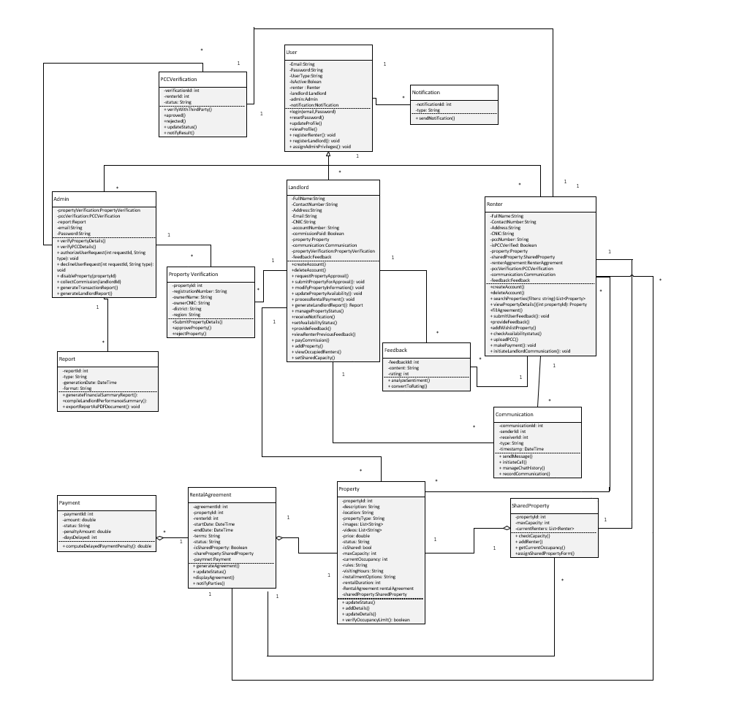

**Description**

This class diagram shows a rental management system with three major roles: Admin, Landlord, and Tenant, all derived from the User class. Admin verifies properties, users, and PCCs and produces reports. Landlord manages properties, rental agreements, and tenant feedback, while Tenant pays rent, signs agreements, and communicates with landlords. The Property class maintains rental details, and there are links to Property Verification for verifying the details of property and Shared Property Management for handling shared rentals. Payment is made for keeping a record of rent payments, and Rental Agreement maintains details about the lease. Other functionalities are Communication, Notification, and Report about system records and issues.

### Activity Diagram

1. **Login (Renter ,Landlord, Admin)**

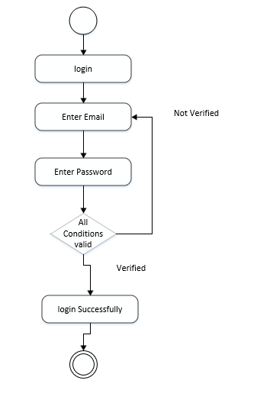

**Description:**

This diagram represents the user enters their email and password; if the email is verified, the login is successful; otherwise, verification is required.This system ensures user authentication, allowing only verified users to log in.

**2.Forget Password**

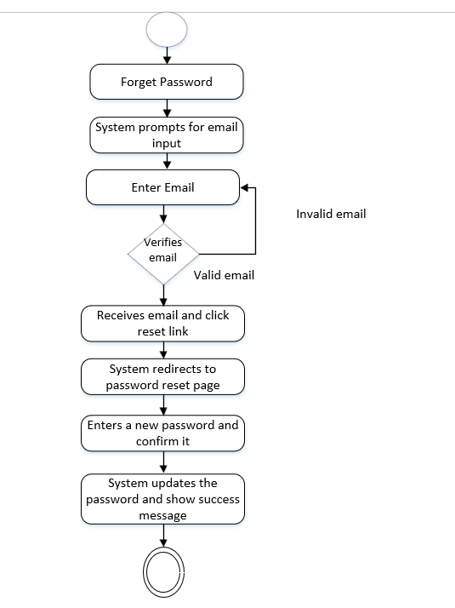

**Description:**

This diagram represents the user enters their email; if valid, they receive a reset link, which redirects them to the password reset page.After entering and confirming a new password, the system updates it and displays a success message.

**3.Account Creation (Renter)**

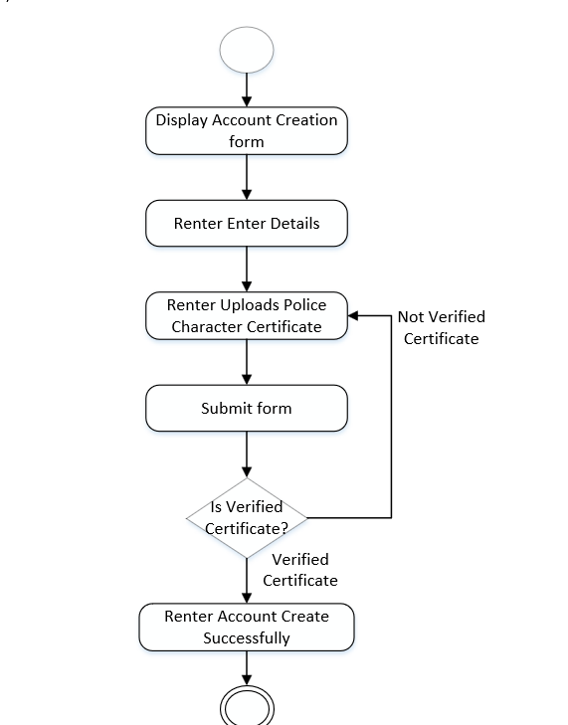

**Description:**

This diagram represent renter fills out the account creation form, uploads a police character certificate, and submits the form.If the certificate is verified, the account is successfully created; otherwise, verification is required.

**4. Account Creation (LandLord)**

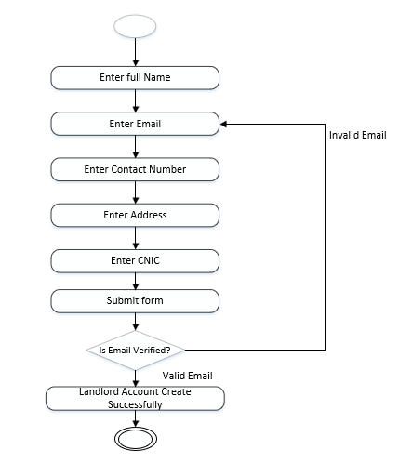

**Description:**

This diagram represents the account creation process for a landlord. It includes steps like entering full name, email, contact number, address, and CNIC, followed by form submission. If the email is invalid, the process loops back for correction. Upon valid email verification, the landlord account is created successfully.

**5.** **Update Profile (Renter, Admin and Landlord)**

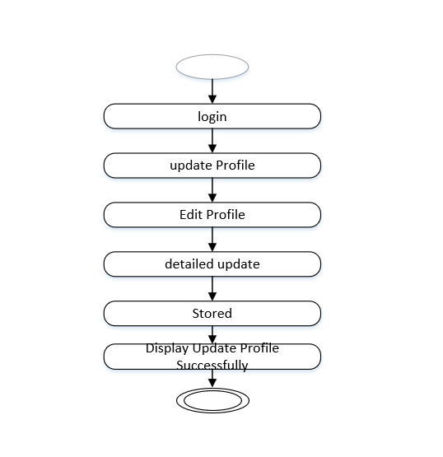

**Description:**

This diagram represents the process of updating a user profile. It starts with the user logging in, followed by updating and submitting profile changes. After submission, the system processes the update and displays the successfully updated profile. The final circle at the bottom indicates the completion of the process.

**6.View Profile(Renter, Landlord , Admin)**

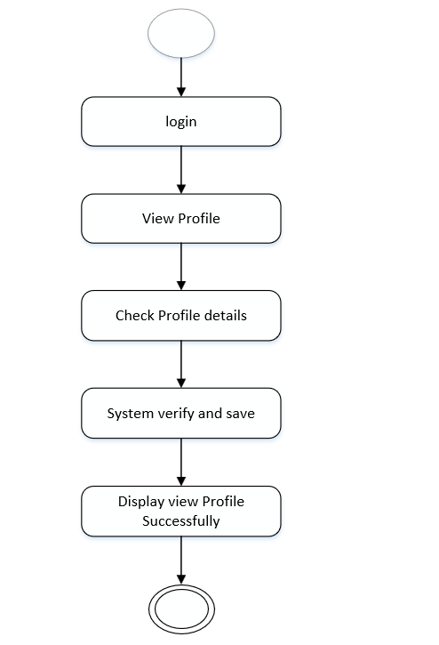

**Description:**

This diagram represents the process of viewing a user profile. It begins with the user logging in, followed by selecting the option to view the profile.The system then checks the profile details, verifies the information, and successfully displays the profile. The final circle at the bottom indicates the completion of the process.

**7. Delete Profile(Renter, Landlord , Admin)**

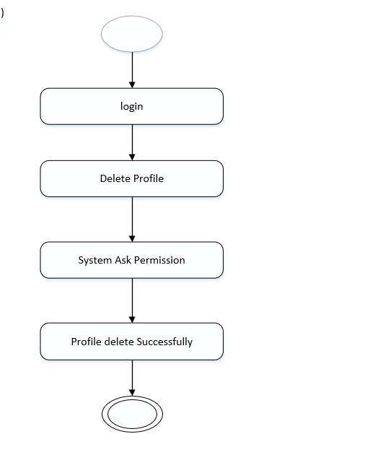

**Description:**

Users can search for properties by applying various filters, including location, budget, property type, and category. Once filters are selected, they are submitted, and the system validates the input. If the filters are valid, renters can view property details and save the property for further action, such as contacting the landlord.

**8.Verify Police Character Certificate**

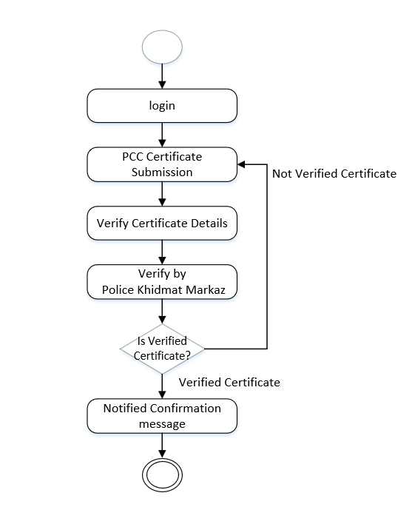

**Description:**

This diagram outlines the process of verifying a Police Character Certificate (PCC) for a renter. It begins with the renter logging in and submitting the PCC. The certificate details are then verified, followed by verification from the Police Khidmat Markaz. If the certificate is verified, a confirmation message is sent; otherwise, it remains unverified.

**9**.**Add To WishList**

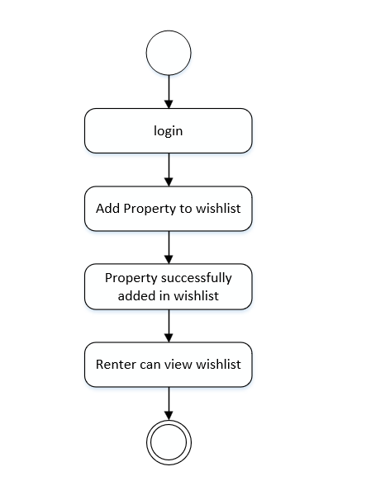

**Description:**

This diagram represents the process of adding a property to a wishlist for a renter. It starts with the renter logging into the system, then selecting a property to add to the wishlist. Once the property is successfully added, the renter can view the wishlist.

**10.Chat(LandLord With Renter)**

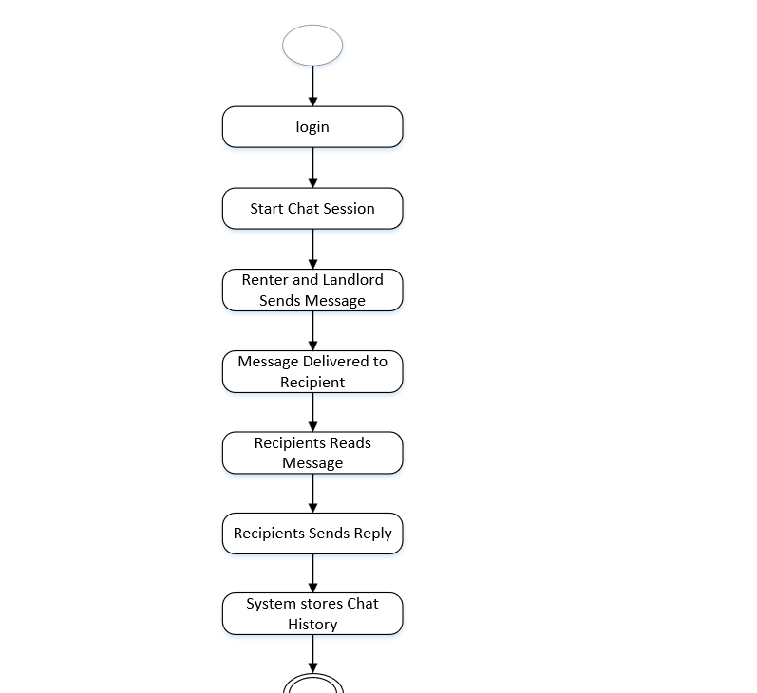

**Descripition:**

This diagram illustrates the chat session process between a renter and a landlord. The renter logs in and sends a message, which is delivered to the landlord. The landlord reads the message and sends a reply, while the system stores the chat history.

**11.Call(LandLord With Renter)**

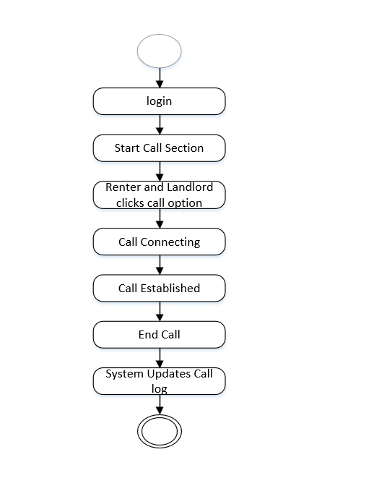

**Descripition:**

This diagram outlines the process for making a call between a tenant and a landlord. The tenant logs in and selects the call option. After the call is connected and established, either party can end the call, and the system updates the call log accordingly.

**12. Search Property**

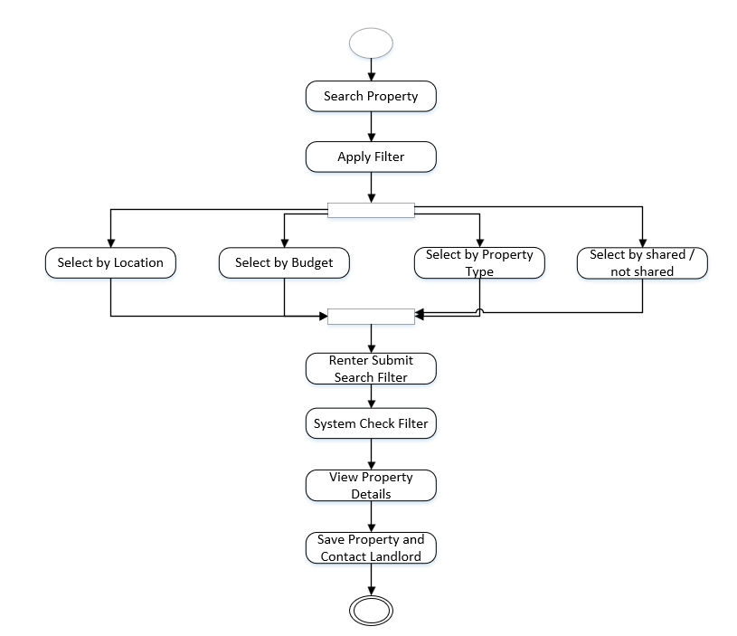

**Descripition:**

This diagram outlines the process for a tenant searching for a property. The tenant starts by searching for a property and applies filters such as location, budget, and property type. After refining the search, they review the property details and can either proceed to apply or continue refining the search criteria. Finally, the system saves the selected property for further action.

**13. Feedback Notification**

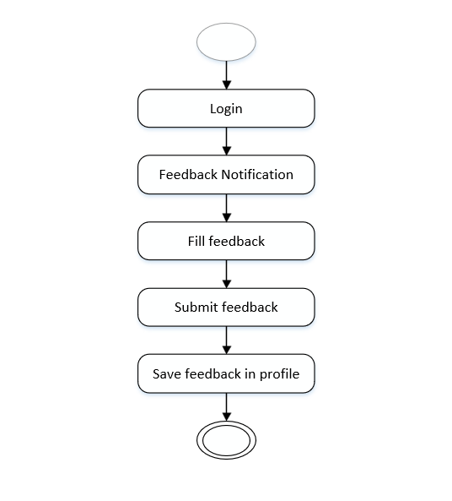

**Descripition:**

This diagram shows the process of providing feedback for a tenant or landlord. After logging in, the user receives a feedback notification and proceeds to fill out the feedback form. Once completed, the feedback is submitted and then saved in the user's profile for future reference.

**14.Send Payment**

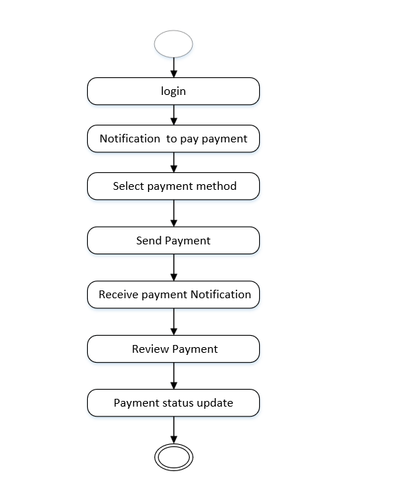

**Descripition:**

This diagram outlines the "Send Payment" process begins when the user logs into the system. Once logged in, the renter receives a notification prompting them to make a payment. After receiving the notification, the renter selects their preferred payment method and proceeds to send the payment. Once the payment is sent, the renter receives a notification confirming the transaction, and the paymenstatus is updated in the system accordingly.

### Sequence Diagram

1. **Admin Login**



**Description**

This is the sequence diagram of the Admin Login process. The admin will be submitting his email and password, which will then be passed to the system for validation. The system checks with the database on whether the credentials are valid or not and fetches the validation result. In case the credentials match, it will redirect the admin to the dashboard else will show an error notification, ensuring safe access to the admin panel based on the verification of credentials.

1. **Landlord Login**



**Description**

The sequence diagram depicts the process of account creation and login for the Landlord. In this, the Landlord will enter the account details, and the system validates and stores them in the database, thus proving that the account is created. The Landlord will then enter the email and password to log in, and the system validates these credentials with the database. If the credentials are valid, it redirects the Landlord to the dashboard; otherwise, an error notification will be displayed. This will ensure secure access and proper account creation for landlords.

1. **Renter Login and Account Creation**



**Description**

The sequence diagram depicts how a renter logs into the system and uploads his PCC. The renter enters his account details and uploads the PCC, which is sent to the system for validation. The system communicates with the database to verify the account details and PCC. If the credentials and PCC are valid, the renter is redirected to his dashboard. It promptly alerts the renter of an invalid identity and informs him that a PCC should be uploaded if he does not have one.

1. **Landlord Property Upload**



**Description**

This sequence diagram depicts the flow of property approval for a landlord. The landlord provides property details to the system. The system validates the count of properties in the database. In case it is the first property of the landlord, a one-time commission amount is paid, and the system proceeds further by sending the request for property approval to the admin. The admin verifies the same with PLRA. Based on the verification, the property is either approved or rejected, and the landlord is notified accordingly.

1. **Renter Property Search**



**Description**

The sequence diagram illustrates the Renter login and property search process. The Renter logs in by providing credentials, which are validated by the system and database. Upon successful login, the Renter applies search filters like location, budget, or category. The system validates the filters, searches for matching properties in the database, and returns the results. If properties are available, they are displayed with an option to add them to the wishlist; otherwise, the Renter is notified that no matching properties were found.

1. **Communication Module**



**Description**

The sequence diagram represents the interaction of a Renter, System, Database, Chatbot, and Landlord in the selection and communication of a property. Upon choosing a property, the system retrieves the landlord details from the database. The Renter can now begin a chat session, in which the chatbot fetches and provides the history of the chat. The Renter can also make a call request, in which the call is connected and a notification is sent to the landlord. This enables easy communication between the renters and the landlords.

1. **Fill Agreement**



**Description**

This sequence diagram describes the process that a renter goes through to fill an agreement. The renter requests to fill an agreement, and the system checks the login status of the renter with the database. If the renter is logged in, the system displays agreement details, allows the renter to fill it, and finalizes the agreement. If the renter has no account, the user is asked to sign up for an account, which is then validated and created successfully before proceeding forward. In this way, the agreement can be processed by only the logged-in user.

1. **Renter Makes Payment**



**Description**

This sequence diagram depicts the rent payment process where the renter initiates a payment through the system. The system fetches landlord account details from the database and validates them using the Skrill API. If the account is validated successfully, the payment is processed, and the transaction is recorded, notifying the landlord of the payment. The system notifies the renter that it cannot process his/her payment in case the account validation fails. Alternative flows are given for both scenarios of existing as well as non-existing accounts.

1. **Payment Penality On Renters**



**Description**

This sequence diagram represents the process of applying a penalty for overdue rent payments. The system checks the status of the rent payment from the database and identifies if the payment is delayed by more than five days. It calculates a 2% penalty on the total rent and updates the payment record with the penalty in the database. The renter is notified of the overdue payment along with the penalty details. The landlord is also being informed of his updated payment status with the added penalty.

1. **Sentiment Analysis**



**Description**

This sequence diagram shows the process of feedback and rating updates between the landlord and the renter. The landlord provides feedback for the renter, which is stored in the database and analyzed by a sentiment analysis service to update the rating of the renter. In the same way, the renter provides feedback for the property, which is stored, analyzed, and used to update the rating of the property. The rating is stored to the relevant profiles after sentiment analysis converts the feedback into a rating. It means that there is transparent and accurate feedback-driven rating updates.

### State Diagram

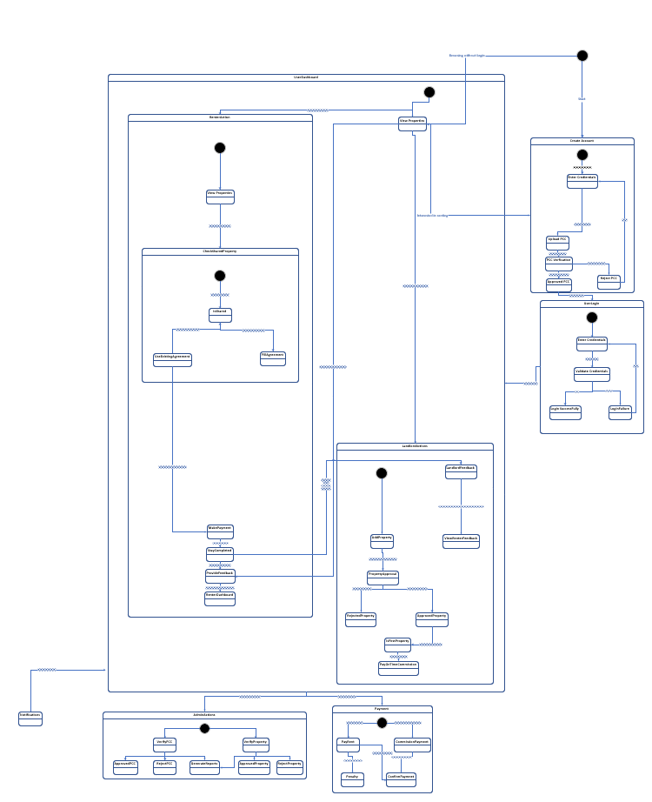

**Description**

This state diagram illustrates the workflow of a property rental system, starting with user account creation and credential validation. Users can browse properties without logging in but must log in to proceed with renting. Renters initiate the rental process by checking shared property status, uploading PCC, completing agreements, making payments, and providing feedback after their stay. Landlords can add properties for admin approval, view renter feedback given by previous landlords, and provide their own feedback after a stay is completed. Admins manage PCC and property verifications, approvals, and payment processes, including renters’ rent payments and landlords’ commission payments, ensuring smooth transactions.

### Layered Architecture



**Descripition**

This layered architecture diagram outlines the structure of a property management system. At the top, the Presentation Layer provides dashboards for the admin, landlord, and renter, serving as the user interface for each role. Below it, the Application Layer handles core modules like user authentication, property listings, payment processing, AI chatbot, and reporting. The Business Logic Layer is responsible for the system's essential APIs, including property management, renter verification, and third-party integrations. Finally, the Data Access Layer interfaces with Firebase to manage data storage and retrieval. This architecture ensures clear separation of concerns, making the system scalable, maintainable, and easier to manage.

# Human Interface Design

### Screen Images

### 

**Admin Screens**

**Welcome Screen**

* Purpose: Initial screen introducing the admin platform.
* Elements:
  + App logo and name.
* User Interaction: Admin selects the appropriate option to begin.

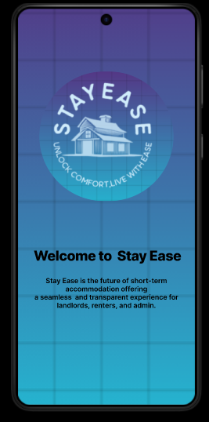

**Select User Type**

* Purpose: Identifies the role of the user.
* Elements:
  + User type options (e.g., Admin, Renter, landlord).
* User Interaction: Admin chooses the role to access relevant functionalities.

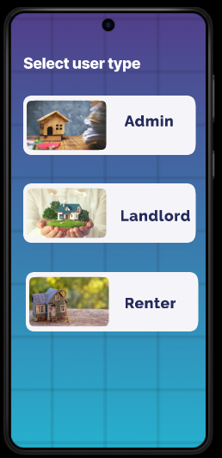

**Login**

* Purpose: Authenticates the admin to access the dashboard.
* Elements:
  + Input fields for Email and Password.
  + Button: Login.
* User Interaction: Admin enters credentials to log in.

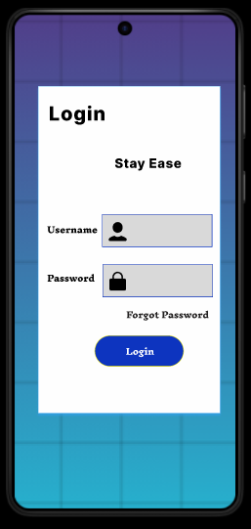

**Admin Dashboard:**

This Admin Dashboard manages property transactions, listings, reports, and PCS verifications. It features a navigation bar for quick access to Dashboard, Notifications, Search, and Reports, ensuring efficient property management.

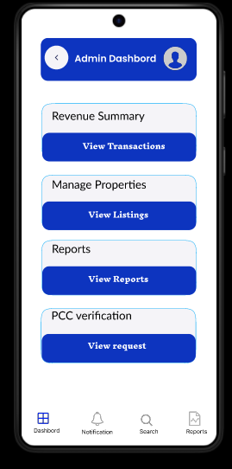

**Admin Profile:**

This Admin Profile screen in the mobile app allows administrators to update or delete their account credentials. It includes fields for email ID and password, along with Update and Delete buttons for managing profile settings efficiently.

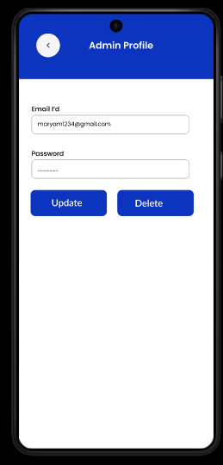

**Property Verification Requests**

* Purpose: Manage property verification requests from landlords.
* Elements:
  + List of requests with property details (e.g., Address, Landlord Name).
  + Action buttons: Approve or Reject.
* User Interaction: Admin reviews requests and decides.

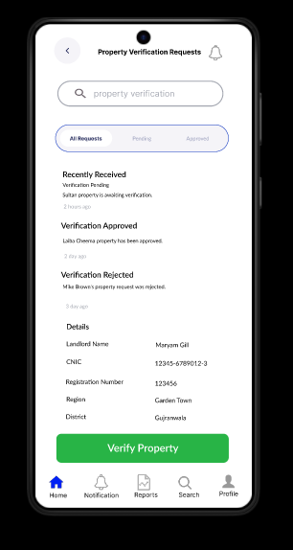

**Renter Agreement Verification**

* Purpose: Validate renter agreements submitted by landlords or renters.
* Elements:
  + Agreement details: Renter Name, Property Address, Terms.
  + Action buttons: Approve or Request Revision.
* User Interaction: Admin reviews and verifies agreements.

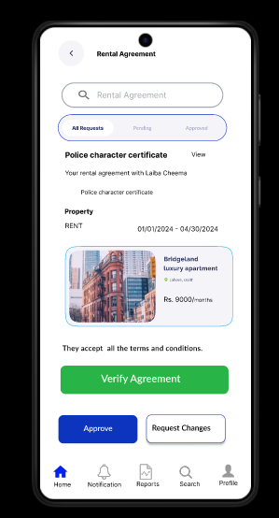

**Receive Commission Payments**

* Purpose: Record and process commission payments from landlords.
* Elements:
  + Payment details: Landlord Name, Property ID, Amount.
  + Status: Pending, Received, or Overdue.
* User Interaction: Admin marks payments as received and generates receipts if necessary.

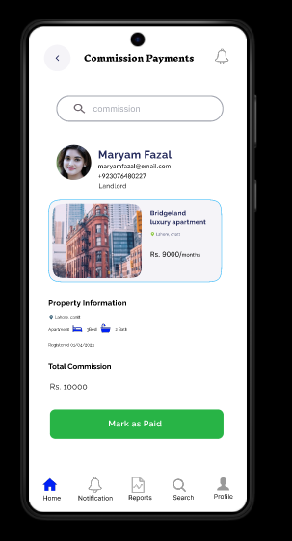

**Reports:**

This Reports screen in the Admin Dashboard provides access to Property Reports and Transaction Reports. It enables administrators to review key data related to properties and financial transactions. The navigation bar ensures quick access to Dashboard, Notifications, Search, and Reports.

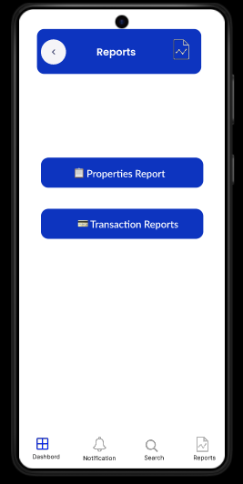

**Generate Property Listing Reports**

* Purpose: Provide insights into property listings.
* Elements:
  + Report filters: Date Range, Property Type, Location.
  + Button: Generate Report.
* User Interaction: Admin selects filters and views or downloads the report.

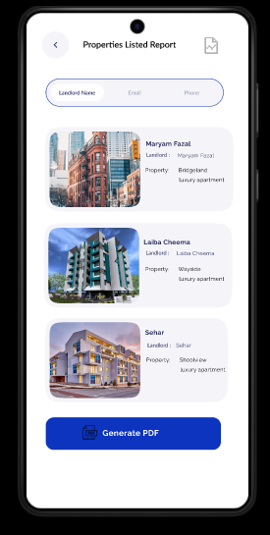

**Transaction Reports**

* Purpose: Generate detailed records of financial transactions.
* Elements:
  + Filters: Date Range, Landlord/Renter, Transaction Type.
  + Report Output: List of transactions with details like Amount, Date, Status.
* User Interaction: Admin applies filters to view or download transaction records.

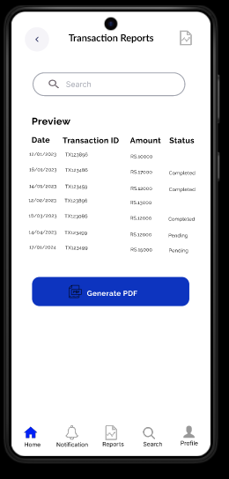

**LandLord Screens**

**Welcome Screen:**

Entry point of the app, directing users to proceed further.

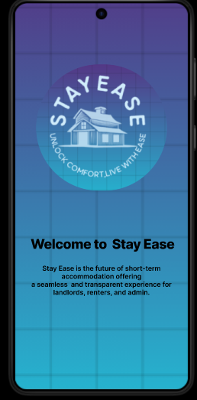

**Select User Type:**

Users select their role: renter and admin.

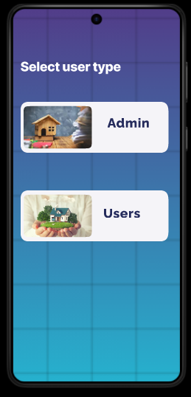

**Create Account Screen:**

Allows new users to register for an account.

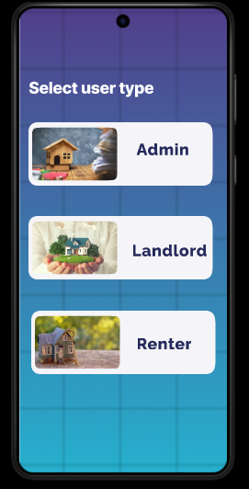

**Login Screen:**

Enables existing users to log in.

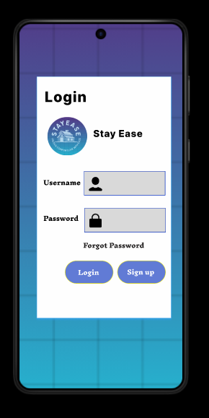

**Home Screen**

This **Home Screen** lets users , filter, and browse property listings, with options to add properties. The navigation bar provides quick access to **Home, Notifications, Payment, Search,** and **Profile**.

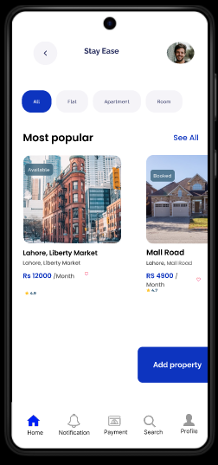

**Property Registration Request:**

**Property Request**:

Submits property details for admin review and verification.

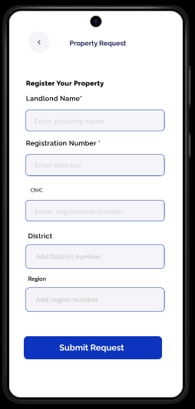

**Verification Approval Notification:**

Sends a notification confirming successful property verification.

Signals landlords that their property is now ready to list.

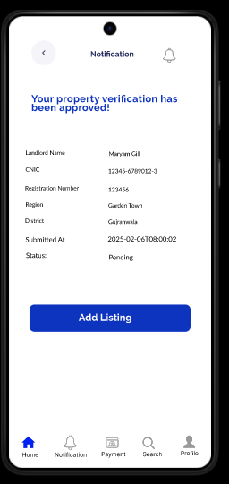

**Property Listing Screen:**

Add phone numbers, property category, and listing type.

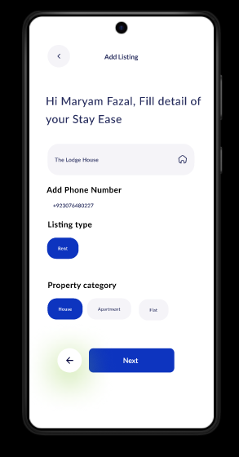

**Adding location:**

Input the exact property location using map.

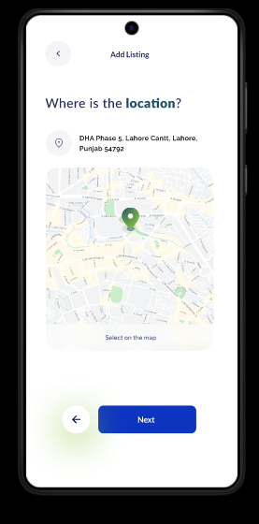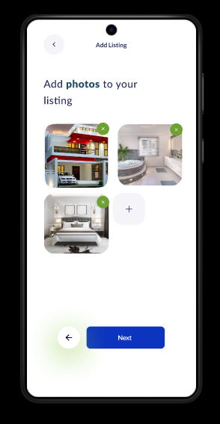

**Photos :**

Upload property images for listing.

**Video:**

Upload property Video for listing. **Rent and Features:**

Add rent price, number of bedrooms, bathrooms, and kitchens

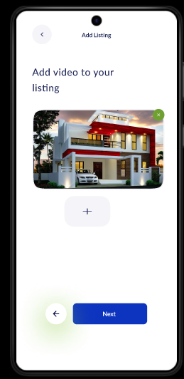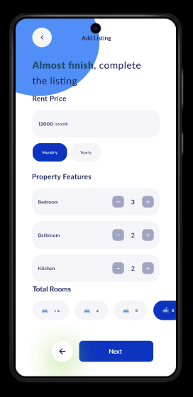

.

**Visiting Time Slots:**

Schedule available times for renters to visit.

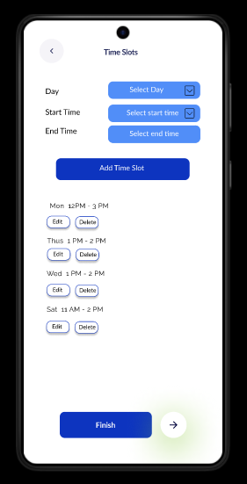

**Your listing is now published**

new

Add role and regulation

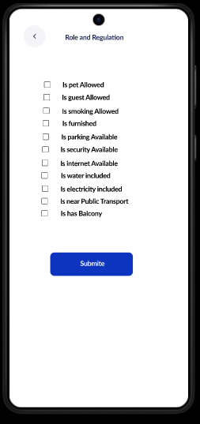

Provides feedback confirmation when the listing is published.

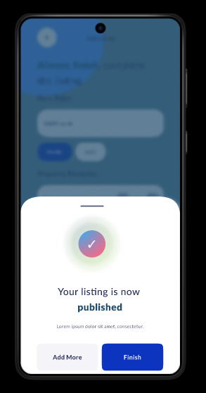

Provides feedback on errors when the listing is published

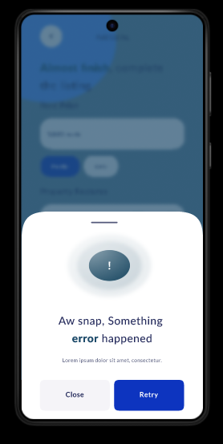

**Landlord Profile Screen:**

Displays a summary of the landlord’s transactions.

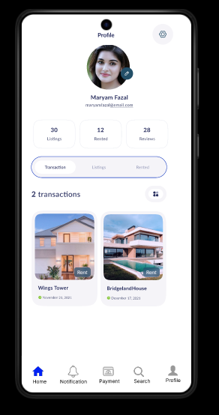

**Landlord Profile Screen:**

Displays a summary of the landlord’s property listings.

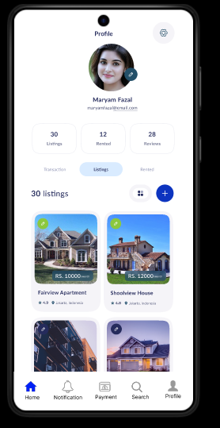

**Edit profile:**

Edit personal information

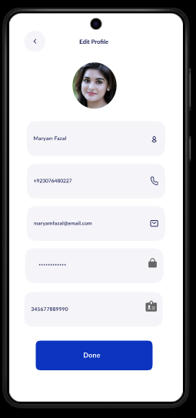

**Renter Review and Feedback Screens:**

Allows landlords to view reviews and feedback left by renters.

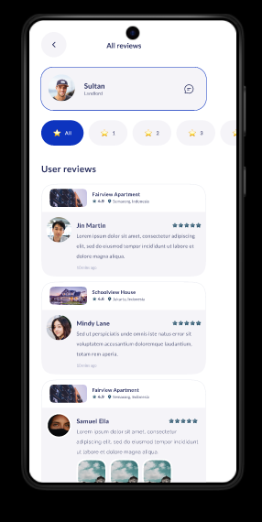

**All Notification:**

About payment received, incoming payment, Mark Residences, payment commission.

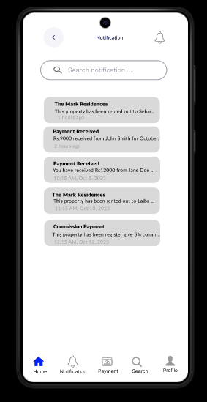

**Property Details Screen:**

Shows the specific property details chosen by renters.

Provides visibility into renter preferences.

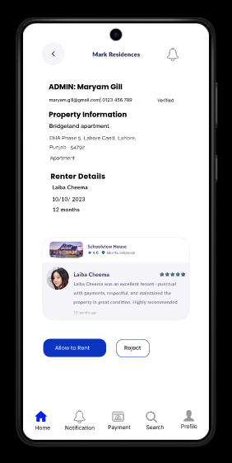

**Property Details the renter choices:**

Provides visibility into renter preferences

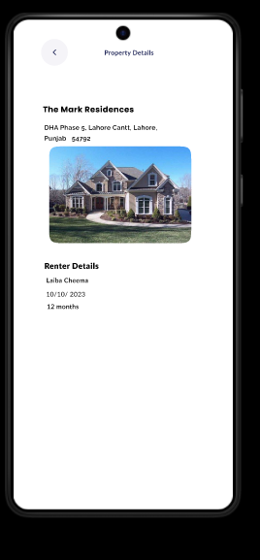

**Commission Payment Screen:**

Facilitates payment to the admin for using the platform.

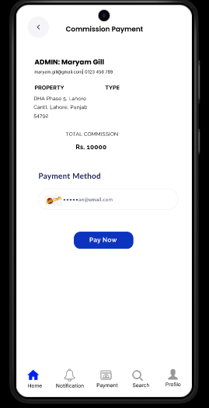

**Select Credit Card:**

Supports credit card selection and confirms successful transactions.

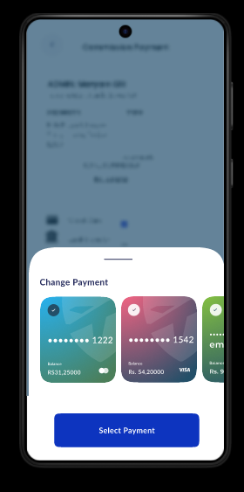

Your transaction is success transfer to Admin account:

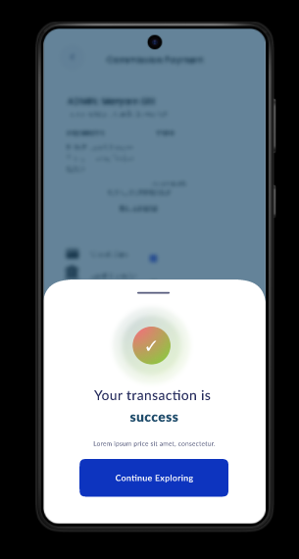

**Communication Screen:**

Renters to call landlord phone number directly.

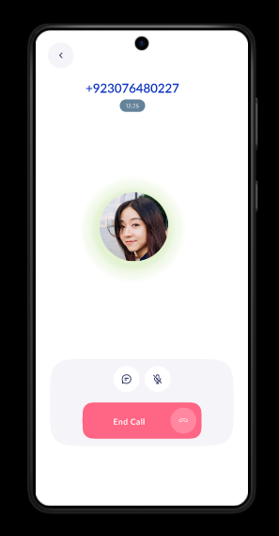

new

**Communication Screen:**

Provides features for renters chat with landlords within the app.

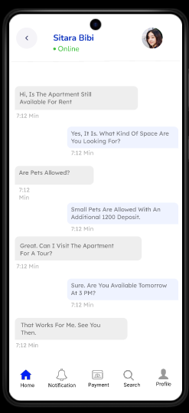

**Landlord Feedback Screen:**

Allows landlords to leave feedback about renters.

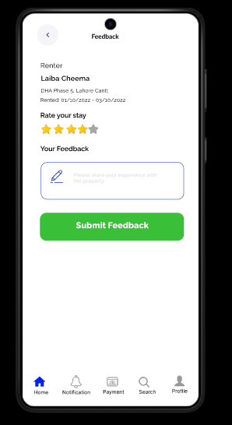

**Renter Screens**

**Welcome Screen:**

Displays a welcoming message or introduction.



**Home Screen:**

**Front Screen**

* **Purpose**: Acts as the home dashboard.
* **Elements**:
  + Search bar for properties.
  + Quick links for features like **Filters**, **Wishlist**, and **Notifications**.
  + Recent or recommended properties based on user preferences.
* **User Interaction**: Start a search or navigate to other sections (e.g., filters, wishlist).

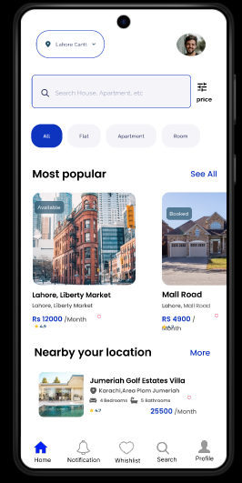

**Notification for Renter:**

• **Purpose**: Encourages users to log in or create an account to continue.

• **Elements**:

* Message box stating: “Please log in to access all features.”
* Login/Sign-Up buttons.

• **User Interaction**: Users are guided to log in or sign up before proceeding

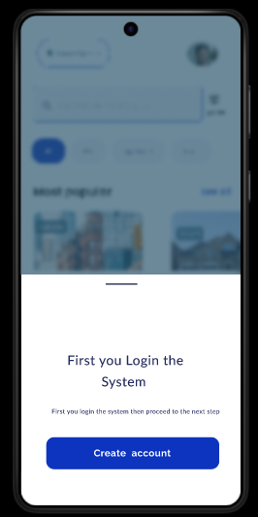

**Create Account:**

If new, the user can choose to Create Account.

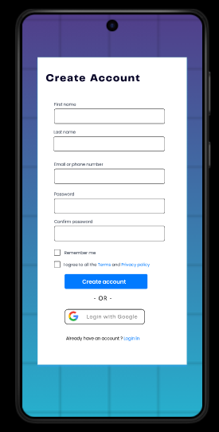

**Login:**

• **Purpose**: Authenticates users to access their profiles.

• **Elements**:

* Input fields: **Email** and **Password**.
* “Forgot Password?” link.
* **Sign-Up** button for new users.

• **User Interaction**: Users log in or create account if they don’t have an account.



**Apply location filter:**

• **Purpose**: Narrow down search results to a specific geographic area.

• **Elements**:

* Input box for entering a location or using GPS for current location.
* Dropdown or map view for selecting regions.

• **User Interaction**: Users input or select a location to apply a location filter.

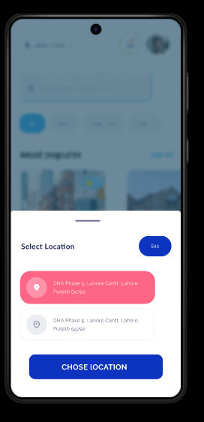

**Search Nearby Location**

* **Purpose**: Suggests properties close to the user’s location.
* **Elements**:
  + Button: **Search Nearby**.
  + List of nearby properties with distances shown.
* **User Interaction**: Users can tap on nearby results or refine further.

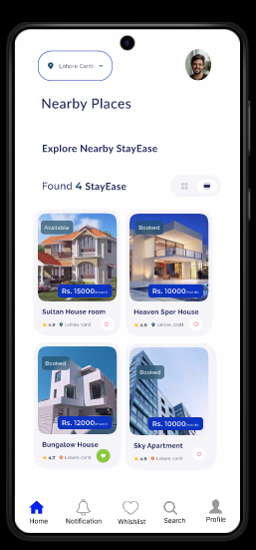

**Search Wrong Location**

* **Purpose**: Handles invalid location inputs.
* **Elements**:
  + Error message: “No properties found in this location. Try another area.”
* **User Interaction**: Users are prompted to adjust the search query.

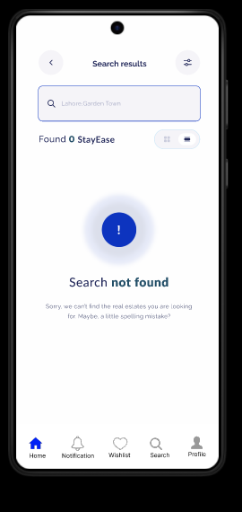

**Search Nearby Location**

* **Purpose**: Suggests properties close to the user’s location.
* **Elements**:
  + Button: **Search Nearby**.
  + List of nearby properties with distances shown.
* **User Interaction**: Users can tap on nearby results or refine further.

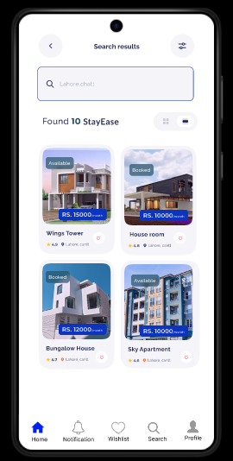

**Apply Property Type Filter**

* **Purpose**: Refine searches by property type (e.g., apartments, houses).
* **Elements**:
  + Dropdown or toggles for property types.
  + Example types: **Apartment**, **Flats**, **House**.
* **User Interaction**: Select a property type, and the results are filtered accordingly

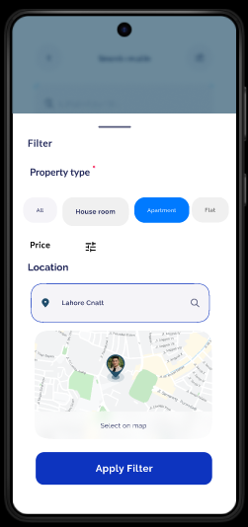

**Apartment Show on Screen**

* **Purpose**: Displays filtered results.
* **Elements**:
  + Property cards with:
    - Image.
    - Rent price.
    - Brief description (e.g., “2BHK near Downtown”).
  + Call-to-action buttons like **View Details**.
* **User Interaction**: Users browse the results and click on a property for more details.

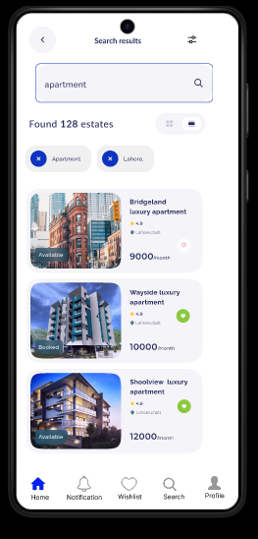

**Apply Price Filter**

* **Purpose**: Filter properties based on budget.
* **Elements**:
  + Slider or input fields for price range.
  + Example: “Rs.9000–Rs.12,000 per month.”
* **User Interaction**: Adjust price range and view updated results.

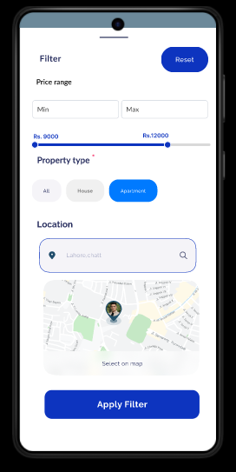

**Shown Results After All Filters**

* **Purpose**: Displays properties that meet all criteria (location, type, price).
* **Elements**:
  + Finalized list of properties.
  + Button: **Save to Wishlist** or **View Details**.
* **User Interaction**: Users browse, shortlist, or proceed to book.

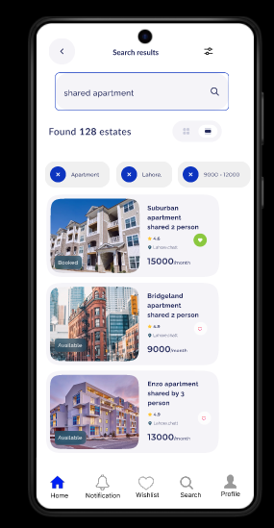

**Property Details Display**

* **Purpose**: Provides key property information.
* **Elements**:
  + Property Name.
  + Location.
  + Monthly Rent.
  + Features: Number of bedrooms and bathrooms.
  + Availability label (e.g., “Available” or “Not Available”).
  + Star rating (e.g., **4.9 stars**)
  + Landlord Name.
  + Contact options like direct call on landlord phone number or in-app chat
  + Book Now button to initiate rental requests.
  + Schedule Visit button to arrange a viewing.

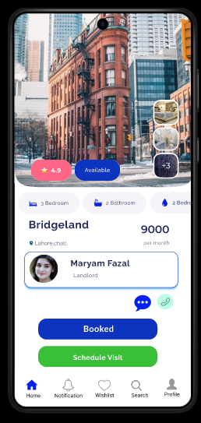

**View Reviews**

* **Purpose**: Help users make informed decisions.
* **Elements**:
  + User-submitted ratings and reviews.
  + Average rating displayed as stars.
* **User Interaction**: Read feedback on properties.

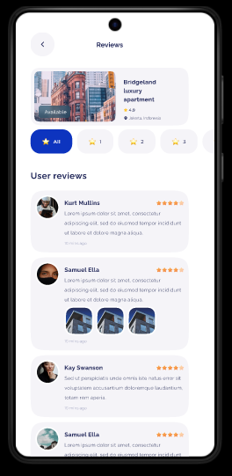

**Call to Landlord**

* **Purpose**: Directly contact landlords.
* **Elements**:
  + Button: **Call Landlord**.
  + Pop-up confirming the action before dialing.
* **User Interaction**: Users call landlords to inquire further.

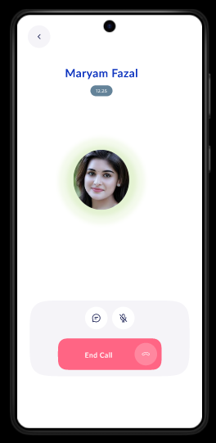

**Chat with Landlord within App**

* **Purpose**: Facilitates communication between renters and landlords.
* **Elements**:
  + In-app chat interface:
    - Message box.
    - Send button.
  + Chat history.
* **User Interaction**: Users type messages to discuss details or set up visits.

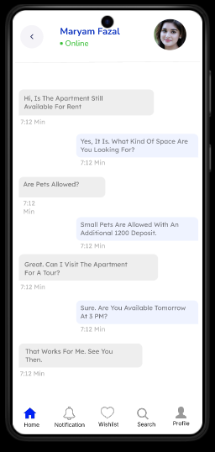

**Select Time Slot for Visiting**

* **Purpose**: Schedule property visits.
* **Elements**:
  + Calendar view for selecting dates.
  + Time slot options (e.g., “10:00 AM–12:00 PM”).
* **User Interaction**: Select a convenient slot and confirm.

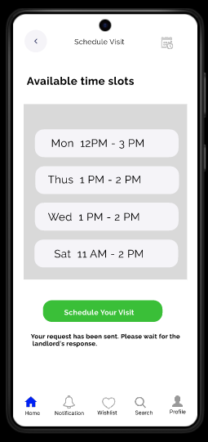

**View Wishlist**

* **Purpose**: Access saved properties.
* **Elements**:
  + List of bookmarked properties.
  + Actions like **Remove from Wishlist** or **View Details**.
* **User Interaction**: Browse and manage saved properties.

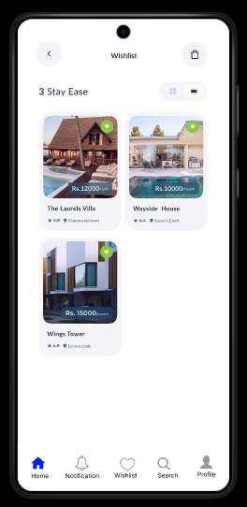

**First fill the agreement:**

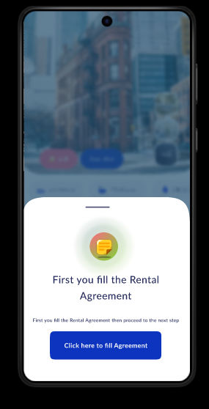

**Fill the Agreement**

* **Purpose**: Digitally sign rental agreements.
* **Elements**:
  + Digital form with:
    - Tenant details.
    - Property details.
    - Terms and conditions.
  + Signature field.
* **User Interaction**: Users review, complete, and sign the agreement.

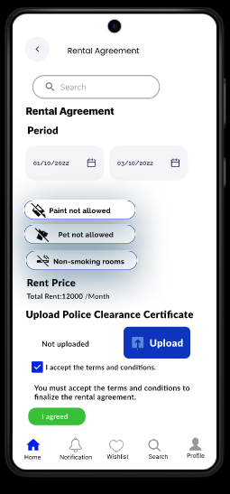

**Notification for Approved Request**

* **Purpose**: Notify renters when their request is approved.
* **Elements**:
  + Message: “Your rental request has been approved by the landlord.”
* **User Interaction**: Users can proceed to payments or other actions.

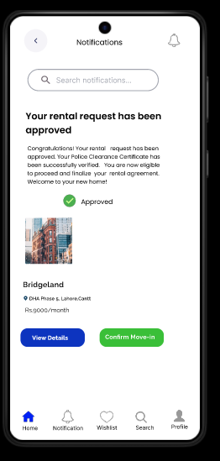

**Notification of Incoming Payment**

* **Purpose**: Alert about rent payments.
* **Elements**:
  + Reminder message for upcoming or overdue payments.
* **User Interaction**: Users are prompted to pay on time.

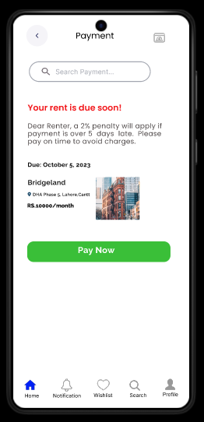

**Choose Payment Type**

This **Rent Payment** screen allows users to pay for properties. It displays property details, total amount due, payment breakdown (rent and utilities), and payment method. A **"Pay Now"** button finalizes the transaction. The navigation bar offers quick access to **Home, Notifications, Wishlist, Search,** and **Profile**.

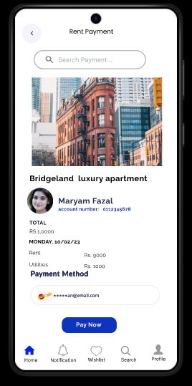

**Payment Choice**

* **Purpose**: Finalize payments.
* **Elements**:
  + Payment confirmation screen showing:
    - Amount.
    - Payment type.
    - Transaction ID (if applicable).
  + Button: **Confirm Payment**.
* **User Interaction**: Users confirm and complete the transaction.

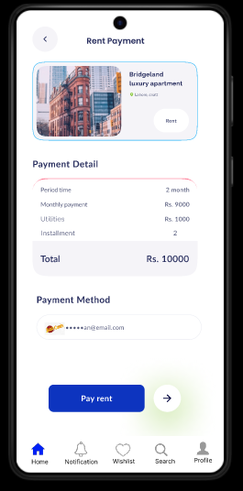

**Select Credit Card:**

Supports credit card selection and confirms successful transactions

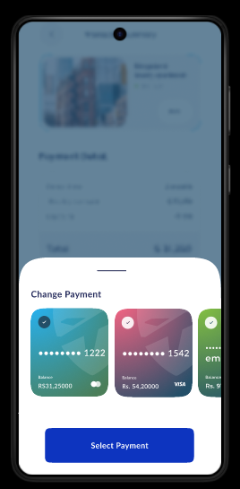

**Message:**

Your transaction is success transfer.

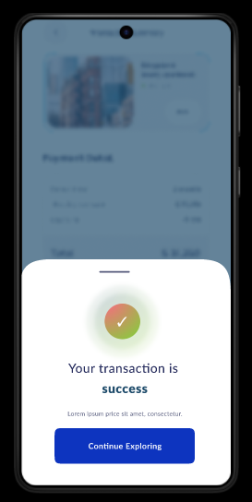

**Transaction Detail Page**

1. **Purpose**: This screen displays the details of a completed transaction, typically for a booking or purchase.
2. **Key Elements**:
   * **Header**: "Transaction Detail" indicates the purpose of the page.
   * **Image**: Displays the property or service associated with the transaction.
   * **Details Section**:
     + Shows key transaction information such as:
       - Order ID
       - Transaction Date
       - Property/Service details.
   * **Payment Details**:
     + Includes the total price, payment method, and other relevant payment information.
   * **Call-to-Action**:
     + A button at the bottom says, "Click here to add feedback," prompting the user to proceed to a feedback form.

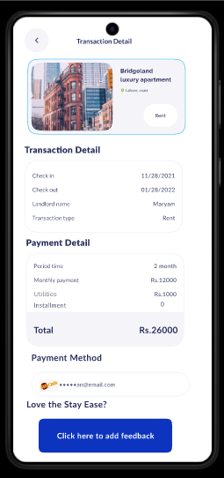

**Feedback Page**

1. **Purpose**: This screen allows the user to leave feedback about their experience with the transaction or service.
2. **Key Elements**:
   * **Header**: "Feedback" indicates the page's purpose.
   * **Image**: Shows the same property or service as in the transaction detail page, providing context for the feedback.
   * **Details Section**:
     + Displays the name of the property or service, alongside its rating and basic details.
   * **Feedback Form**:
     + A text input area for users to leave comments or suggestions.
     + A star rating system to give a numerical rating.
   * **Submit Button**:
     + Green button labeled "Submit Feedback" to finalize the feedback submission.

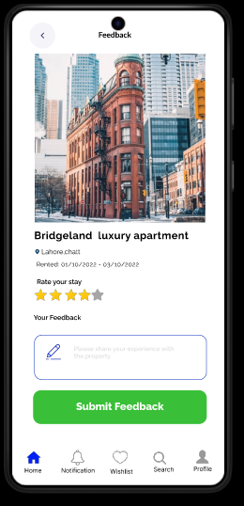

## 6 . Implementation Screens

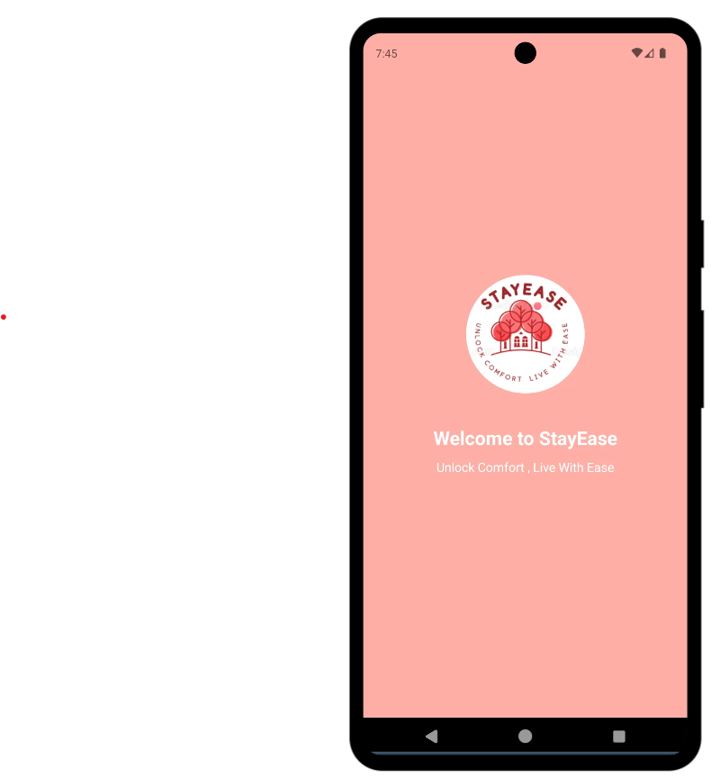

**Landlord**

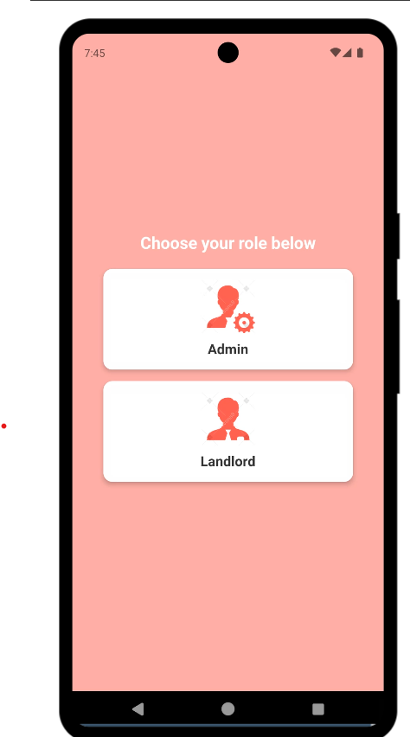

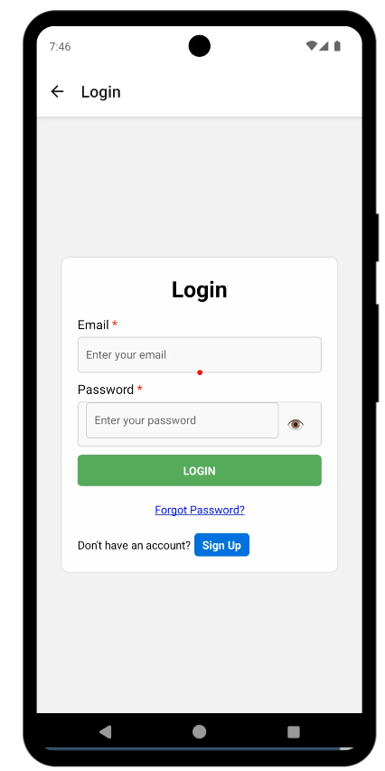

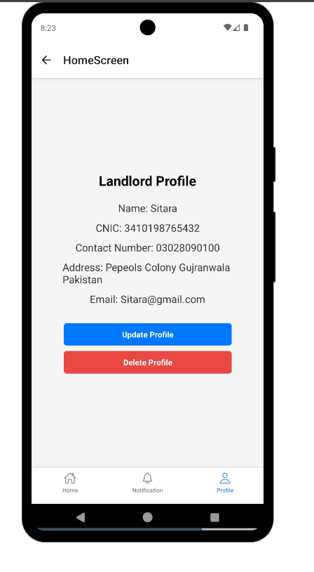

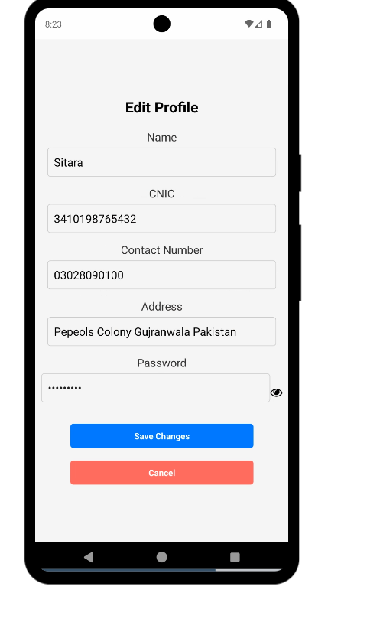

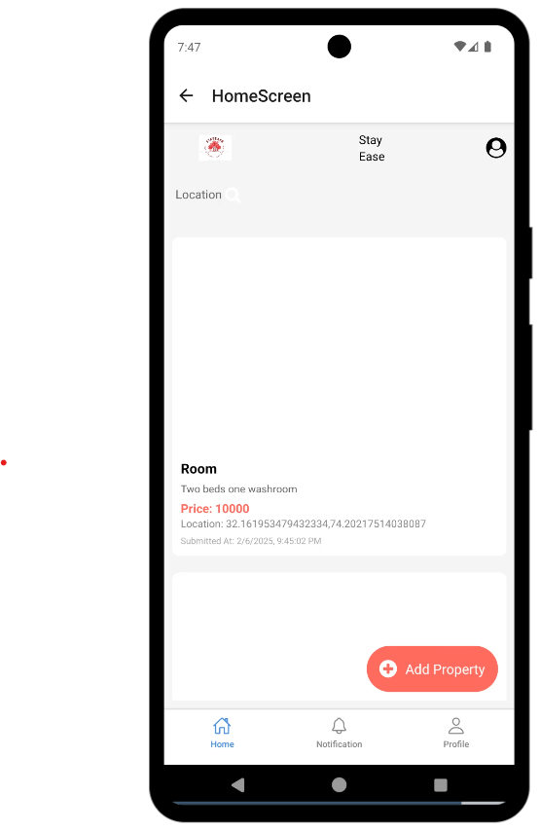

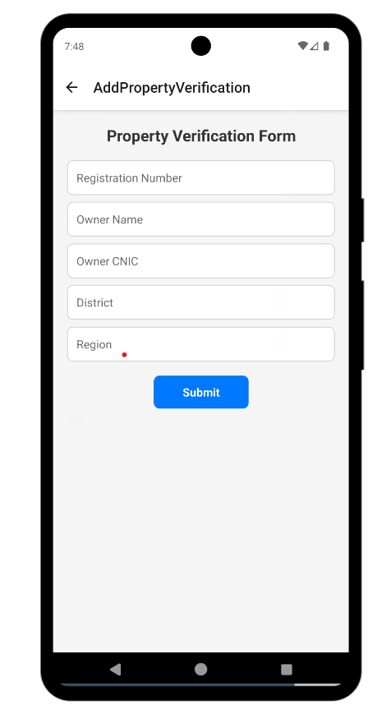

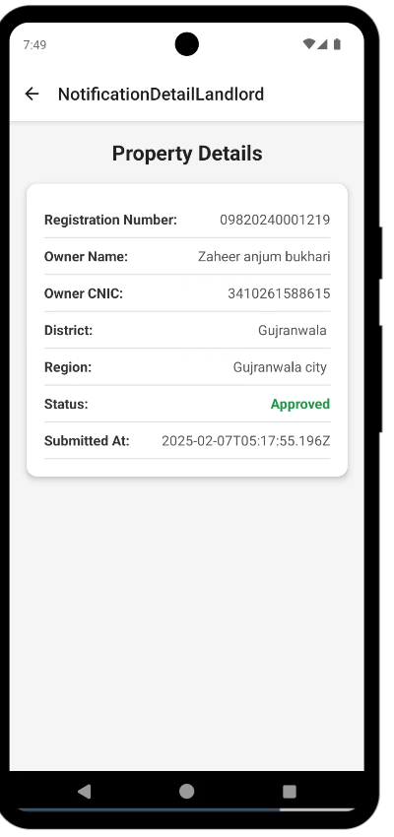

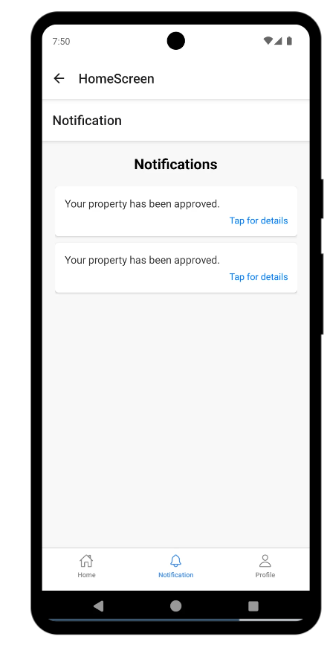

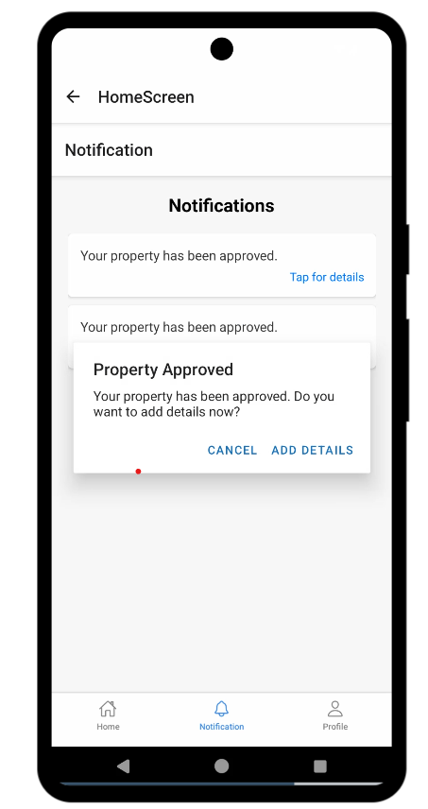

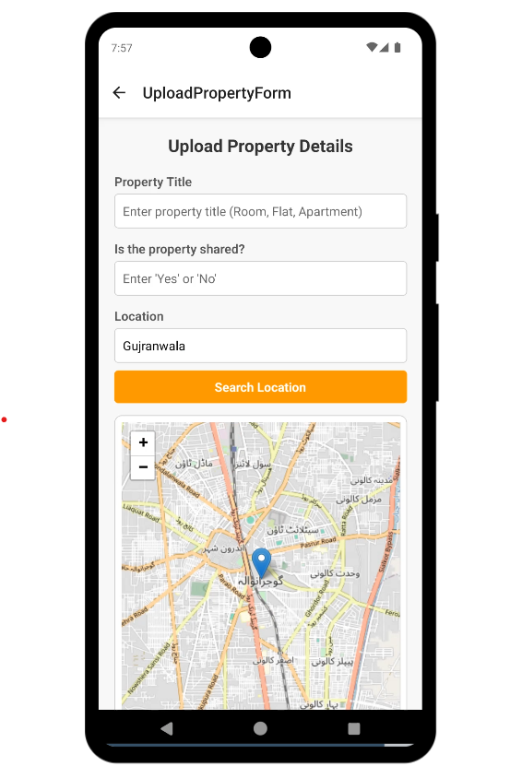

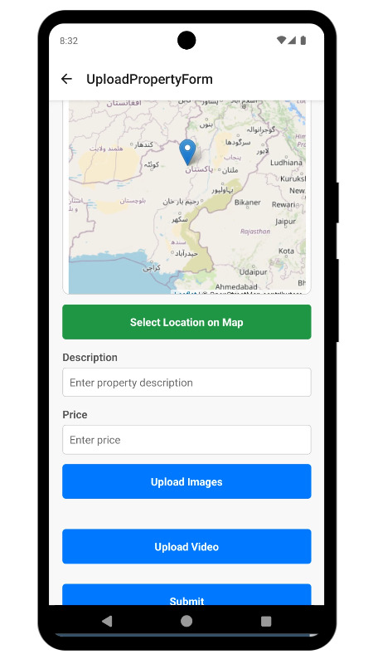

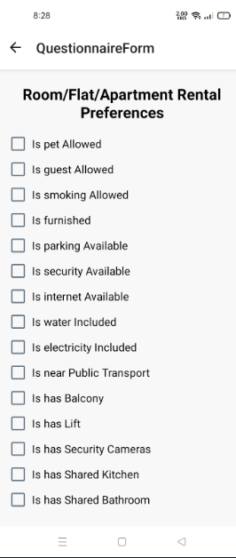

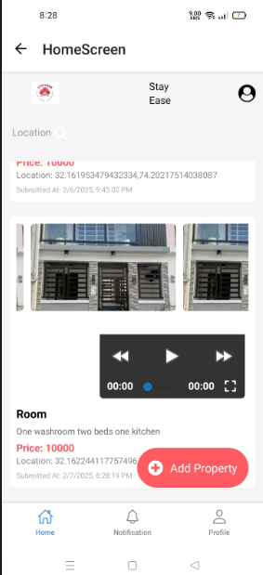

**Admin**





